

SPECIAL NEEDS PLAN
MODEL OF CARE 2026

Contract H5496

TABLE OF CONTENTS

 | 58
  Summary | 3
  1A. Description of the SNP Population ……………………………………………….. | 6
  1B. Subpopulation—Most Vulnerable Beneficiaries ………………………………….. | 20
  2. Care Coordination.......……………………………………………………………… | 31
  2A.SNP Staff Structure ………………………………………………………………... | 31
  2B. Health Risk Assessment Tool …………………………………………………... | 48
  2C Face to Face ……………………………………….................................................  2D. Individualized Care Plan …………………………………………………….......... | 54
  2E. Interdisciplinary Care Team ……………………………………………………..... | 62
  2F. Care Transition Protocols ……………………………………………………......... | 72
  3. Provider Network …………………………………………………………………… | 80
  3A. Specialized Expertise ……………………………………………………............... | 80
  3B. Use of Clinical Practice Guidelines and Care Transition Protocols………………. | 86
  3C. MOC Training for the Provider Network …………………………………………. | 93
  4. MOC Quality Measurement and Performance Improvement ......…………………... | 96
  4A. MOC Quality Performance Improvement Plan…………………………………… | 96
  4B. Measurable Goals and Health Outcomes for the MOC…………………………… | 109
  4C. Measuring Patient Experience of Care (SNP Member Satisfaction)……………… | 118
  4D. Ongoing Performance Improvement Evaluation of the MOC……………………. | 121
  4E. Dissemination of SNP Quality Performance Related to the MOC………………...  APPENDIX A Organizational Chart  APPENDIX B Health Risk Assessment  APPENDIX C Factor 3A Factor 2 Evidence of Specialized Training of ICT  APPENDIX D Model of Care Training Deck and Model of Care Training Provider Attestation | 124

SUMMARY

Target Population
Imperial Health Plan of California C-SNP serves a target population of current SNP members in California: Alameda, Amador, Butte, Contra Costa, Del Norte, El Dorado, Fresno, Glenn, Humboldt, Imperial, Inyo, Kern, Kings, Los Angeles, Madera, Marin, Mariposa, Mendocino, Merced, Modoc, Mono, Monterey, Napa, Nevada, Orange, Placer, Plumas, Riverside, Sacramento, San Benito, San Bernardino, San Diego, San Francisco, San Joaquin, San Luis Obispo, San Mateo, Santa Barbara, Santa Clara, Santa Cruz, Shasta, Sisikyou, Solano, Sonoma, Stanislaus, Tehama, Tulare, Tuolumne, Ventura, Yolo, Yuba. counties.
C-SNPs are SNPs that restrict enrollment to special needs individuals with specific severe or disabling chronic conditions, defined in 42 CFR 422.2. Approximately two-thirds of Medicare enrollees have multiple chronic conditions requiring coordination of care among primary providers, medical and mental health specialists, inpatient and outpatient facilities, and extensive ancillary services related to diagnostic testing and therapeutic management. Imperial Health Plan intends to offer the C-SNP Plan in the chronic conditions shown in Figure 1a below.

Imperial performs a population assessment to build a Model of Care that will best serve the needs of the members. Imperial reverifies members’ C-SNP-qualifying conditions at least annually (or more frequently if indicated) via claims data, PCP attestations, and HRA results. Any member who no longer meets qualifying criteria is notified and assisted with transition to another plan.

Imperial Health Plan intends to offer the C-SNP Plan in the following chronic conditions: Cardiovascular disorders including Cardiac Arrhythmias, Coronary Artery Disease, Peripheral Vascular Disease, Chronic Venous Thromboembolic disorder; Chronic Heart Failure; Hypertension; and Diabetes Mellitus. Imperial performs a population assessment to build a Model of Care that will best serve the needs of the members.

Provider Network

Imperial Health Plan contracts with a comprehensive network of facilities and providers to serve the needs of the dual population. Facilities within the network include but are not limited to acute hospitals, emergency facilities, diagnostic/surgery centers, skilled nursing, rehabilitation, and psychiatric centers. The provider network includes various PCPs and specialty providers in but not limited to Cardiology, Endocrinology, Nephrology, Neurology, Psychiatry, and Pulmonology.

Care Management and Coordination

The Initial Health Risk Assessment (HRA) is conducted within 90 days of enrollment, and an annual reassessment is conducted for each member within 365 days of the last assessment or within 30 days after any significant change in condition (hospital admission, major surgery, change in diagnosis, etc.). In the event of a hospitalization or a change in health status, prescribed medications or utilization of services, reassessments occur more frequently. The initial health risk assessment (HRA) to members is conducted by phone, mail, or in-person if necessary. The standardized health risk assessment (HRA) questionnaire evaluates the physical, psychosocial, cognitive, and functional needs of the SNP members. In addition to the HRA, Imperial will be developing a comprehensive risk assessment solution that will integrate claims, clinical and population data to comprehensively assess the risk of its SNP members. Therefore, this 360-degree assessment provides the member’s health status and acuity level, including both vulnerability/care gaps and resilience factors which, clinical interventions and the development of the individualized care plan (ICP). The case manager develops and discusses the ICP with the member and the interdisciplinary care team to ensure that the goals are mutually agreed upon. The disciplinary care team consists of but is not limited to Primary Care Physicians, Specialists, care managers, administrative management staff, community resource specialists, behavioral health specialists, pharmacists, and family members. The case manager utilizes the ICP to accomplish, track interventions and document progress towards set goals. With each member contact, the case manager assesses the member’s progress towards the goals. The Case manager defines and discusses the barriers in achieving the identified goals and modifies the goals based on member and caregivers needs. The ICP is maintained on an online portal hosted by Imperial’s servers and is accessible to the care management team.
This Model of Care (MOC) summary is intended to provide a broad overview of the SNP’s MOC. The MOC summary will reference Imperial’s most recent Population Health Strategy for Medicare Population throughout the document. The MOC and Population Health Programs are intended to compliment each other, using the same staff and operational/policy areas. Although the full extent of any MOC cannot be conveyed in a short summary, this provides a general overview of how Imperial addresses SNP member needs. For more information about this health plan refer to the Special Needs Plan’s website at: https://www.imperialhealthplan.com.
1A Description of the SNP Population
1A Factor 1: Determine, Verify, and Track Eligibility of SNP Beneficiaries.
Imperial Health Plan of California C-SNP serves a target population of current SNP members in California: Alameda, Amador, Butte, Contra Costa, Del Norte, El Dorado, Fresno, Glenn, Humboldt, Imperial, Inyo, Kern, Kings, Los Angeles, Madera, Marin, Mariposa, Mendocino, Merced, Modoc, Monterey, Napa, Nevada, Orange, Placer, Plumas, Riverside, Sacramento, San Benito, San Bernardino, San Diego, San Francisco, San Joaquin, San Luis Obispo, San Mateo, Santa Barbara, Santa Clara, Shasta, Sisikyou, Solano, Sonoma, Stanislaus, Tehama, Tulare, Tuolumne, Ventura, Yolo, Yuba.
Imperial Health Plan performs a population assessment to build a Model of Care that will best serve the needs of the members. Additionally, this population assessment assists in identifying existing community resources and gaps in services, including clinical, case management, social services, long term care services, and hospice services in the areas that it serves. Imperial offers C-SNP in the following chronic conditions: Cardiovascular disorders including Cardiac Arrhythmias, Coronary Artery Disease, Peripheral Vascular Disease, Chronic Venous Thromboembolic disorder; Chronic Heart Failure; Hypertension; and Diabetes Mellitus. As members are enrolled into Imperial’s C-SNP, the enrolling agents present the benefits of the C-SNP and review a qualifying questionnaire that has been approved by CMS. Upon identification of this qualifying condition, beneficiary is enrolled in the C-SNP. Within 90 days, an HRA is performed to confirm qualifying condition. Incremental files received in a two - way methodology from CMS via Imperial’s contracted submission vendor ensure that an updated enrollment and disenrollment file is obtained. The eligibility file uploads to the IT platform, which makes it available to the health plan eligibility staff, verification and tracking of SNP beneficiaries.
On a monthly basis, Imperial receives pertinent demographic information, effective date of enrollment and benefit status indicators. Imperial utilizes this information to assign service coordination activities and determine eligibility for Case Management. To determine eligibility for Case Management, Imperial takes into consideration social, cognitive, and environmental factors, living conditions and comorbidities associated with the SNP population. The enrollment data analyst receives enrollment applications directly from beneficiaries via the sales agent. The enrollment data analyst reviews the application and checks eligibility via the Medicare system. The information tabulated below reflects the demographics and disease prevalence targeted by the SNP in the service areas
CALIFORNIA
 | Alameda, Ca | Butte, CA | Contra Costa, CA | El Dorado, CA | Fresno, CA | Imperial, CA | Kern, CA | Kings, CA | Los Angeles, Ca | Madera, CA | Marin, CA | Merced, CA | Mendocino, ca | Monterey, CA | Napa, CA | Nevada, CA | Orange, CA
BENEFICIARIES | 260,000 | 40,000 | 261,000 | 57,000 | 123,000 | 26,000 | 104,000 | 18,000 | 1,663,00 | 24,000 | 78,000 | 27,000 | 18,000 | 50,000 | 35,000 | 31,000 | 562,000
HISPANIC or LATINO | 8.7% | 3.7% | 17.7% | 16.4% | 25.% | 67.0% | 15.8% | 47.4% | 32.6% | 23.0% | 7.9% | 18.4% | 0% | 7.9% | 3.4% | 2.2% | 17.0%
WHITE | 56.8% | 97.1% | 64.1% | 96.5% | 67.9.1% | 58.0% | 82.9% | 68.2% | 59.6% | 72.6% | 95.9% | 76.1% | 97.1% | 90.9% | 92.6% | 88.3% | 74.4%
AFRICAN AMERICAN | 7.9% | 0% | 10.0% | 0% | 7.4% | 0% | 0% | 0% | 10.9% | 0% | 0% | 0% | 0% | 0% | 0% | 0% | 1.2%
ASIAN | 26.1% | 0% | 14.8%% | 0% | 12.4% | 0% | 2.0% | 0% | 15.9% | 0% | 2.5% | 13.5% | 0% | 4.8% | 4.8% | 0% | 15.8%
NATIVE HAWAIIAN & PACIFIC ISLANDER | 7.3% | 0% | 7.5% | 0% | 9.3% | 15.8% | 7.4% | 18.7% | 10.1% | 11.9% | 0% | 8.0% | 0% | 0% | 0% | 0% | 5.2%
HYPERTENSION | 46.2% | 47.0% | 55.5% | 68.1% | 65.3% | 64.6% | 67.2% | 72.5% | 51.4% | 43.7% | 38.2% | 74.4% | 42.2% | 60.1% | 49.1% | 47.7% | 45.6%
TYPE 2 DIABETES | 18.1% | 18.5% | 33.2% | 12.1% | 19.4% | 28.5% | 28.9% | 29.1% | 24.0% | 17.5% | 17.5% | 10.2% | 7.7% | 25.3% | 23.8% | 14.5% | 23.4%
CHF | 14.5% | 18.0% | 19.9% | 20.8% | 27.6% | 18.8% | 26.7% | 18.3% | 17.3% | 19.2% | 32.5% | 20.6% | 9.6% | 19.7% | 15.4% | 38.8% | 18.5%

 | Placer | Riverside CA | Sacramento, Ca | San Benito, CA | SAN BERNARDINO, CA | SAN DIEGO, CA | SAN FRANCISCO, CA | SAN JOAQUIN, CA | SAN MATEO, CA | San Luis Obispo, CA | SANTA BARBARA, CA | SANTA CLARA, CA | Santa Cruz, CA | STANISLAUS, CA | TULARE, CA | Del Norte, Siskiyou, Lassen, Trinity, Modoc, Plumas, Sierra
BENEFICIARIES | 93,000 | 391,000 | 226,000 | 11,000 | 282,000 | 534,000 | 153,000 | 112,000 | 159,000 | 79,000 | 83,000 | 293,000 | 45,000 | 89,000 | 84,000 | 25,000
HISPANIC or LATINO | 5.0% | 26.1% | 14.8% | 40.2% | 33.5% | 20.9% | 4.5% | 26.9% | 22.4% | 4.7% | 19.4% | 16.8% | 5.1% | 13.4% | 44.5% | 4.1%
WHITE | 85.1% | 75.2% | 79.4% | 80.6% | 63.5.9% | 77.8% | 37.1% | 67.1% | 73.8% | 85.9% | 88.9% | 61.2% | 94.1% | 85.6% | 65.8% | 90.6%
AFRICAN AMERICAN | 0% | 9.7% | 9.9% | 0% | 12.0% | 3.9% | 4.1% | 6.7% | 0% | 0% | 0% | 3.9% | 0% | 0% | 0% | 0%
ASIAN | 5.8% | 2.9% | 3.4% | 0% | 6.0% | 9.6% | 54.1% | 8.5% | 15.2% | 0% | 2.6% | 32.9% | 4.2% | 4.1% | 8.3% | 3.4%
NATIVE HAWAIIAN & PACIFIC ISLANDER | 0% | 5.8% | 1.3% | 18.4% | 14.2% | 4.0% | 3.2% | 16.0% | 10.4% | 4.0% | 0% | 1.8% | 0% | 0% | 19.7% | 0%
HYPERTENSION | 52.8% | 58.0% | 66.5% | 53.8% | 63.3% | 50.4% | 38.6% | 54.5% | 47.1% | 45.1% | 43.2% | 60.0% | 50.5% | 50.5% | 74.7% | 71.6%
TYPE 2 DIABETES | 20.2% | 23.% | 24.2% | 19.2% | 34.4% | 16.5% | 25.2% | 20.7% | 19.5% | 15.9% | 14.0% | 17.5% | 6.6% | 42.7% | 28.0% | 24.4%
CHF | 21.1% | 16.9% | 23.2% | 21.3% | 16.8% | 21.4% | 21.5% | 16.1% | 14.1% | 27.8% | 18.9% | 17.97% | 21.0% | 27.3% | 18.7% | 20.3%

 | Shasta, CA | Solano, CA | Sonoma, CA | Tehama, Glenn and Colusa, CA | Tuolumne, Calaveras, Amador, Inyo, Mariposa, Mono, Alpine | Humbolt, CA | VENTURA, CA | YOLO, CA
BENEFICIARIES | 44,000 | 120,000 | 123,000 | 24,000 | 66,000 | 33,000 | 156,000 | 36,000
HISPANIC or LATINO | 8.5% | 14.2% | 9.2% | 9.6% | 12.6% | 10.5% | 14.6% | 8.9%
WHITE | 96.7% | 49.8% | 92.1% | 88.7% | 89.6% | 84.5% | 84.8% | 81.5%
AFRICAN AMERICAN | 0% | 19.1% | 0% | 0% | 0% | 4.5% | 0% | 0%
ASIAN | 0% | 21.4% | 0% | 0% | 0% | 0% | 8.20% | 2.2%
NATIVE HAWAIIAN & PACIFIC ISLANDER | 0% | 7.2% | 0% | 6.0% | 4.6% | 0% | 4.2% | 10.2%
HYPERTENSION | 59.9% | 48.4% | 53.5% | 58.9% | 52.2% | 42.9% | 51.1% | 44.9%
TYPE 2 DIABETES | 21.4% | 28.9% | 11.2% | 7.5% | 9.0% | 13.0% | 16.0% | 6.7%
CHF | 14.4% | 11.1% | 19.5% | 22.9% | 23.8% | 15.2% | 21.2% | 11.9%

Imperial’s demographic characteristics for its H5496 C-SNP membership are tracking according to the below:
California
Average Gender & Age
Male | 51.54%
Female | 48.46%
Average Age | 71.4
Ethnicity
White | 50.43%
Hispanic/Latino | 14.79%
African American | 5.96%
Asian | 16.54%
Native Hawaiian & Pacific Islander | 0%
American Indian/Alaskan Native | 0.37%
Other | 9.16%
Unknown | 2.75%
Chronic Conditions
HTN | 92.07%
T2 Diabetes | 71.04%
CHF | 23.62%
Coronary | 24.11%
Hyperlipidemia | 89.08%
COPD | 11.57%
Chronic Kidney Disease | 33.82%
Asthma | 12.38%

Enrollment process for SNP Identification, Verification and Tracking:
For enrollments into a chronic special needs plan (C-SNP), Imperial Health contacts the provider or provider’s office to confirm that the enrollee has the qualifying condition to enroll into the C-SNP.
Imperial utilizes a CMS-approved pre-enrollment qualification assessment tool prior to enrollment and obtain verification of the condition from the provider or provider’s office on a post-enrollment basis. Verification from the provider can be in the form of a note from a provider or the provider’s office, or documented telephone contact via Wipro M360 with the provider or provider’s office confirming that the enrollee has the qualifying condition. Upon completion of the signed qualification assessment form from the member and member’s provider; form is scanned and stored in member’s record within Wipro M360.
Disenrollment process for SNP:
Imperial Health has until the end of the first month of enrollment to confirm that the member has the qualifying condition necessary for enrollment into the SNP. If Imperial Health cannot confirm that the member has the qualifying condition within that time, the plan has the first seven calendar days of the following month (i.e., the second month of enrollment) in which to send the member notice of his/her disenrollment at the end of that month for not having the qualifying condition. Members are informed via correspondence advising they do not have the condition to remain enrolled or Imperial Health was unable to obtain medical information from their provider. Members will be provided with guidance within the notice of their special election period.
Disenrollment is effective at the end of the second month of enrollment; however, Imperial Health retains the member if confirmation of the qualifying condition is obtained at any point during the second month of enrollment. In the event the plan submits a disenrollment request to CMS prior to confirming the qualifying condition, a reinstatement request must be submitted to CMS (or its designee).
CMS provides a Special Enrollment Period (SEP) for members enrolled in the C-SNP who are no longer eligible for the C-SNP because they do not meet the required special needs status for enrollment or wish to disenroll from Imperial. When such an event occurs, Imperial Health sends appropriate notice(s) to the member explaining the disenrollment. The member has an SEP that begins with the month of notification and continues through the two following months to enroll in another MA organization for a prospective effective date. This SEP allows a member time to find a new plan while reducing the potential for incurring a late enrollment penalty.
Imperial’s member retention department works diligently to ensure membership remains enrolled. This process involves a welcome call by the department, outreach by member services for any post enrollment needs the member may have, coordinating appointments and medication refills, arranging for any continuity of care if necessary, and resolving member-initiated concerns expeditiously.

Enrollment/Eligibility Process:
Imperial verifies a patient’s risk for poor health outcomes by completing a risk assessment. It evaluates social determinants of health and/or chronic conditions as well by contacting the member’s existing provider or provider’s office to verify that the member has qualifying chronic conditions and risk factors. Imperial reconfirms a member’s eligibility at least annually. To obtain eligibility verification, Imperial sends a fax or other dated document that allows the existing provider to select the member’s diagnosed chronic condition(s) from the C-SNP list of qualified conditions.

1A Factor 2 and 3: Describe the social, cognitive, and environmental factors, living conditions and co-morbidities associated with the SNP population. Identify and describe the medical & health conditions impacting SNP beneficiaries

Imperial’s SNP program is designed and developed to meet the needs of our members who face daily obstacles in their life including but not limited to the following: being financially challenged, isolated from family members, disabled, chronically ill, frail or near end of life. Social Determinants of Health such as Social, Cultural, Cognitive, and Environmental factors play a big impact on SNP members health condition. The Imperial SNP serves a diverse population, ranging from urban to rural, with different socioeconomic levels and varying access to healthcare and social supports. Additionally, Imperial SNPs serve a diverse range of racial and ethnic populations, with varying age and gender ratios. According to the United States Census, there is a large population of 65 years of older living below the poverty line. Please see the table below:

State | Percent of 65-year-old and older living below poverty
California | 11.1%

The gender breakdown is roughly even across the states and counties. The most prevalent chronic diseases in these states and counties are hypertension, hyperlipidemia, coronary artery disease, diabetes, and congestive heart failure (CHF).

Behavioral Health
Adults with Serious Mental Illness and children with Serious Emotional Distress (SED) face a variety of barriers to achieving and maintaining physical, mental, and emotional health. Persons with SMI have diagnoses of psychotic disorders, bipolar disorders, major depressive disorder with psychosis or treatment-resistant depression, and can also include anxiety, eating and personality disorders if the functional impairment is severe enough. In 2020, there were an estimated 14.2 million adults aged 18 or older in the United States with Serious Mental Illness. This is equivalent to 5.6% of all US Adults. ￼ Females have a higher prevalence of SMI compared to males. For adults aged 50 and older in America, 72.9% received Mental Health Services. According to America’s Health Rank, from 2018-2020, there has been an increase of 9, 239 deaths due to intentional self-harm. There has been an increased rate of depression in adults aged 65 and older-from 13.0% to 14.2% .
Imperial is committed to providing services for this vulnerable population by providing integrated care that promotes improved population outcomes and patient satisfaction; in addition to reduced costs through comprehensive primary, secondary, and tertiary preventive measures. Imperial recognizes that people with SMI face increased burdens of morbidity and mortality, as well as decreased quality of life. Our organization has implemented evidence based direct services and case management, including social determinants of health, to achieve better patient self-activation, self-determination, and quality of life. Progress to these goals will be measured both individually and on a population basis. Imperial collaborates with behavioral health resources such as psychiatrists, psychologists, adult day centers, nurses, social workers, and community organizers to reach these beneficiaries who may not be able to advocate for themselves and are at risk of being overlooked.
Additionally, people with Severe Mental Illness (SMI) constitute a vulnerable population, as they face increased morbidity and mortality compared to the general population and generally receive lower-quality and higher cost care. Moreover, SMI and substance use disorders (SUDs) can lead to increased housing instability, incarceration, difficulties with employment, poor social support, and repeated hospitalizations. SMI may also lead to a co-diagnosis of one or more SUDS. People with SMI/SUD may also encounter inequities in the distribution of healthcare, particularly when there is intersectionality of SMI/SUD with race or ethnicity, gender, sexual orientation, economic disadvantage, and limitations in English language proficiency. There are also disparities in the prevalence of SMI/SUDs among different populations.
The following table details the population of people with mental health challenges representative of the states in 2023. An overall ranking 1-13 indicates lower prevalence of mental illness and higher rates of access to care. An overall ranking 39-51 indicates higher prevalence of mental illness and lower rates of access to care.
Ranking of States who need Mental Health Services
California | 22
Adult Prevalence of Mental Illness
California | 22.19%
Adult Prevalence of Substance Use Disorders
California | 18.04%
Adults with Cognitive Disability who Could not see a doctor due to costs
California | 29.67%
Adults with Mental Illness who did not receive Mental Health Services
Prevalence by State
California | 82.77%
Adults with AMI Reporting Unmet Need
California | 24.7%
Adults Reporting 14+ Mentally Unhealthy Days a Month Who Could Not See a Doctor Due to Costs
California | 20.26%

In 2023, more than 5.7 million Medicare beneficiaries were enrolled in a Special needs Program (SNP). 9% of these members are enrolled in a Chronic- Special Needs Program (C-SNP). These members have severe, or multiple chronic conditions . C-SNP members have multiple chronic and complex medical and behavior conditions and can lead to multiple re-admissions. Additionally, these members faced multiple challenges from social determinants/social risk factors including but not limited to the following: low literacy, lack of transportation, lack of family and social support, cultural beliefs, lack of/limited access to food, lack of public and housing safety, limited English proficiency and behavioral health disorders. Inequities in the distribution of SDOH may lead to functional issues and other social issues that limit their access to medical care. Patients with chronic conditions and those who are dually eligible often share common vulnerabilities as has also been validated by Imperial’s analysis of its current membership. The prevalence of multiple co-morbidities is particularly high among C-SNP members, which CMS measured in 2014 as 60% having at least three physical and mental health diagnoses, and 25% having five or more diagnoses. Partially because of these co-morbidities, C-SNP members are consistently among the highest cost groups of Medicare and Medicaid expenditures. This membership has limited social, economic, and family resources. Poverty worsens the health and special needs of C-SNP beneficiaries. They tend to fall through the gaps since there is limited care coordination for this cohort of patients. The patients with diabetes, chronic heart failure, and cardiovascular disorders frequently experience avoidable readmissions. Often their clinical conditions co-exist with other comorbidities such as dementia, depression, advanced renal disease, or cancers. These issues contribute to a significant impact on their quality of life. The members often need help with Activities of Daily Living (ADLs) and Independent Activities of Daily Living (IADLs), assistance within their homes and with transportation. A large portion of our membership tends to have a lower health literacy level compared to other Medicare beneficiaries.

Imperial’s current experience with the Medicare beneficiaries reveals the following: Almost 25% of the population has diabetes, 25% has chronic heart failure and 20% of the membership has a cardiovascular disorder. Diabetes, cardiovascular disorders, and chronic heart failure are often correlated, through the mechanism of cardiometabolic disease. Members tend to have other comorbidities including neurological disorders (3%), psychiatric disorders (8%), cancers (3%), renal disorders (10%), and pulmonary disorders (7%). In addition, Cardiovascular conditions are inclusive of the following: coronary heart disease, cardiomyopathy, hypertension, stroke, syncope, vascular disorders, stroke, and arrythmias.

Social and Environmental Conditions
Many of our members are currently living in shelters, shared living facilities or alone due to lack of social support or family members who are dispersed throughout the nation and are unable to provide care for our members. Depending on where they are staying, they can be experiencing living conditions that cannot accommodate their needs. This can include living conditions that are not clean, cluttered areas, pest and rodent infestations, steep stairs, narrow hallways, that can impact our members who are disabled or rely on mobile equipment such as a wheelchair or walker. Additionally, these members may also be homeless or have been threatened with homelessness.
SNP members are often low-economic level individuals with little funds and cannot afford to live in a safe neighborhood or find safe housing. SNP members live in neighborhoods that have higher crime rates, poor air quality, overcrowding and additional environmental risk factors that will negatively impact their overall health. Often, these neighborhoods will have limited access to housing with inadequate plumbing, heating, cooling, nutritious, affordable, fresh foods, household supplies and are considered food deserts. They may suffer from poor ventilation, and this impacts members with pulmonary diseases. Overcrowding is also an issue when member’s are not able to afford safe housing as the close living conditions increase their risk of developing infectious diseases and negatively impacting both mental and physical health.
Transportation
For many of our SNP members, many face challenges in accessing appropriate transportation to their medical appointments, basic living needs and daily activities. Certain chronic conditions will terminate their driving privileges, such as visual impairments or blindness. SNP members may have little to no access to personal or family transportation and rely on public or health plan provided transportation to navigate their errands and appointments. With the addition of needed a walker or wheelchair to move around, this also discourages members from leaving their house for medical appointments or grocery shopping. This impacts our members as they are more likely to miss medical appointments that is important for their health and management of their chronic conditions.

Social and Cognitive Challenges
As our SNP population ages, they face many social and cognitive decline that affect their daily lives independently. They may suffer from memory loss such as Alzheimer's and dementia. As our members get older, the condition may progress and get worse with time. They will start forgetting medical appointments, changes in hygiene, driving, cooking, managing their finances, cleaning their houses, falls or loss of balance, managing daily medication, social engagements, experiencing difficulty navigating their normal daily activities. Moving around their house or even their neighborhood becomes a challenge as their memory deteriorates, causing negative impact on their health. Cognitive impairment is at greater risk when they are socially isolated and lose connection to close family and friends as it becomes more difficult to recognize faces of once familiar connections. As many of our members are socially isolated from family, they are at a higher risk of depression, social isolation, and anxiety. Their health becomes impacted when they are at fall risk from tremors or loss of balance, forgetting their medical appointments and medication which increases their risk of hospital utilization and readmissions. In these situations, it is important members create social circle with their family/friends that can help support them and assist in these daily activities to manage and improve their quality of life.
Language Barriers
SNP membership include populations with limited English proficiency. Amongst Imperial’s population served in these counties, the most spoken languages are Spanish, Chinese, Tagalog, and Vietnamese. This is also a barrier for the members since it may limit their access to care. Additionally, members of minority and disenfranchised communities may also face discrimination based on race and ethnicity, and English ￼
To address language needs for our SNP membership, Imperial contracts with Connect TransPerfect, an interpreter services vendor, who provides language assistance services. These specific interpreter services are provided to our SNP members and include the following ten threshold languages: Arabic, Armenian, Chinese, English, Khmer, Korean, Russian, Spanish, Tagalog, and Vietnamese. Additionally, Imperial’s vendor provides language services for multiple languages to meet the needs of our SNP membership.
When there is a lack of interpreter services, members will face challenges discussing and interpreting important health information being discussed by their care team, including their Primary Care Physician. Providing interpreter services helps ensure the SNP members can comprehend medical information from their care plan team.

Language barriers also affect health outcomes of members of the vulnerable members. Many members come from low literacy backgrounds and face challenges comprehending medical terminology and treatment plans recommended by their care team. Some members with Limited English Proficiency rely on family members and/or minors to translate on their behalf which can result in improper translation or misinterpretation of given medical instructions.

Imperial Health Plan employees are trained in Cultural Awareness and Competency and Language Assistance. In addition, we provide resources for our providers on how to access trained interpreter services for members. This helps reduce chances of miscommunication of instructions and ensures members effectively understand their treatment plans.

Cultural Beliefs
SNP members come from different cultural and religious backgrounds and their beliefs play a role in their healthcare decisions. This can include decisions about medication adherence, medication management, blood transfusions and out-patient treatment. Cultural beliefs can also include adopting specific diets created for their health risks, and the gender of their provider . SNP members may have specific dietary beliefs and choices that can impact their health as some foods may be considered harmful to their specific chronic condition(s). It may become a challenge to create specific dietary needs, but it is important members are given an appropriate explanation as to why it is considered harmful and what options they can eat to help manage and improve their overall quality of health.

Caregiver Considerations
SNP members often have a caregiver who helps manage their health needs and assists with ADLs. Unfortunately, many caregivers are not fully equipped and trained to provide care for older adults with multiple chronic conditions and needs. They may become overwhelmed and stressed out over time while caring for these elders and the quality of care deteriorates overtime. Additionally, both caregivers’ and members’ mental health are greatly impacted as the challenges can become too much for both parties, leading to negative outcomes. When caregivers experience burnout, they are at a higher risk of depression, stress, and anxiety. This affects not only their work as a caregiver, but also their personal life outside of work. When the stress becomes too much, it is important for caregivers to consider different options that can help alleviate or better manage the care of the elders.

1A Factor 4: Define the unique characteristics of the SNP population served.
C-SNP population are members who have comorbid chronic conditions that are considered disabling or life-threatening. The chronic conditions include Cardiovascular Disorder, Chronic Heart Failure and Diabetes. These members require specialized care plans that address their health concerns. SNP members have multiple chronic conditions and face many challenges which require monitoring and assistance, however, many lack the support needed from family or a caregiver to assist them in their activities of daily living. Many SNP members live in low-income neighborhoods where there is inconsistent and/or limited access to basic human needs including household supplies, running water, electricity, and fresh foods. They have limited access to phone and/or internet, creating another barrier for members to communicate with their providers, if they are unable to visit in-person. When they have limited finances, SNP members face the challenges of paying rent, resulting in homelessness or living in shelters. Members also have limited mobility and living in shelters and moving around becomes more difficult because of the crowded environment.
SNP members may also live in areas with limited access to transportation or they have limited access to funds to afford transportation. As a result, members face missing medical appointments with their providers, picking up their medications and lack of access to grocery stores. In addition, many members are faced with relying on fast food to budget their monthly income. Due to these barriers, it affects not only the SNP members’ emotional mental health but also affects their overall quality of life. Additionally, SNP members require specialized health plans developed to address their health risks but many with low literacy and low education background may not fully comprehend the severity of their health conditions and other information from their Primary Care Physician (PCP), making them hesitant to ask questions about treatment plans and medication adherence instructions. The result of this, the members will miss continuous care tracking with their primary provider, out-patient treatments and instead, require medical emergency treatment due to the advanced stages of their co-morbid diseases.

1 B Subpopulation‐ Most Vulnerable Beneficiaries

Imperial strives to deliver tailored services to its most vulnerable members through the various methods delineated in this section.
1B Factor 1: Define and identify the most vulnerable beneficiaries within the SNP population and provide a complete description of specially tailored services for such beneficiaries
Our SNP population consists of poor, frail, disabled, and chronically ill members or near end of life. SNP members have a higher burden of co-morbidities and complex, unresolved needs that require coordination between their care team, multiple providers, specialists, and additional clinics or facilities to help manage their health. These members are often identified through early identification through Enrollment and Eligibility and risk stratification levels from Imperial’s Case Management program. The Case Managers closely work and monitor these members during Interdisciplinary Care meetings. We focus on addressing our member’s needs, coordinating medical, behavioral, social, support, cultural and linguistic needs, religious beliefs, multiple medication management, high utilization needs and educational benefits. Imperial’s SNP program is developed to specifically address the needs of our high-risk populations that have been shown a decline in independently caring for themselves and/or have multiple chronic conditions that will require close monitoring to ensure they are receiving adequate care to manage their health.
Our most vulnerable members include the individuals with severe or disabling chronic conditions. These beneficiaries are typically older, with multiple comorbid conditions, and so are more challenging and costly to treat. These members have multiple chronic and complex medical and behavioral conditions which may lead to multiple hospital readmissions or complex medication regimens. They may experience functional, social, and environmental issues that limit their access to medical services. Each member's care plans are created for their unique health needs but depending on the severity and health needs, additional services can provide to provide the most appropriate care coordination and care management services.
Our membership in the C-SNP exhibits certain characteristics, including sensory or communication issues such as language, hearing, or cognitive difficulties, disability, and related issues that impact access to health care services or create specific health challenges such as minimal physical activities, lack of appropriate transportation or impaired mobility, which may increase fall risks. These members may also experience caregiver issues including loss of a caregiver, vulnerability to abuse or neglect and an unstable home environment, low literacy levels resulting in difficulty understanding health issues or how to access care. The most vulnerable members in the C-SNP tend to be older (over 70 years of age), female, minority population with a middle school level of education. They tend to live alone with limited access to transportation, communication devices or social support.
Imperial’s most vulnerable members are those categorized as ‘High-Risk’ based on HRA scores, ICD-10 codes, and prior utilization. This group includes members with ≥3 chronic conditions, ≥1 recent hospital admission, or psychosocial factors (e.g., homelessness). We label them as High-Risk in the care management system for closer oversight.
This high-risk membership is identified through the enrollment data using the health risk assessment, and the annual wellness visit. The encounter data that is submitted for RAPS and EDPS submission is used to risk stratify the membership based on ICD-10 an CPT codes to identify members with chronic conditions that include but are not limited to chronic respiratory disorders, coronary artery disease, congestive heart failure, chronic kidney disease, diabetes, diabetic manifestations and complications, neurological disorders, vascular disease, major depressive disorder, and dementia. These assessments are performed by a physician (MD or DO), Nurse Practitioner or Physician Assistant. The evaluations assess, address, and document all chronic conditions being treated by the primary care provider, or referred to a specialist, including complications, treatment plans, and follow-up instructions. The evaluation also is used to assess, address, and document all status conditions such as paraplegia, hemiplegia, ostomies, amputations, organ transplant, respiratory dependence, and renal dialysis.
This population’s identification incorporates social risk with clinical data to derive a score. The risk stratification process allows Imperial to direct resources towards the patients with the greatest need for case management services. Identification and risk stratification is based on factors such as clinical assessment, claims data, utilization management review and input from case managers, disease managers and clinical records.

Imperial’s most vulnerable population also includes members who may be at risk of:
- Multiple ED visits
- Inpatient admissions
- Psychiatric Admission
- Needing assistance with ADLs/IADLs
- Decline in functional status
- Facing loss of current living arrangement
- Facing rapid decline of independent care
- Being transferred to a home or institutionalized or
- Homeless

The following data sources are also used for risk stratification:
- Health Risk Assessment
- Input from case managers/care team
- Claim and encounter data
- Utilization for hospital admissions, readmission
- Member or family input
- Provider Referral
- Clinicals

In addition to Health Risk Assessments, Imperial uses claims and utilization data to distinguish certain codes to identify the most vulnerable SNP members with poor outcomes and high utilization. Imperial also identifies at-risk characteristics through chart reviews to capture non-structured data that may not have been submitted through encounter data. This analysis provides a more layered and textured understanding of a beneficiary's clinical, social, and behavioral milieu. These members tend to suffer from neglect and lack skills in how to access care. Imperial uses community resources such as health centers which help in providing services that reduce barriers to care that these members face. To address these needs, Imperial realizes that simply addressing the physical and mental health of the C-SNP members is not enough. Instead, we collaborate with community partners to address needs such as English-language, health and technology literacy, food, income, housing insecurity, and transportation needs. For example, Imperial will partner with services to provide fresh fruits and vegetables, or pre-cooked meals to low-income members or those transportation barriers. As part of the HRA process, Imperial case managers coordinate social services which the member may not be aware are available to them. Continuum of needs and complexity of care is needed within this Special Needs Population. These members are stratified in order to design their care coordination and care management services. Imperial’s SNP program’s goal with risk stratification is to target and provide intervention to address their complex care needs.
Risk stratification criteria: An enrollee must be classified as "high risk" if they meet at least one of the following criteria:
  - Oxygen Use: Has been on oxygen therapy within the past 90 days.
  - Hospitalization: Has been hospitalized within the last 90 days or has had three or more voluntary or involuntary hospitalizations within the past year.
  - Emergency Room Visits: Has had three or more emergency room visits in the past year, combined with evidence of high service utilization such as multiple prescriptions related to chronic diseases.
  - IHSS Utilization: Receives In-Home Supportive Services (IHSS) equal to or greater than 195 hours per month. These individuals can be identified through IHSS assessment files.
  - Enrollment in MSSP: Is enrolled in the Multipurpose Senior Services Program (MSSP) and receiving services such as:
    - Professional nursing services
    - Physical, occupational and speech therapies
    - Mental health services
    - Therapeutic activities
    - Social services
    - Personal care
    - Hot meals and nutritional counseling
    - Transportation to and from the participant’s residence

  - Community-Based Adult Services (CBAS): Is receiving CBAS services. Services include:
    - Professional nursing services
    - Physical, occupational and speech therapies
    - Mental health services
    - Therapeutic activities
    - Social services
    - Personal care
    - Hot meals and nutritional counseling
    - Transportation to and from the participant’s residence
  - Chronic/Complex Conditions: Has been diagnosed with End Stage Renal Disease, Acquired Immunodeficiency Syndrome (AIDS), or has undergone a recent organ transplant.
  - Cancer Treatment: Is currently receiving treatment for cancer.
  - Antipsychotic Medication: Has been prescribed antipsychotic medications within the past 90 days.
  - Polypharmacy: Has been prescribed 15 or more medications in the past 90 days.
  - Other Conditions: As identified by MMP based on local resources and specific enrollee needs.

Special Considerations for New Enrollees: Any new enrollees who lack sufficient historical data must be automatically stratified as "higher risk" until further data becomes available

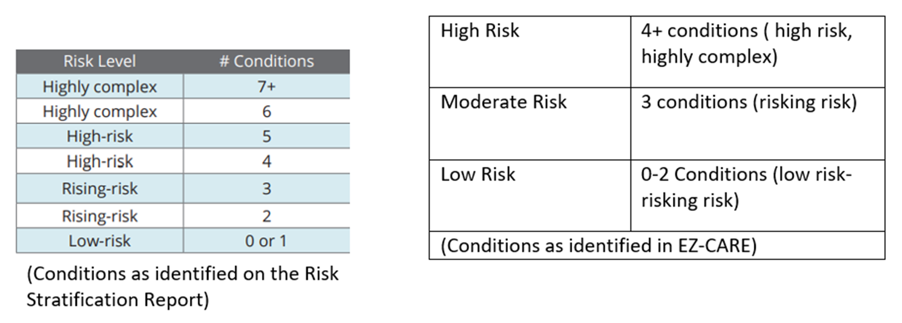

1B Factor 2 and 3: Explain in detail how the average age, gender, ethnicity, language barriers, deficits in health literacy, poor socioeconomic status, as well as other factors, affect the health outcomes of the most vulnerable beneficiaries. Shows the relationship between the demographic characteristics of most venerable beneficiaries and their unique clinical requirements.

Our SNP population is primarily made up of elders, aged 65 and older. As they age, the elderly become frailer and develop more chronic conditions. They are at higher risk for cognitive impairment and suffering from various impairments that can lead to negative impact on their treatment plans, medication schedule and overall independent self-care. Imperials CSNP population is 52.1% male and 47.9% female, with the average age being 71, These members are the most vulnerable and at risk of poor outcomes, increase service utilization related to clinical comorbidities and limited social support. Members may not seek timely care which could help eliminate the need for emergent clinical attention. These members may need care beyond what would be needed for an average Medicare beneficiary. For example, they may need help with creating appointments with their primary care physician, visits from clinical and social workers at their residence, frequent telephonic contact, assistance with diet planning and physical activity. We use reports from our utilization management department, case management department, pharmacy, claims, and chart reviews to create a composite of each vulnerable patient. This information is ingested by a proprietary data warehouse that incorporates asynchronous and disparate data elements to provide a composite picture of the patient. This composite also helps predict resource utilization and clinical deterioration in the near term (3-6 months). Additionally, Imperial is leveraging technological solutions that aid in risk assessment, taking not only claims and chart data but social risk factors to construct a more comprehensive, predictive score for its members.

The clinical team then deploys resources to aid this cohort. Data from the health risk assessment and pharmacy utilization allows us to determine patients who may need prescription refill reminder, frequent visits to address worsening depression signs, or providing transportation services to their primary care physician and their specialist providers. Our most vulnerable membership suffers from multiple clinical and behavioral comorbidities, often having increased social risk. This leads to avoidable hospitalization and readmissions. Members also have complex medication regimens, and polypharmacy that impairs overall quality of life and health. Their functional, social, and environmental issues limit their access to medical services. They have minimal physical activity, poor transportation, impaired mobility, and a high fall risk. They have limited caregiver access, poor literacy level and an unstable living situation. They are also vulnerable to abuse and neglect. They have limited understanding of their underlying health issues and are unsure about the process to access proper care.

The vulnerable patients have multiple chronic conditions, social isolation, cognitive impairments, and challenges to accessing care e.g., language or cultural barriers and frail conditions. Imperial has an established policy and procedure that facilitates the identification of these members. The coordination process refers and links members into helpful community programs and resources that address special needs, including but not limited to economic, legal, housing, psychosocial and medical services. These services are integrated into the member’s individual care plan and may be coordinated with the assistance of community health centers, advocacy groups and Imperial’s care coordination team. Imperial works with county protective services, home health agencies and it’s the clinical teams to leverage relationships with community and clinical partners to provide care in areas of concern. Home visits by providers allow for an accurate assessment of the member’s living condition and determining what services are beneficial for them. Transportation through local services vendors ensures patients can visit their providers. Mobile phone use, mail, in home visits all reduce social isolation. Ensuring that patients frequently visit their community senior centers and take part in activities is an important strategy in achieving this goal.

Ethnicity:
Ethnicity has a huge impact on health outcomes based on several factors including: culture and religious beliefs, healthcare service utilization, dietary and medical treatment beliefs including alternative and Eastern treatments. Additionally, certain ethnicities are less likely to utilize nursing home or skilled nursing facilities and instead try to focus on managing member’s health as a family at home until it is no longer feasible which can negatively impact the member’s health if the appropriate resources and care training is not in place. Additionally, advanced directives and end-of-life decision making it less likely to be discussed in households because of cultural and religious beliefs.

One group of Imperial’s SNP membership is in California, a state that has a significant Hispanic/Latino population. According to California Health Care Foundation, in 2020, one in nine Latino over the age of 65 reported lack of health care coverage or lack of knowledge of accessing available health care sources. It is estimated about 38% of Latinos reported delaying their necessary care due to lack of insurance and/or lack of affordable care available in their area. Additionally, they may experience limited access to transportation and funds to support their medical costs. Only 61% of Latinos reported having a regular physical activity routine. This correlates with the significant 36% obesity response rate amongst the Latino population. The Latino population also have the highest prevalence of diagnosed and non-diagnosed diabetes mellitus outside of the Caucasian populations. One of the causes for the huge gap in health care stems from multiple barriers including but not limited to: limited English-speaking proficiency, lack of access to education programs including diabetes, programs that are not sensitive to their cultural differences between both Latino, other populations and subpopulations, lack of explanation provided for them and lack of effective decision making conversations with their providers, creating a gap in health disparities amongst the Latino population.

Additionally, members have cultural dietary preferences that may make designing dietary needs for their specific chronic condition needs a challenge. Usually, members may have a negative reaction when they are advised to modify and remove certain foods they are accustomed to but are now advised to remove it. However, it is important to explain the importance as to why it is harmful to their specific conditions and what substitutes they can replace.

Social Determinants of Health Affecting SNP Members:
SNP members are often low-economic level individuals who cannot afford to live in a safe neighborhood or house. These neighborhoods often have higher crime rates, poor air quality, overcrowding and additional environmental risk factors that will negatively impact their overall health. They rely heavily on EBT Food Stamps, food banks, shelters, soup kitchens and community donations to meet their basic needs. Often, these neighborhoods will have limited access to nutritious, affordable, fresh foods, household supplies and are considered food deserts. This population is also at a higher risk of poor hygiene and dental care due to lack of funds and accessible services in their area. They are unable to afford dental care or live in a community where there is limited access to a dentist. Approximately 1 in 6 adults aged 65 and older have untreated cavities. Adults with a 6th grade level education are 3x more likely to experience dental issues because there is a lack of understanding the importance of dental need. Imperial’s SNP program provides dental coverage to provide services for our members and they can receive the necessary preventative dental care.
Additionally, members with little to no income will often report running out of money for food and medical funds. With the cost of copays, medication, medical supplies, this greatly decreases a significant portion of their monthly funds. When part of their funds is depleted, they may be forced to decide how to ration their funds for certain medications or necessary medical services because they can’t afford it, affecting the management of their health and multiple chronic conditions. By missing necessary medical services and missing medications, members are at higher risk of hospital readmissions and preventative treatments.

Some SNP members also cannot afford to own a personal car or are unable to drive due to their specific health conditions. Their transportation options may be limited depending on their specific service area and generally they must rely on family/friends to assist in transporting to medical appointments and going to stores for basic needs. As our population ages and they become frailer, driving becomes a challenge as they start to experience vision and hearing impairment.

Imperial offers transportation for our members to their medical appointments to ensure they do not miss receiving necessary treatment for their health.

Our members may not have access to a telephone or do not own a phone due to being homeless, and/or can no longer afford rental payments and electricity due to lack of funds. Due to lack of the ability to communicate, members’ medical services may become disrupted, delaying the necessary treatments.

Language and Literacy Level:
Language barriers can cause a delay in service and treatment among our population, affecting their health management outcomes. Most SNP members are measured to be 6th grade reading literacy and have a low-income background. If a member is unable to understand their treatment plan, this increases chances of members misinterpreting medically necessary appointments and preventative exams such as annual physicals, colonoscopy and receiving their important vaccines. They will also suffer from poor management of their medications and causing harm to their health. This can create issues with treatment management, leading to preventable emergency room visits.

Health literacy also impacts member’s understanding of accessing healthcare information and making informed decisions regarding their health. Due to this, they are less likely to visit their primary care provider and annual wellness exams and receive important vaccines. There is a gap in understanding the importance of these exams, which increases their risk of late intervention or higher rates of hospital admissions and long-term care needs. Also, filling out paperwork and comprehending their health needs to make informed decisions becomes a daunting challenge when their literacy level is below 6th grade.

Due to language barriers, members will generally rely on family members or their young children to help translate on their behalf, which can cause misinterpretation of health care needs and services provided by their care team. Many do not have anyone to rely on for interpreter services as they live alone or isolated from their family and friends.

Imperial employs staff who possess multilingual skills and cultural awareness and competency. Training is mandatory and provided upon hire and annually as well. The health plan also contracts with TransPerfect to provide interpreter services for our members. Additionally, we provide notice to members about their rights in requesting and accessing language assistance services to assist in accurate interpretation. This includes telephonic or material requests. We highly discourage our SNP members in using young family members to ensure member has an accurate understanding of their health care needs.

1B Factor 4: Identifies and describes established relationships with partners in the community to provide needed resources

Recognizing the critical need of such a need can at times be relative to social services, Imperial helps members and their family/responsible party obtain access to information regarding community support, including clinical, behavioral/mental health, social, environmental/housing, financial and other personal health, and service resources such as:
      - Personal care attendant
      - Adult day care
      - Assisted living centers
      - Nursing homes
      - Hospice
      - Home modifications
      - Home delivered meals
      - Transportation
      - Caregiver support groups
      - Cell Phone Programs –Free or discounted cellular service for income eligible consumers
      - Mobile Crisis Service Center –Services for people experiencing risks or a psychological crisis who requires mental health intervention, information and referrals, linkage to appropriate treatment
      - Adult Protective Services /Elder Abuse to obtain specific Local Department of Social Services APS
      - Homeless shelters
      - Soup kitchens and food banks
      - Caregiver Relief Services
      - Department of Aging

Imperial has established relationships with community-based providers and agencies. These collaborations allow Imperial to work with these providers and agencies to coordinate care which is effective for our members unique circumstances. Imperial facilitates member and caregiver access based on member preferences through its large community-based network consisting of medical and ancillary providers. These providers have special expertise to care for the unique needs of our beneficiaries. These providers include primary care physicians, specialists in internal medicine other specialties including but not limited to orthopedics, neurology, physical medicine and rehabilitation, pulmonary critical care, nephrology, rheumatology, surgery, psychiatry, physical therapy, podiatry and home health agencies.

Imperial Community Partnerships
Function/Benefit
Companionship, social need coordination, transportation
Meals post-utilization
Transportation

2. Care Coordination
Imperial’s Care Coordination program helps ensure that SNP beneficiaries’ health care needs, preferences for health care services and information sharing are met over time. Member is informed of and consents to Case Management. This process may involve family meetings as well to ensure that the patient and the caregivers are aware of the program and resources available. The goal is to encourage each member to participate in the care plan, agreeing to the goals and interventions. The member is informed of the Interdisciplinary Care Team (ICT) members and meetings. The member may participate in the ICT meeting and/or provide input through the Case Manager and is informed of the outcomes. In accordance with regulations at 42 CFR §422.101(f)(ii) -(v) and 42 CFR §422.152(g)(2)(vii)-(x), Imperial coordinates the delivery of care and measures the effectiveness of the MOC delivery of care coordination.

2A SNP Staff Structure
Imperial Health Plan has defined staff role and responsibilities across all health care functions that are necessary to support and manage many population members within the MOC. Additionally, documentation includes job description and education or training/skills necessary to complete assigned tasks. All staff that function in administrative, clinical and oversight roles are employed by Imperial Health Plan.

2A Factor 1: Administrative Staff Roles and Responsibilities across the health plan functions

Vice President, Member Experience: Accountable for oversight of all processes and responsibilities in the Enrollment department. The manager monitors the enrollment of our C-SNP members. For enrollments into a chronic condition (C-SNP), the Membership representatives must contact the provider or provider’s office to confirm that the individual has the qualifying condition for enrollment in the CSNP.

Enrollment /Disenrollment/Coordination of Benefits (COB) Team: This staff is responsible for the thorough, accurate, timely processing of all enrollment/disenrollment requests or inquiries according to regulations and guidelines set forth by CMS. These roles perform eligibility verification and monitoring and are responsible for all Enrollment and Disenrollment verification and reporting. The team is responsible for verifying Enrollment, Disenrollment, Residence Address Change, Cancellation of Enrollment, and Cancellation of Disenrollment transactions that may have been submitted to Medicare Advantage Prescription Drug System (MARx) by the daily batch process. The team is responsible for verifying eligibility procedures, documentation of findings, communications, workflow using the systems and the established policies and procedures. The department obtains this information in one of the following two ways:

- Contact the provider or provider’s office and obtain verification of the condition prior to enrollment
or
2) Utilize a CMS-approved pre-enrollment qualification assessment tool prior to enrollment and obtain verification of the condition from the provider or provider’s office on a post-enrollment basis.

For either method, verification from the provider can be in the form of a note from a provider or the provider’s office, or documented telephone contact with the provider or provider’s office confirming that the individual has the condition.
Enrollment Representative: The representatives work with the Enrollment /Disenrollment/Coordination of Benefits (COB) Specialist and the Enrollment and Eligibility Manager to assist in administering the COB program by updating the database with correct Medicare and non-Medicare coverage data (such as, Medicare Secondary payor and Commercial) utilizing information provided by internal and external sources in a timely manner. The representatives confirm the various coverage information with each coverage referral source. The representative works collaboratively with the other departments to ensure that benefits available to the beneficiary through the various coverage sources are coordinated. The representative also conducts research and reviews cases of members with other coverage and confirms that coordinated coverage is being delivered seamlessly.
Claims Processing Manager: This role is daily responsible for the thorough review and accurate, timely adjudication of all physical health medical claims. Behavioral Health claims are processed by our delegated vendor Lucet, an NCQA accredited MBHO. The Claims Manager oversees the staff including but not limited to Claims Examiners, Recovery Specialists, and Claims Auditors to ensure proper CPT, ICD-10, & HCPCS coding are used on all submitted claims. The team also performs tasks to identify claims for third party recovery. The staff on average has 2 years claims adjudication experience.
Member Services Team: This team is responsible for providing high quality, customer-focused service. They are responsible for answering all calls, answering inquiries regarding eligibility, plan coverage, authorizations, coordination of benefits and claims payment. The member services representative serves as a point of contact for questions, problem-solving and access to care for members. In addition, he/she provides accurate, prompt, and courteous service in response to written and telephonic inquiries from members. If an issue requires escalation or further review, the Member Services Team member such as a Specialist, Supervisor, or Manager may escalate the matter to the appropriate department until the problem is resolved. The department is also held accountable for its services levels through Key Performance Indicators.
Appeals & Grievance Coordinator: The coordinator has responsibility for logging and investigating all appeals and grievances. The department collects, reviews, and categorizes oral and written member complaints of dissatisfaction and appeals/denial appeals from internal and external sources. The coordinator consults with appropriate staff for resolution of issues. The coordinator prepares and submits correspondence to members regarding issues in accordance with current health plan specific and regulatory requirements.

Oversight for administrative functions are performed by the following:

Claims Director: The Claims Director oversees the Claims Department and is responsible for timely and accurate claims payment as defined by established department standards in compliance with CMS regulations and State regulations. The Director is accountable for ensuring staff receive up-to-date communication and training on health plan products. The Director is responsible for meeting or exceeding established department standards for claims accuracy and claims turnaround time. The Director oversees claims examiners, auditors, recovery specialists, Coordination of Benefits specialists and works with other departments such as Clinical Services , Provider Network Operations, Data Management, Member Services, and the Call Center.
Customer Service Manager: The customer service manager maintains daily oversight and is responsible for the team focus on delivery of timely, courteous, and accurate customer service to members, providers, and others. The department manages the Call Center as well and is measured by Key Performance Indicators (KPI) that are aligned with CMS metrics related to Call Center metrics.
Enrollment and Eligibility Manager: The manager for enrollment and disenrollment daily oversees the functions performed by the coordinators and collaborates with the member services department and the call center. This supervisory role includes but is not limited to verifying eligibility procedures, documentation of findings, communications, workflow using the systems and policies and procedures established and maintains up-to-date knowledge of Medicare and Medicaid eligibility requirements to incorporate into operations and ensure compliance. The Manager ensures compliance with CMS requirements related to enrollment, disenrollment, adherence to situations such as Special Election Periods, Annual Enrollment Period and Open Enrollment Period.
Director, Provider Network Operations: The Senior Director daily oversees the Provider Network Operations (PNO) department, which is responsible for network development, education of network, training of network, and ensuring network adequacy. The department also oversees provider data management and coordinates with the IT and Credentialing departments. The PNO team is responsible for training the network about the MOC and obtaining attestations to this training. The Senior Director oversees the PNO team that is involved in network and contract development in compliance with CMS requirements. It aims to achieve provider and member satisfaction to ensure access to care while ensuring timely communication with providers regarding modifications to any policies and procedures.
Vice President, Information Technology: The Senior maintains daily management oversight for the IT Team. The leadership of the IT department and staff include data management, website management, software development and technology support. The department develops and maintains the Information Security plan, ensures operational readiness, data backup, disaster redundancies and provides timely updates to the Compliance Officer.
Senior Manager, Quality Programs: The Senior Manager leads clinical quality & service initiatives including but not limited to those related to HEDIS, CAHPS, and Health Outcome Surveys. This position oversees and collaborates with the key internal and external stakeholders to develop, implement and perform ongoing monitoring quality improvement program initiatives, including provider outreach and member engagement strategies. The Senior Manager oversees reviews of NCQA Accreditation for Quality Improvement and Model of Care, QI Program Description, Work Plan, Annual Evaluation and QI Policies to align with current process and regulatory requirements. Under guidance from the Chief Medical Officer and in collaboration with the Quality Programs Manager and Director of Quality, Risk, & Analytics, the Senior Manager ensures that quality program structures are implemented and presented to respective Committees/Subcommittees.
Manager, HEDIS® Quality Programs: The Manager oversees all aspects of HEDIS® & CMS measure reporting and workflow design for key initiatives to ensure they meet reporting and audit requirements. For HEDIS, the manager is responsible for developing the internal project timeline, completing and submitting all RoadMap, vendor management, project staffing, and ensuring that all deliverables are completed and submitted timely. This role oversees medical record retrieval and review, data abstraction, using CQI strategies to optimize HEDIS® and Stars data collection to ensure accurate measure rates to ensure quality of care is maintained.
Director, Quality, Risk and Data Analytics Manager: This role is responsible for daily management and oversight of all activities within the Quality Improvement, Risk Adjustment, and Analytics teams. The Director is responsible for validating data quality, structuring an efficient data management process, planning and implementation of enterprise-wide system integration that support the Model of Care Metrics and operational efficiencies.

VP of Growth and Director, Inside Sales and Agent Support: These roles are responsible for managing and daily oversight including but not limited to recruiting, training, and supports quality independent contractors and agency partners in local markets.
The VP of Growth is responsible for the development of marketing materials and social media campaigns including but not limited to website implementation, press releases, social media messaging, member newsletter and other member-facing strategies. The role collaborates with internal stakeholders on the development of marketing materials.

Compliance Officer: This individual is responsible for compliance with regulatory and contractual requirements. The Compliance Officer manages the development and daily oversight of processes and procedures in the areas of compliance and auditing. The Compliance Officer reports to the Chief Executive Officer. The Compliance Officer is responsible for implementing the organization’s Compliance Program to help ensure adherence to all Federal, State, and contractual requirements. The Compliance Officer supervises the Compliance Department, and the roles and responsibility include but are not limited to:
- Oversee reporting to regulatory agencies
- Coordinate internal investigations and external investigations of delegated entities as needed to ensure compliance with CMS requirements by Imperial.
- Conduct annual compliance training as well as of new employees
- Lead the Compliance Committee and report to the Board at least quarterly
- Ensure adherence to the sponsor’s contractual commitment to work with the delegated entities so that they are abiding by CMS requirements as well.
- Inform senior leadership and management about compliance status and updates
- Create, administer, and coordinate training programs to ensure the organization is educated about the Compliance Program, Standards of Conduct, compliance policies and procedures and all statutory and regulatory guidelines.
- Ensures that all member marketing materials comply with CMS guidelines as it pertains to Imperial Health’s Model of Care SNP population

UM Supervisor: The UM Supervisor reports to the Sr. Director of Utilization management and daily supervises the outpatient coordinators. In addition, supports daily operations pertaining to the outpatient authorizations workflows. The UM Supervisor participates in member and provider engagement calls. In addition, the UM Supervisor reinforces Provider Education to Physicians and Office Staff. The UM Supervisor oversees on-going production reports, as requested by management.

UM Coordinators:
UM Coordinators are responsible for supporting the Outpatient authorization workflows. This includes but not limited to:
- Interface with Provider and Members regarding authorization status
- Provide Physician and Office Staff with education related to authorization requests.
- Processing the authorizations in a timely manner in accordance with regulatory time frames and documenting authorizations in the EZ CAP system
- Daily data entry for authorizations received via fax

2A Factor 2: Clinical staff roles and responsibilities:
Clinical Services Manager: The Manager maintains daily oversight and is responsible for documentation and coordination of information necessary for review by appropriate medical personnel in preparation for appeal or hearing. The department is responsible for the preparation and submission of correspondence regarding denials, appeals and hearings to members, providers, and health plan in accordance with current health plan specific language, citing accurate rules and criteria within timelines. The manager will have a nursing degree (LVN, RN, NP, FNP, DNP).
Medical Management Specialists: The Specialist is responsible for administration of HRAs, development of member centered care plans, education on and coordination of, assessed needs and services. The Specialist coordinates with the Clinical Department and assists with referrals for social programs, medical needs, and transitions of care.
Health Equity, Health Education, Cultural and Linguistics Specialist: The Health Education Cultural and Linguistics Specialist is responsible for implementing Health Education programs catered to our SNP members. The specialist will provide Health Education program resources and materials in threshold languages for members. The Health Education Specialist, under guidance from the Vice President of Clinical Services and Chief Medical Officer, will collaborate with healthcare vendors focusing on but not limited to Diabetes Management, Smoking Cessation and Nutrition. In addition, the specialist implements Cultural and Linguistics training sessions for staff and providers, notifying them about accessible interpreter services.
Transitions in Care Planner: This individual is responsible for community outreach for transitions. The nurse assists members with navigating the health care community, supports members with self-care education and connections to community resources, and advocates on behalf of the members. The role also supports the clinical staff responsible for coordinating a member’s care by ensuring that the team is equipped with a holistic understanding of the patient’s situation.

Director, Pharmacy and Population Health: Reporting to the Chief Medical Officer, the Director of Pharmacy & Population Health maintains daily management and oversight of pharmacy operations and oversees completion of Health Risk Assessments. This individual is licensed as a PharmD License is verified at time of credentialing and hiring. The Director works with the Pharmacy Benefits Manager, Chief Medical Officer, and the Pharmacy and Therapeutics Committee to ensure the development of clinical guidelines related to pharmaceutical agents, and appropriateness of use criteria in consultation with the medical and nursing resources. The Director oversees the development of and adherence to medication protocols. The Directors is responsible for ongoing management of pharmacy services for all Imperial products. The Director supervises pharmacists, pharmacy technicians, and Pharmacy Concierge staff. The Director acts as a resource regarding clinical criteria/questions and complex requests; working with medical directors to provide benefits within State and Federal guidelines. Some other functions include but are not limited to:
- Supporting medical management nursing staff in making Part B decisions.
- Reviewing prior authorization requests/coverage determinations.
- Assisting with clinical aspects of grievances and appeals.
- Acting as primary management liaison with Pharmacy Benefits Manager (PBM).
- Oversight and monitoring of Part D functions as mandated by CMS.
- Contributes clinical expertise to and work with staff to prepare materials for the Pharmacy & Therapeutics Committee (P&T).
Pharmacist: The Clinical Pharmacist is responsible for pharmacy utilization management, pharmacotherapy, medication therapy management, pharmacy consultation, and drug trend analysis. This individual also monitors adherence to the clinical guidelines. Licensure: RPH, PharmD.
Manager, Utilization Management: The Manager maintains daily management and oversight and responsible for program development and coordination in medical management for all utilization management activities, post service review, and complex case management. The Manager acts as a resource regarding clinical criteria/questions and complex requests while working with medical directors to provide benefits within State and Federal guidelines. The role supports medical management nursing staff in making Part C decisions. The manager has a nursing license (LVN, RN, NP, FNP, DNP); verified at time of hire/credentialing.

Nurse Case Managers are responsible for review of prior authorizations, post service review, Inpatient review, monitoring and coordination of complex care needs, directing member care through transitions of care, advanced care planning and education for members. The coordinator is also responsible for training for Care Transition, Case Management and ICT teams.
Case Manager: The Case Manager leads the ICT and engages the member, member’s family/caregiver to facilitate the development of a care plan in collaboration with the interdisciplinary care team. The case manager manages care plans which outline the activities and services that will be provided to the member to support established health goals and outcomes. Additionally, the ICT works with the members’ primary care providers (PCPs) to ensure that care is coordinated. The case manager also coordinates with the team including the clinicians and social workers to ensure the patient is being provided direct beneficiary care and education on self-management. Manager has a nursing license (LVN, RN, NP, FNP, DNP). Case Managers must have at least one year of experience with geriatric or chronic disease management. All Care Managers complete annual training in advanced care coordination, transitions of care, and MOC requirements.

Senior Director, Clinical Services: Reporting to the Chief Medical Officer, the Senior Director of Clinical Services is a Registered Nurse with an active unrestricted license in the State of California. The Director maintains daily management and oversight of the department and is responsible for program development and coordination for all utilization management activities, post service review, complex case management and case management/care coordination activities. The role acts as a resource regarding clinical criteria questions, complex requests and support the department nursing staff in making Part C decisions. Works with medical directors to provide benefits within State and Federal guidelines. Supports medical management nursing staff in making Part C decisions.

The Senior Director of Clinical Services maintains daily management and oversight and responsible for the direction, management, and compliance to standards for all daily clinical operational activities within the Clinical Services Program. The authority and responsibility for Model of Care, Case Management, Population Health Management, Disease Management, and oversight for the programmatic planning, development and implementation activities that includes but not limited to:
  - Develop and administers the Clinical Services Program, Policies and Procedures, Work Plans and Annual Evaluations
  - Manages clinical services and non-clinical staff and program staff
  - Manages staff performance to strategic and operational goals
- Ensure adherence to Local, NCQA, State, and Federal Laws and guidelines
- Participates in Medical Service Committee Meetings, and others deemed necessary by Chief Medical Officer

Chief Medical Officer: The Chief Medical Officer maintains daily management and oversight for the medical care delivered to beneficiaries for products and services and oversees the health care needs of the membership. The Chief Medical Officer is the senior most professional in the organization responsible for clinical oversight. The Medical Officer is accountable for and provides professional consultation related to the utilization/cost management and clinical quality management functions. The Chief Medical Officer works with the Compliance Department to ensure compliance by delegated entities. This role oversees the other medical directors and specialty panel as well. The Chief Medical Officer works collaboratively with other plan functions that interface with the medical management department. This physician leads the Clinical Practice Committee, Pharmacy Department, Health Information Management, Credentialing Department. The Chief Medical Officer provides clinical expertise related to the Interdisciplinary Care Team, development of policies and procedures, and technological adoption to enhance value in care delivery. Licensure: Board Certified Medical Doctor. Licensed as MD or DO.

Non-Physician Practitioner (NPP): This position serves as an extension of primary medical care, with a focus to maintain or improve upon health and quality of life by identifying barriers and improving access and quality of primary and preventive care. Under the supervision of a physician in accordance with professional standards and state regulations. As part of the member’s ICT, NPPs may also provide routine assessments and care planning for members. They collaborate and communicate with member’s PCP in the community-based care setting. Licensing: Board Certified NP, PA, with experience in the primary care setting.

Contracted Clinical Staff Roles and Responsibilities

Medical Director: These contracted physicians are responsible for providing clinical expertise to support the MOC, such as leading or participating in ICT meetings, participate in clinical quality improvement initiatives, providing advanced clinical support to Care Management/Utilization Management staff, Part C appeal review, Potential Quality Issue Review. Licensure: Board Certified Medical Doctor (MD or DO). Behavioral Health Director: This role provides expertise and/or oversight to support the assessment and treatment of emotional, behavioral, and cognitive problems, behavioral health case management; assist members to access timely and appropriate behavioral health services. This role ensures that staff analyzes data for oversight provider network, monitoring and coordination of complex behavioral care needs and transitions. The BH Director works with the Chief Medical Officer to develop Behavioral Health policies and procedures that are consistent with guidelines and regulations while optimizing value in care delivery. Licensing: Board Certified Psychiatrist with an MD/DO.

Manager, Human Resources
The Manager of Human Resources maintains daily management and oversight for the HR staffing, and resource allocation needs for the organization that supports the Model of Care. The Manager reports and works collaboratively with Executive Leadership, Management team and frontline staff. In addition, the HR Manager oversees the organizational initial and annual MOC Staff training and maintains the documentation of such training.

2A Factor 3: Coordination of Responsibilities and job titles
Imperial Health Plan employee responsibilities include but are not limited to their scope. In the event of an employee’s title and/or position change, an appropriately trained employee will oversee and accommodate the position changes. In some situations, an individual may hold two job titles. Please see Appendix A for Imperial’s Organized Staff Structure.
Refer to Organizational Chart Appendix A

2A. Factor 4: Contingency Plans Used to Address Ongoing Continuity of Critical Staff Functions.

Contingency Plan is used to address ongoing continuity of critical staff function. Imperial Health Plan has policy and procedure in place in case of natural disaster or weather-related issues. This has been further developed and strengthened to adapt to Public Health Emergencies (PHE) such as a pandemic.
Communication is a key element of Model of Care. To maintain continuity, Imperial has back up for its information system. The server backs up every night to an off-site server out of state but in the US. The server also backs up daily to the hard drive to ensure communication and information is maintained.
Staff are cross trained to ensure redundancy so that critical operations can continue in the setting of a disaster or situation due to which all staff personnel are not available. Personnel are also provided cell phones and laptop computers issued by the organization which can provide internet access as well as access to the company servers through a Virtual Provider Network (VPN). The phone exchange is programmable to transfer calls from the office phones to mobile phones as well. This contingency plan allows for critical operation to ensure ongoing continuity of staff functions by allowing the staff to work remotely. The organization currently does have staff on its payroll who work remotely, allowing it to scale up its remote operations during a contingency. Virtual meetings are currently held and will expand during contingency via conference calls and videoconferencing technology currently employed by Imperial. The organization has adapted to videoconferencing to ensure a hybrid workplace to accommodate individuals unable to attend physically. Video conferencing is being leveraged to engage with patients as well. Telehealth services through vendor agreements have allowed outreach to beneficiaries during PHE such as the pandemic.
As needed, Imperial Health Plan has contracts in place with human resources placement firms to provide temporary, per diem, and permanent staff to supplement the workforce requirements as needed in a contingency situation. The contingency plan is reviewed at least annually. Ongoing communications are maintained with release of information via the website, fax transmissions and electronic mail communication.

2A Factor 5:. How the organization conducts initial and annual MOC training for its employed and contracted staff.
The Human Resources Department in collaboration with the Compliance Department oversees the annual and initial MOC Training. The goal of the SNP Model of Care Training is to promote an understanding of the MOC requirements, the infrastructure in place to administer the MOC, help deliver value based coordinated care to beneficiaries, ensure compliance with CMS requirements for the MOC and elevate the care of vulnerable beneficiaries. All clinical staff are required to complete MOC training at time of hire. Thereafter, annual MOC training is conducted with attestations required of employees and vendors involved in MOC related activity. If after several attempts, an employee does not complete training, a performance improvement plan is created with escalation upto and including termination. HR manages this process to ensure it is compliant with labor regulations. Vendors/Contractors are informed, and the training is a condition for contracting and is cause for termination.
Human Resources conducts the initial and annual MOC Training for departments that have administrative and clinical involvement and oversight in the MOC. The involved departments include but not limited to:
- Appeals and Grievances
- Behavioral Health
- Claims
- Clinical Services (Case Management, PHM, Utilization Management)
- Compliance
- Credentialing
- Data Management
- Health Education/Cultural & Linguistics
- Human Resources
- Information Technology
- Medicare Enrollment and Eligibility
- Medicare Marketing
- Member Services
- Pharmacy
- Quality Improvement
- Provider Relations/Network Operations
Imperial’s Human Resources (HR) Department plays a critical oversight role for the initial and annually required MOC training for employees and contracted staff. New employees are required to complete several mandatory training modules and annually thereafter.
Initial MOC Training
As part of the onboarding process for new hires and contracted staff, they receive the required MOC Training. Upon completion of the initial training, a signed attestation statement is signed by the employee, then forwarded to Human Resources, and maintained in the employee personnel file. The Human Resources department ensures training is completed within 90 days of hire.

Annual MOC Training
Annually, the HR Department will conduct the annual MOC Staff Training. An email notification is sent to all staff including the MOC Training Deck that details:
- The purpose of MOC training
- Annual training completion deadline
- A signed attestation (by employee and manager), providing evidence of training completion
- Completed MOC Training Attestation should be submitted to HR within 90-days of the original communication.
Initial and annual MOC training is mandatory for all employed and contracted staff that work with Imperial Health Plan with the focus specifically for staff who provide or manage care coordination services, and administrative staff involved with enrollment, member care services, claims, pharmacy, and marketing. sales. All new hires receive training on the MOC during their orientation. The training is also provided in the form of PowerPoint slides on our website https://www.imperialhealthplan.com/.

The training covers the following elements:

- History of SNP plans
- Overview of the DSNP
- Specific population demographic, needs
- Eligibility for SNP
- Most vulnerable members
- Care Coordination in DNSP
- Staff Structure
- Health Risk Assessment
- Individualized Care Plan
- Face to Face
- Interdisciplinary Care Team
- Care Transition
- Provider Network
- CPGs and Care Transition Protocols
- MOC Training
- MOC Quality Measurement and Performance Improvement
- MOC Quality Performance Improvement Plan
- Goals and Health Outcomes for the MOC
- Patient Experience of Care
- Performance Improvement Evaluation of the MOC
- Communication of SNP Quality Performance Related to the MOC

Any changes to the MOC Training are communicated by the Senior Director of Clinical Services in consultation with the Chief Medical Officer and HR to ensure the updated MOC is being provided to the intended recipients.

Training Oversight and Strategies
HR monitors for the updated MOC training attestations as it pertains the Initial and Annual MOC Staff trainings.
The training strategy is to leverage technology and personnel. The initial and annual MOC training is computer based via PowerPoint slides and discussion. A sign-in sheet logs attendance and follow up on the education delivered. Strategies include web-based training modules such as business overview, Compliance, Fraud and Abuse, Cultural Competency, HIPPA and Confidentiality. Orientation guides and departments standard operating policies and mentoring over a 4-week period ensures knowledge transference and acquisition. The knowledge content includes the Model of Care, Health Risk Assessment Tool, Policies and Procedures of the Care Coordination, Disease Management, Case Management and Care Transitions team. The Chief Medical Officer will also offer didactic sessions related to population health. The Senior Director of Clinical Services of Clinical Services and the Nurse Managers are responsible for ensuring adequate training of clinical and non-clinical staff with all aspects of the Model of Care, Health Risk Assessments, and the Annual Wellness Visits. The training records are maintained in the department's records as well as documented in the HR file of the relevant staff. All staff are expected to attend the mandatory training meetings.
The slides serving as examples of the training are provided in Appendix D
Imperial Health Plan recognizes that not all staff are able to participate when the annual MOC training is scheduled. Additional training opportunities are available in all the following formats to meet the needs of staff who cannot attend the annual MOC training include but not limited to:
- Meetings (team and/or department); Town Halls
- Web-based (PowerPoint training)
- Face to face (used when employee cannot participate in the other options).
- MS Teams/Videoconferencing
2A Factor 6: How Organization Documents and Maintains Training Records
All participation and completion of training is documented, tracked, and maintained through the HR Department which provides reporting and notification to managers for follow up for any staff who are delinquent in their training. The MOC training is mandatory for all staff and contracted employees. The training records are maintained in the HR department. Employees attend the webinar, and then asked to sign dated attendee list, and signed training attestations are placed in employee’s HR file evidencing that training has been completed.

2A Factor 7: Actions if training is not completed
Upon notification from HR, the manager will work with the employees identified as not completing the mandatory initial and annal MOC training by developing a corrective action plan to complete the training. Failure to complete the training within the designated timeframe may lead to corrective actions. These will include but not limited to reminder e-mails about training, phone calls to the employee, outreach, counseling, and written warning.

The training for the Model of Care is mandatory and provided at least annually. If staff, whether employed or contracted, are unable to complete the required initial and annual MOC training, the supervising manager will be responsible for oversight and follow-up with those specific employees not attending. Leadership works with HR to initiate disciplinary actions in accordance with HR policies and procedures and may include verbal and written warnings.
2B Health R Risk Assessment Tool (HRAT)
In compliance with 42 CFR §422.101(f)(i); 42CFR §422.152(g)(2)(iv), SNP conducts a Health Risk Assessment for everyone enrolled in the SNP.

2.B. Factor 1. How the organization uses the HRAT to develop and update the Individualized Care Plan (ICP) for each beneficiary
The Health Risk Assessment Tool (HRAT) includes questions focusing on the medical, psychosocial, cognitive, and functional needs and disabilities of enrolled beneficiaries. It also gathers beneficiary’s personal preferences and barriers to their care; as well as identifies their current and future health risks. These questions were designed to identify the beneficiary’s health status, confirm their estimated level of health risk, and enable the care team to provide feedback to the beneficiary, their representatives, and the interdisciplinary care team. Imperial uses a standardized HRA questionnaire that incorporates the PHQ-2/PHQ-9 for depression screening and a Mini-Cog assessment for cognition and Gero-palliative assessment. Results are documented in the care management platform and trigger a Behavioral Health or Palliative Care referral if thresholds are met.
The HRAT is completed by a MOC SNP-trained Imperial care team member (ie: care managers, care coordinators, quality coordinators, member services representative), contracted vendors, primary care physicians, and/or nurse practitioners. Completion of HRAT is conducted by mail, via telephone, in the member’s home, or during their doctor’s visit/appointment. Initial HRAT are offered to all beneficiaries 90 days before or after their initial enrollment. Annual reassessments are completed within 365 days of the last HRA or beneficiary’s enrollment anniversary date; and at the time of any significant “change of condition” event that may potentially change the beneficiary’s health status.

HRA responses are entered in the Care Management System. Care plans are then generated to optimize the care delivery of Imperial’s population health and chronic disease management programs.

For new enrollees, a paper copy of the HRA is mailed to their home mailing address prior to their enrollment date or upon identification on the monthly enrollment/eligibility file. Phone outreach is conducted if no HRAis returned within one (1) month of the HRA mailing date or beneficiary’s enrollment date. For existing enrollees, phone outreach is conducted within ninety (90) days upon identification on the monthly eligibility/enrollment file. When a beneficiary completes an Annual Well Visit (AWV) with their primary care provider or Imperial contracted nurse practitioner within ninety (90) days of the enrollment date, no phone outreach will be conducted. AWV may be conducted by phone or face-to-face in the beneficiary’s home. Responses and information from the AWV note will be used to complete HRA in the Case Managment System.
When a beneficiary is unreachable after multiple attempts which include missing scheduled appointments, unsuccessful three (3) phone outreaches, or beneficiary refusing home visits, Imperial sends a letter notifying them about the attempts in contacting them, an explanation about the HRA, and availability of case management services that are free of charge.
Completed HRAs is assigned to a care manager to review and ensure all questions were satisfactorily answered. If questions are missing or answers provided are not clear, the case manager completes a phone outreach to get the member’s pertinent response to the questions. If the care manager is unable to get the pertinent responses, s/he will assess the beneficiary’s medical records by reviewing the beneficiary’s referral and claims history. The care manager reviews the responses on the HRA and works with the member, caregiver, and Interdisciplinary Care Team (ICT) to develop and implement an Individualized Care Plan (ICP).
The quality and content of the Health Risk Assessment identifies the medical, functional, cognitive, psychosocial, and mental health needs of each SNP beneficiary. The HRA is appended in Appendix B.
Imperial uses a comprehensive HRA to stratify members into risk categories for care coordination and identify their needs in the following areas:
    - Medical - Diagnosis history, medications, pain, dental, immunizations, health screening
    - Functional - Weight, physical activity, ADLs, IADLs
    - Cognitive - memory, attention, language, thinking
    - Psychosocial - Family/friend involvement, spiritual, stress, well-being, abuse, social concerns
- Behavioral-substance use/abuse, Readiness for Change

Refer to Imperial’s HRA Appendix B

The HRA has predetermined triggers that alert staff to follow up further with a more specific assessment. The HRA allows for a standardized, comprehensive approach to collecting, analyzing and communicating information. The beneficiary’s referral history, claims data, and HRA are used to screen the needs/risks of the beneficiary for the development of a person-centered care plan. Areas identified for care planning include needs that require interventions by:
    - Member services or enrollment
    - Care Coordination
    - Access to Care
    - Health literacy
    - Transitions
      - End of life
      - Complex Case Management
    - Primary Care
      - Preventive medicine
    - Community Social Agencies
    - Behavioral Health
    - Depression
    - Disease Management

2B Factor 2: How the organization conducts the initial HRA and annual reassessment for each beneficiary.
The ICP is developed based on HRA data regarding their primary health concern, member’s preferences, priorities, and risk level. The assessment includes a full medication review (prescribed, over-the-counter medications, vitamins, and herbal supplements; discussions with the member’s PCP occur; review of the HRA for prioritization of problems and interventions and need for community resources, identification of co-morbidities associated with common conditions found in this dual eligible population such as: chronic obstructive pulmonary disease, cardiovascular disease, cerebral vascular disease, and diabetes. The evaluation also includes but is not limited to an assessment of home safety, safety with mobility and equipment in the home, falls risk, functional limitations and decreased activities of daily living and the process for inclusion into the member’s individual care plan (ICP)This information is then reviewed and collated by the interdisciplinary team (IDT) to strategize on developing an individualized care plan for each SNP beneficiary. Clinicians including the medical officer, providers for the patient, nurses, coordinators, social workers, pharmacist, and other staff collaborate to develop the ICP which is then elaborated in collaboration with the beneficiary and caregivers to guide the treatment for the duration of the member’s enrollment. Imperial considers a Health Risk Assessment completed if at least one item in the HRA is completed beyond the beneficiary’s name, DOB and gender. For the avoidance of doubt, outreach involves 3 attempts, in any combination of mail and/or phone. The third outreach is linked with a simultaneous mailing of the unable to reach letter and may also include an HRA blank for the member to complete. The HRA form may be an extensive form or an abbreviated form.
2B Factor 3: How organization disseminates the HRAT information to the Interdisciplinary Care Team (ICT) and how the ICT uses that information.
Information collected from the HRA determines the risk level using Imperial’s risk stratifying methodology for each member and is used to develop the ICP. The system stratifies members into 3 categories (high, medium, or low) based on member conditions, utilizations, and level of care needs. HRA results are reviewed with members and incorporated needs are shared with all ICT members, including the member, via mail, or in the case of providers, through fax. The ICP is the main tool used to document changes and communications between members of the ICT. Each ICT member or ancillary provider has access as applicable.

The communications of the HRA findings are shared with the interdisciplinary care team. A copy of the HRA is provided for the member’s chart for care planning consideration of identified issues. The Nurse Case Managers communicate directly with all ICP participants reviewing care plans, and conduct these either asynchronously (via-emails) or synchronously (via Teams meeting or similar technology) during daily ICT meeting. The ICP is reviewed with member and member’s caregivers, and they receive a copy of the ICP via mail and are encouraged to review the ICP and share with the PCP at the next office visit. The ICP is documented and maintained in the Care Management System. PCPs receive a copy of the ICP updates from Imperial’s Care Management team.
The ICT will reach out to members three times to conduct their HRA. This is done either through mail or three phone calls. After the third attempt, if a member is unreachable or declines to complete their HRA, the case manager will reach out to the member’s provider, requesting the medical records to complete the HRA. Once it is complete, the HRA will be sent to the member’s provider for review and scheduling a follow-up appointment. Members will be provided with a hard copy of their HRA after their appointment.
HRA reassessment can be required sooner if there is a change in the member’s health status, worsening health, hospital readmission, change in medication or requested by the member’s ICT.

2B Factor 4: The detailed plan and rationale for reviewing, analyzing, and stratifying (if applicable), the HRA results.
Declines in function and health that may trigger a change of condition assessment may include, but are not limited to:
    - Decline in decision making from last assessment
    - Decline in mood pattern (sad or anxious)
    - Behavioral symptoms
    - Decline in an ADL area
    - Incontinence patterns change from last assessment
    - Placement of indwelling catheter
    - Emergence of condition or disease in which resident is unstable
    - Emergence of unplanned weight loss (5% in 30 days or 10% in 180 day)
    - Emergence of new pressure ulcer stage 2 or higher, when no previous stage 2 or higher was present
    - Initiation of use of trunk restraint or chair prevents rising
    - Hospital admits or emergency department visit.
    - Change in cognitive status

Improvement in function and health that trigger a change of condition assessment are:
    - Improvement in decision making from last assessment
    - Improvement in an ADL area
    - Decrease in the prevalence of sad or anxious mood pattern
    - Decrease in the number of behavior symptoms
    - Improvement in incontinence pattern.

The risk assessment self-scores are based on the risk areas. The scoring of the HRA is one component of the risk stratification determination. Another is based on the clinical assessment of the risk of clinical deterioration by a member found within Imperial’s internal predictive modeling software. Based on authorization and claims data, a risk profile updated with each data in load. The scoring monitors the age, gender, high risk medications, mental health/substance abuse conditions, number of diagnoses, active medications, and previous hospitalizations in the past 6 months. The determination of involvement cadence is based on the needs of the member which include the calculation from the HRA, the calculated risk software and member preference. Member follow-ups are as frequent as needed in correlation with the care plan and associated problems. General follow-up intervals are established in accordance with the stratified risk as follows: high risk every 14 days, medium risk every 30 days and low risk every 60 days. The purpose of the follow–up intervals for member contact is to reassess the member’s condition as compared to the previous assessment.

Through the Care management platform, the Clinical team will perform an analysis on the scores to determine groupings based on terciles: high, medium and low risk. The team will use these scores and terciles to assign members to programs, such as chronic disease management, and other interventions to maintain and/or improve health ￼.

If a member has a utilization, whether inpatient or outpatient, data generated from these encounters will be used to modify the ICP. Similarly, encounters between the Imperial Health Plan care team and the patient, caregiver and family will also be used to modify the ICP to make the care plan a living plan that is responsive to the needs of the patient.
ICPs are updated at least annually. Patients are risk stratified based on number of chronic conditions (up to 2-low); 2-4 conditions -medium; more than 4 – high risk. High and moderate risk patients get an ICP at least annually and to the extent possible, quarterly. Every member will receive an ICP. If health conditions change, the ICP will be updated to address the health care needs. If patients refuse or unable to reach to complete an HRA, records from providers, PBM, supplementary benefits vendors, specialists, enrollment questionnaires, encounter data, claims data and authorization data is used to create a risk profile for the member. The HRA is updated within 90 days of enrollment and re-administers it annually (no later than 365 days from the last HRA) or within 30 days after any significant change in condition (hospital admission, major surgery, change in diagnosis, etc.).. If a member is not reachable, the UTR letter is sent but the profile is generated as above and updated whenever member contact is made. Thereafter annual HRA are administered. Health status changes are monitored through ER visits, observations stays, admits, surgeries, authorization requests for high intensity interventions, new treatment requests for cancer therapy, trauma claims, failure to thrive admissions.

2. C. Face to Face Encounter
Imperial Health Plan assists members with scheduling face-to-face encounters through different modalities, based on member’s health risk and needs. For high-risk members, the Plan attempts to schedule a face-to-face or telehealth visit within 30 days of enrollment or identification of high risk. If a member cannot be reached after 3 attempts, staff will document the reason (refusal, no contact, etc.) in the Care Management System and send a second letter within 10 days to re-offer the visit.

2C Factor 1: Face-to-Face Essentials

Imperial Health Plan performs the Health Risk Assessment annually, with the first HRA beginning the first twelve months of enrollment. To ensure members schedule appointments with their Primary Care Physician (PCP), case managers in the member’s ICT will offer to assist members in the process of setting up appointments. If the member accepts, the Case Manager will help schedule appointments either in-person with the PCP or telehealth or video health encounter with the Virtual Care Clinic Nurse Practitioner (NP).
The case managers will attempt to reach members three times, offering assistance in scheduling face-to-face encounters. If they are unreachable after three attempts, the Case Manager will mail a letter to the member regarding Imperial’s attempt in contacting them. Face to face encounters via virtual or in person are attempted to ensure that the density of information gained is clinically helpful. Patient navigators, Case Manager, Pharmacy Staff, PCPs, and Specialists notes are used to gain this insight. For virtual encounters, members are provided an opportunity to decline the meeting at the beginning of the meeting when the member or Power of Attorney (POA) is requested to respond in the affirmative or decline the virtual visit. The member decision is recorded in the patient record.

2C Factor 2: Identifying Appropriate Personnel
Imperial Health Plan includes multiple appropriate personnel who can deliver care for our members including but not limited to licensed:
- Physicians
- Specialists
- Contracted Providers/Physicians
- Pharmacist
- Behavioral Health Consultant
- Nurse Practitioners
All appropriate personnel provide services for members based on their unique health needs, through different modalities. This includes in-person, Teladoc and Home Health Care. During home health care visits, licensed physicians, specialists or nurse practitioners will visit members to provide the care needed. Home Health services include completing health assessments, preventative exams, continuous monitoring of their health and assisting in reducing unnecessary emergency room visits. These services are offered to members who have limited access or resources to visit a physician in person or limited resources to utilize virtual visits and telehealth platform. Clinical Pharmacist are available to assist members questions and creating a plan for medication management. The coordination of services will be based on the care plan created by the Case Manager and the members’ ICT.

2C Factor 3: Verification of qualifying encounter
After a member’s appointment, contracted providers will submit a claim to Imperial Health Plan verifying the member’s visit, documenting qualifying face-to-face encounters: in-person, Home Health Care and telehealth. Case managers can also access appointment history from the documents submitted on EZCare detailing the visits.

2C Factor 4: Types of Clinical Functions
During face-to-face visits, various clinical functions may include, but are not limited to:
- Health Risk Assessments (HRA)
- Coordinating face-to-face appointments
- Home Health Care Enrollment
- Annual Wellness Visits and Preventative Exams
- Member Care Plan Review
- Health Education Referrals
- Medication Management
- Behavioral Health Assessment

These clinical functions are used to ensure members are receiving continuous care and are aware of the various health care services offered in the health plan. Based on a member’s overall health and an updated ICP, new specialists may be referred. Outpatient services or self-management programs referrals may be incorporated into face-to-face encounters. Further preventative exams may be conducted if a member addresses new health concerns. Examples of self-management programs can include diabetes, nutrition, weight maintenance and smoking cessation. Additional preventative exams may be conducted to prevent emergency room visits. If a patient is prescribed new medication, the pharmacist will provide guidance in medication administration and instructions for members to follow accordingly. If a member was newly discharged from the hospital, a new health assessment will be conducted to reevaluate their health status and new health risks that should be addressed. This can include post-discharge visits with their primary care provider, new diet changes, medication management and additional services that can assist during their recovery period.

2C Factor 5: Addressing Identified Health Concerns

The Imperial case manager is responsible for addressing how health concerns identified during encounters and educating members or their caregivers about issues that might develop. These concerns may include, but are not limited to:
- Conditions that compromise member safety
- History of high service utilization
- Use of inappropriate services
- Current treatment plan has been ineffective
- Permanent or temporary loss of function
- High-cost illnesses or injuries
- Co-morbid conditions
- Medical/psychological/functional complications
- Health education deficits, including preventive services
- Poor or inconsistent treatment/medication adherence
- Inadequate social support
- Lack of financial resources to meet health or other basic needs
- Identification of barriers, or potential barriers, to meeting goals or complying with the case management plan
The case manager then works with the members, caregivers, healthcare providers and other members of the IDT to develop interventions to address these concerns and support the achievement of health goals. The case manager will set the frequency of reviews of the care plan, after determination of the member’s risk level and utilization pattern, and then document the proposed intervention, communicate it to the member, and then set any necessary follow-ups. These interventions will be in addition to the at least annual review of the ICP, any time that the condition of the member changes, or upon the completion of an ICP goal or need for revision.
Completion of the HRA will trigger standard care plans based on health status and established clinical practice guidelines and best practices. The care manager can, in consultation with the IDT and member, modify these care plans in drafting the ICP.
Some of these interventions include:
- Health education
- Interpretation of benefits and coverage
- Community resource referrals
- Facilitating referrals to other health organizations
- Post-discharge service authorizations and member outreach (e.g., DME, home health services and coordination of physician appointments)
- Service coordination
- Medication reconciliation review
- Assistance in developing a self-management plan
- Community-based services (e.g., home or hospital visits)
- Provider-based Intensive Case Management (Behavioral Health)
- Special needs program interventions
- Ongoing assessment of barriers to meeting goals or complying with the case management plan and interventions to address those barriers
- Referral to other physical and behavioral CM programs
Finally, the IDT will use Global IDT guidelines in streamlining the IDT and review processes. The guidelines in turn will identify members, based on severity and unmet needs, who will most benefit from intensive case management. Members with less severity and need can be reviewed less frequently, with a minimum of an annual review.

2C Factor 6: Care Coordination Activities
The ICT will help coordinate follow-up appointments for members based on their care plan and documentation provided after their annual visits. Case managers will discuss their health needs and what type of services can help address their health needs. Follow-up appointments are also advised and created for members to continue receiving adequate care from their providers. Member’s ICT will review referral requests for specialists, following up on authorizations and referring members to preventative health education programs.

2. D. Individualized Care Plan (ICP)
In compliance with regulations at 42 CFR §422.101(f)(ii); 42 CFR §422.152(g)(2)(iv) Imperial maintains an ICP for everyone enrolled in the SNP.

2D Factor 1: Essential Components of the model of care is ICP.
Depending upon findings of the triggered areas on the assessment completed by the facility or the completed HRA, the care plan includes the following:
- Functional status
- Sensory and physical impairments
- Nutritional status and requirements
- Treatments and procedures
- Psychosocial status
- Dental condition
- Rehabilitation and restorative potential
- Cognitive status
- Drug therapy
- Dietary preferences

The essential components of the ICP include the results of the HRA which helps risk stratify the member and allows for planning of resources needed to effectively serve that member. The ICP allows the Care Manager to focus on setting goals and interventions for the member based on that member’s needs such as chronic conditions, psychosocial issues, personal goals. According to the needs identified in the HRA, special services and benefits are included in the members care plan. Outcomes of goals are measured and documented in the care plan. The care plan is developed in collaboration with the members and personal goals are a large factor for consideration. If caregivers are involved, the ICP will detail their responsibility to help member’s reach their personal goals. Caregivers can include paid caregivers or family members and friends. It is the member’s ICT Nurse Case Manager reviews goals and treatment plans with the member’s caregiver. This can include medication management, providing transportation services to routine follow-ups and assistance with their ADLs and or IADLs.
Member preference for providers and care location, personal health goals and how the care is delivered are honored to the extent possible. The member’s care preference is also accommodated such as the need for specific providers and location where care is delivered, personal health goals and achievements, milestones, self-management goals and objectives, the beneficiary’s personal healthcare preferences (likes and dislikes), services specifically tailored to the beneficiary’s needs, and the identification of whether these goals are met or not met.
Beneficiaries’ personal health care preferences are also acknowledged and addressed. This may involve working with diet preferences due to cultural influences whereby a certain food may be unhealthy. The ICP will work within cultural contact to help develop a diet plan that works for the beneficiary while attaining the hoped-for result.
If the beneficiary’s goals are not met, a reassessment process of the goals will occur to identify a meaningful and achievable goal. Special services and benefits are included in the member’s plan of care according to the needs identified on the Health Risk Assessment. The outcomes of goals are measured and documented in the care plan. The ICP also addresses add-on benefits and services for vulnerable beneficiaries such as those with dementia, persons with substance use disorders, frequent falls, member’s utilizing 9 or more medications, unmanaged chronic disease, end-of life matters or no relationship with a PCP.

2D Factor 2: The process to develop the ICP, including how often the ICP is modified as beneficiaries’ health care needs change.

Based upon the above information, input from the member and Interdisciplinary Care Team (ICT), the team will develop a plan of care to include interventions, referrals, education opportunities, preventive care, medication, and safety based on member’s preferences and needs. The ICP is developed in compliance with Regulations at 42 CFR §422.101(f)(ii); 42CFR §422.152(g)(2)(iv) that stipulate that all SNPs must develop and implement an ICP for everyone enrolled in the SNP.
All members of the interdisciplinary care team (ICT) and the members work together to develop the care plan. To the extent possible, the member is a key part of the planning team and is involved in the development and review of the plan. The plan of care can be updated at any time. It is a living document and comes in two types, based on time resolution factors. For problems and issues that are short in time to resolve, they are placed on a temporary care plan as they are considered not to be a long or permanent change in care. Temporary care plans have short time frames and are discontinued when completed. They are tracked for trends. For long term issues, the care plan is reviewed and revised quarterly, annually and as a change in condition is identified. The care plan is maintained in the Case Management System and disseminated through the respective member and provider channels, when applicable.
Modifications are made to the care plan as changes occur. Communication of the care plan and updates are provided through Imperial’s Case Management System. A hard copy of care plan will be sent to the external providers.
Member care plans are reviewed and revised by the member’s care manager, in coordination with the member’s primary care practitioner. All members of the ICT are involved in the development and review of the ICP. The member, whenever feasible, is a vital component of the ICT and is involved in the development and review of his/her plan of care. In addition, specialists involved in the care of the member are involved in the development and review of the plan of care. Revisions are based upon the changing health needs of the member, as identified in the HRA and feedback from providers.
Care plans are reviewed and revised according to the following frequency:
- Every six months, following completion of the Health Risk Assessment.
- When there has been a change in the member’s condition (i.e., hospitalization, new onset of chronic condition and change in psychosocial function). The ICP revision includes an evaluation of the identified goals and whether they have been met.

At minimum, each ICP is formally reviewed/updated every 6 months or more frequently if there is any change in health status. Once updated, the Care Manager obtains verbal or written consent from the member or caregiver, documenting acceptance of the revised goals/interventions in the Care Management System. Depending on the clinical milieu, number of chronic conditions, extent of medication list, prior ER visits, prior hospitalizations, and review of HRAs and ICP, beneficiaries are stratified into low, medium, and high risk.

2D: Factor 3: The personnel responsible for development of the ICP, including how beneficiaries and/or caregivers are involved.

The case manager leads the ICT and engages the member, member’s family/caregiver to facilitate the development of a care plan in collaboration with the interdisciplinary care team. The care plan outlines the activities and services that will be provided to the member to support established health goals and outcomes and will be managed by the case manager. Additionally, the ICT works with members’ primary care providers (PCPs) to ensure that care is coordinated. The member and family representatives are also involved in the development of the plan as well as assisting member in treatment plan management. All stakeholders work with the member’s PCP and other providers to identify and prioritize issues, implement solutions, and deliver the services. The Care Managers who help develop the care plans are Registered Nurses. The model is member-centric and depends on member engagement, activation, and empowerment. The care plan identifies the member’s services and benefits to be provided that have measurable outcomes and goals. The care manager discusses the plan with the member to reach feasible goals. The team meets at least quarterly and if the beneficiary is stratified into a medium of high-risk category, the meetings occur every 4-8 weeks. The ICT convenes (via phone/virtual) within 5 business days of any high-risk event (e.g., hospitalization) to review the ICP. Otherwise, the ICT meets quarterly at a minimum. We document outcomes in the Care Management System and communicate changes to the member/caregiver. Interdisciplinary Team Meetings are conducted asynchronously (via-emails) or synchronously (via Teams meeting or similar technology) daily, Monday through Friday.

The beneficiary and the caregiver are also involved to the extent possible. Their participation is encouraged during the team meetings and preferences and guidance factored into the care plan. This involvement is important to promote self-management. When engaged, the patient becomes the primary decision maker with the team engaging to identify patient needs, preferences, and strengths. Any changes are incorporated into the plan and shared with the beneficiary and caregiver.
ICP changes are made when a patient’s clinical experience changes, such as diagnosis, admission, or change of support or functional status.
2D Factor 4: How the ICP is documented, updated and where it is maintained.
The ICP is created, maintained, revised, documented, and stored in the Case Management System. The member is mailed a hard copy of ICP. The external ICT receives the ICP via web portal mail or fax. Imperial maintains a policy and procedure relating to HIPAA and information system back-up and disaster recovery procedures. This also includes the ICP as well, which is part of the patient’s medical record. The ICP document is uploaded into the member document file in the Case Management System and is accessible by authorized personnel. As the beneficiary conditions change or the ICP is modified, the updated document is also uploaded into the Case Management System.

2D Factor 5: How updates and modifications to the ICP are communicated to the beneficiary and other stakeholders.
The Case Manager is responsible for communicating to the members, ICT, plan staff and network providers of any revision to the ICP. ICP is changed with a consult with member and communicated via mail, face to face interaction, or telephone. Case Manager communicates the significant event that occurred to trigger the revision in ICP to all ICT by updating the management system. The PCP is faxed a copy of the updated ICP and is asked to verify their collaboration.

2.E. Interdisciplinary Care Team (ICT)

In compliance with regulations at 42 CFR §422.101(f)(iii); 42CFR §422.152(g)(2)(iv) that require all SNPs to use an ICT in the management of care for everyone enrolled in the SNP, Imperial has assembled an ICT that caters to the needs of each SNP beneficiary.

2E. Factor 1: How the organization determines the composition of ICT membership.
The Model of Care relies on a patient-centric team of clinicians and other professionals who are contracted by Imperial Health Plan to care for frail, chronically ill members. This interdisciplinary team is assembled to attain the goal of delivering patient-centric, whole-person, culturally relevant, value driven care to the beneficiary. A beneficiary’s language and method of communication as well as preferences for representatives are respected. Imperial’s Case Manager coordinates the ICT which communicates regularly to manage the member’s medical, cognitive, psychosocial, and functional needs. The Member and caregiver are included on the ICT whenever possible. The preferences of the beneficiary and the caregivers are incorporated into the ICP initially. Patient engagement and activation require a concerted and sincere effort to engage the beneficiary in the conversation around the ICP. Structured interviews to identify beneficiary beliefs, expectations, perceptions, needs and perceived needs, as well as actual barriers to access are very important in facilitating the participation of beneficiaries and their caregivers as members of the ICT.
In addition to the member and family/caregivers, the ICT is comprised of various disciplines whose primary purpose is to coordinate the delivery of services and benefits that address the member’s specific needs. Members of the ICT are determined by analysis of the member’s initial health risk assessment and/or subsequent follow-up assessments as well as the member’s care plan. After a member is enrolled in the plan, he/she is assigned to a Care Manager. The care managers are Registered Nurses and Licensed Vocational Nurses who have case management experience in long-term care continuum, including homecare. If a patient has a particular need, such as care for Diabetes Management or Hypertension, resources may be added to the ICT to address health risks. Specialists can include Dietician, Endocrinologist or Cardiologist who may be requested to join the ICT.
Imperial makes every effort to match our members with care managers who have similar cultural and lingual attributes to ensure communication between the two is effective. Depending on the unique needs of the members, the care manager determines the other appropriate members of the member’s care team. The primary care physician is at the core of the team with specialists and other professionals added as needed. At a minimum, the ICT members include the member, care manager, primary care physician/practitioner, specialists, home and community-based services providers, caregivers and/or family and a medical director. In addition, Imperial has access to a wide variety of internal team members including but not limited to Certified Inpatient, Outpatient Case Managers, Post-Discharge Case Managers, Health Educators, Health Coaches, Nutritionists. The ICT also includes Licensed Physicians, Registered Pharmacists, Registered Nurses, Licensed Vocational Nurses, Nurse Practitioners, Social Workers, and Behavioral Health Specialists. These ICT team members work closely with community-based resources that may be added to the ICT as needed. These resources can contribute to the social-determinant needs of the member, such as food, housing, income, and transportation.
Member participation is facilitated through home health visits, if requested, face-to-face visits, telephone calls, videoconferencing, as well as through mail. The ICT is comprised of these professionals given to meet the need to ensure coordinated care across the entire clinical spectrum. The coordination of care requires an interdisciplinary approach that is holistic and comprehensive. This approach sees the member as an individual with specific strengths and vulnerabilities, as a member of a family and community, and thus addresses several social determinants of health so that beneficiaries are treated within the context of their demographic, social, cultural, and economic situations. Chronic care delivery includes addressing not only physical but mental and emotional health, so that mental health issues become routinized as chronic diseases, working to reduce stigma and improve access. These considerations require the expertise of all the members of the ICT.

The ICT uses health care outcomes and quality of life to evaluate the effectiveness of processes that have been established to manage changes or adjustments to the beneficiary’s health care needs on a continuous basis. Some outcomes evaluated include but are not limited to process, administrative and clinical elements related to the HEDIS® data. These include elements such as readmissions, blood pressure control, glucose control, adherence to medications, and other personal health goals relevant to each beneficiary. If the goals are achieved, more stringent milestones are incorporated. If goals are not being met, a root cause analysis is performed to identify barriers to success. The barriers are then addressed or goals adjusted to incorporate milestones that are meaningful and likely to be achieved. This quality improvement process occurs within time frames chosen by the ICT. Outcomes, utilization, patient satisfaction surveys and related tools are used to assess the effectiveness of the ICT for any patient.
Training of the providers is confirmed to ensure they are qualified to meet the needs of the beneficiary as set forth in the ICP. The Credentials Committee conducts the credentialing of practitioners to ensure they have the training and expertise necessary for serving the targeted beneficiaries.

2 E Factor 2: How the roles and responsibilities of the ICT members (including beneficiaries and/or caregivers) contribute to the development and implementation of an effective interdisciplinary care process.

Case Management is a collaborative process which assesses, plans, coordinates, monitors and evaluates options and services to meet an individual’s health needs. This goal is achieved through communication and available resources to promote quality and cost-effective outcomes. Imperial’s Case Management team helps coordinate the care and ensures a smooth transition of care across the clinical spectrum that the patient navigates. The ICT develops the ICP based upon assessments, discussions with the member, recommendations of the care management team, and input from the PCP. The member is at the center of this enterprise. The care manager provides coordination amongst the various stakeholders. The ICT helps ensure a comprehensive work plan with measurable goals that are clear as well as outcomes. The figure below illustrates the interdependence between the clinical and administrative stakeholders in ensuring that the beneficiary has a seamless experience. (See document page 65 for figure.) The Care Management Process incorporates all these elements in a pictorial form as shown in the figure.

The member’s Interdisciplinary Care Team (ICT) is responsible for developing the individualized care plan based upon assessments, including the Health Risk Assessment discussions with the member, recommendations by care management, input from Primary Care Physician (PCP) and other providers treating the member. The member and his/her family are at the center of the care team along with his/her physician. The care manager is the facilitator to assist the physician and the member to achieve the goals outlined in the comprehensive care plan. The ICT also works to ensure that the comprehensive care plan includes measurable and clear goals and objectives, measurable outcomes, as well as all appropriate services for the member. The comprehensive care plan is developed by the ICT during the first month of the enrollee’s membership.

After the member completes a comprehensive assessment, he/she is assigned to a care manager who identifies the other participants of the member’s ICT based upon the assessments conducted and communicates with the member and their primary care physician. If a specialist is needed based on their HRA report, they will be added into their ICT. This can include, but not limited to an Endocrinologist, Nephrologist, Cardiologist. Health Education Specialist will also be included in the member’s ICT if disease management programs are requested. Imperial Health Plan makes every effort to include the member and/or his or her caretaker in the development of the ICP and ICT meetings. ICT meeting attendance is open to members, families, or caregivers when available and willing to participate in meaningful discussion concerning the member.

Based on the member’s overall health outcomes, continuous care and treatment management will help track member’s progress. If certain health risks need additional assistance, their ICP will be regularly monitored to meet the health goals of the member including new specialists, medication management, chronic disease management programs and health education program referrals. Additional collaboration and programs may be included based on primary provider and member’s input.

The member and their caregiver, if present are the drivers of the ICP/ICT process. The member and/or caregiver’s answers from the HRA are the initial drivers to the initial ICP. Subsequently, the conditions identified in the ICP form the guidelines to the responses from the ICT, where each specialty contributes its perspective to the individualization of the ICP. But it is the preferences and circumstances of the member that drive the ICP. After the contributions of the ICT to the ICP, it is presented or represented to the member or caregiver for review by the case manager. In revising the ICP, the ICT members will use their expertise to suggest interventions that will maintain or improve the outcomes on the Health Outcome Survey. The ICT will work on a whole person basis, taking into account the impact of each existing or proposed intervention on the person’s physical and mental health. In doing so, the team will also look at clinical correlations, such as a possible improvement in glycemic management with improvements in mental health, or the effect of adding an additional pharmaceutical treatment on a member’s health related quality of life. If there are no identified pathways between the member data and the HOS, then the ICT will suggest further investigation as to the disjunction between the HRA and HOS.

The member or caregiver can then provide her or his input into the care plan. In addition to addressing the member’s physical and mental health, the care plan will also address the member’s social risk, such as housing, income, transportation, literacy/education and neighborhood. For factors such as housing or food insecurity, the case manager will refer the member to community resources.

After any urgent care, Emergency Department, inpatient or SNF utilization, the case manager will review the ICP and also contact the member for any necessary or desired revisions. Such a review will also be performed after any major change in status, such as a new chronic or serious acute diagnosis.

The team members may include, but are not limited to:

- Nurse Case Manager
- Medical Expert/ Primary Care Physician as a key leader of the ICT, the PCP provides a comprehensive view of the patient’s clinical care, referrals to specialists as needed, and preventive and primary care.
- Social Services Expert / Social Worker the social services expertise is very important in leveraging community services that may aid the patient and serve as an advocacy resource for the beneficiary.
- Mental/Behavioral Health Expert –when indicated
- Member/Member Family --the member and/or member family provide critical input into their care plan, needs, goals and expectations
- Additional Team Members could be:
- Pharmacist - the pharmacist reviews the patient’s medication profile and assesses medication adherence, medication interactions and implements interventions as needed to address issues around the medication profile of the patient.
- Nutritionist. Health Educator/Coach,
- Nursing/Disease Management Restorative Therapist; Community Resources

2E Factor 3: How ICT members contribute to improving the health status of SNP beneficiaries.
ICT Members contribute to improving the health status of SNP members. Working as a comprehensive team, the ICT collectively works to address all aspects of a member’s care and the interactions between these aspects. This can include case managers' notes during phone calls with the members and listening to their health concerns. Members and their caregivers are also invited to join in the ICT planning as well but their case managers will be the main liaison between the member and their ICT. Thus, different members of the team work together and with the member to ensure that the health status of the member is managed properly or improved while addressing diverse needs such as access to clinical care, medications, transportation, community resources, co-locating behavioral health needs, coordinating care, improving medication adherence. The team also works with data management professionals to ensure the MOC elements are being measured to determine if the interventions are having the intended effect
They make this contribution through the following methods:
    - Analyzing and incorporating the results of HRA into ICP
    - At least annually, if the condition changes, ongoing review, evaluation, and approval of the ICP
    - Make recommendations based on reports from the UM, Claims, Quality and identifying opportunities to improve care/service, actions taken, and improvements resulting from monitoring and evaluation activities
    - Assuring adequate resources and systems necessary to support the ICP are available
    - Taking appropriate action on recommendations for changes in the ICP
    - Ensuring that contracted practitioners and Plan Members actively participate in the meeting the goals of ICP
    - Communicating and coordinating the ICP

Communication and coordination is the key element in the success of reaching goals of ICP. ICT member communications may include face-to-face meetings, web portal, telephone, written documents, reports, and secure emails. The care manager is the main point of contact and is responsible for collecting information for all team members and developing the ICP. The Case Manager is responsible for exchanging information regularly within ICT during and after regular ICT meetings. The figure below demonstrates the interdependency of the various components of an effective ICT.
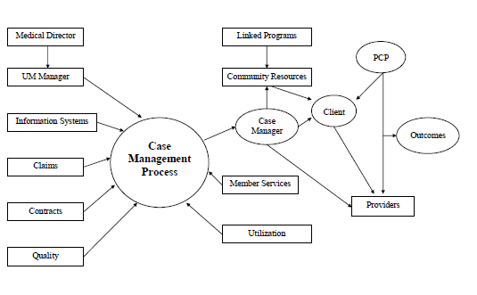

2E Factor 4: How the SNPs communication plan to exchange beneficiary information occurs regularly within the ICT, including evidence of ongoing information exchange.

Communication and collaboration among the members of the ICT, clinically directed by the PCP and supported and managed by the care manager, is the foundation of Imperial’s integrated approach to coordinated care. This approach adds considerable value to chronic SNP eligible beneficiaries and their providers from whom communication and coordination of services may be difficult. To promote effective and efficient communication, ICT members communicate via many ways including phone calls, secure email, secure web portal, web-conferencing, conference calls, written documents and reports and face-to-face meetings. The participation of the beneficiary is also facilitated via education and outreach to beneficiaries about the ICT. The care manager acts as the main point of contact and is responsible for collecting information from all providers and incorporating all into the central repository, the plan of care. Imperial directs staff to document the record on a real-time basis through the care management system. All internal members of the ICT can access the latest information regarding the member. ICT members may document directly in the record or are able to scan and store related documents in the record as well. The care manager disseminates reports generated through the proceedings of the ICT to the primary care physician and the other ICT members within five business days of the meeting. ICT members may review the documented outcomes of the meeting real-time in care management system, which is the repository of clinical information including authorizations for clinical services and inpatient services Imperial Health Plan. IT system incorporates documentation related to authorizations, encounters, claims data, Health Risk Assessments, care management plans, and member contacts, member demographics, and available clinical records. All internal members of the ICT can access the latest information regarding the member. ICT members may document directly in the record or are able to scan and store related documents in the record as well. The care manager disseminates reports generated through the proceedings of the ICT to the primary care physician and the other ICT members within ten business days of the meeting. ICT members may review the documented outcomes of the meeting real-time in care management system. Record of communication between ICT members can be obtained in the IT platform (EZCap or EZCare) that is used by the team. The patient’s clinical team can access the system via the provider portal. I

The ICT also meets quarterly and monthly, andmore frequently as needs warrant. The reports and discussions of these meetings are saved on a secure server that is available to authorized ICT members. Other forms of communication with the patient and providers include faxes, letters, and secure email related to medications, and recommendations.

The member is mailed a written version of the comprehensive care plan as well as updates. Regular quarterly meetings may be more frequent if the beneficiary’s condition warrants the meeting.

Communication plans are created for regular exchange of information within the ICT including accommodations for members with sensory, language or cognitive barriers. Imperial leverages its resources for translators to communicate with beneficiaries in their preferred. Behavioral specialists, speech therapists, psychologists are also incorporated in the ICT to ensure that barriers related to cognitive deficiencies are addressed. The use of TDD technology facilitates mitigating barriers related to hearing impairments.

The communication with the member starts upon:
- Enrollment into the SNP
- Procurement of the HRA
- Identification of SNP conditions and verification through various sources including communication with PCP and / or specialists
- Communication with the patient and family/advocates
- Categorize by estimated intensity of involvement needed.
- Identify potential barriers to care for the patient
- ICT meetings to discuss issues and set meeting with patient/representative
- Obtain patient input into needs, and share considerations from ICT
- Prepare a ICP and obtain sign off upon finalization
- Conduct regular ICT and monitor progress and outcomes
- Update ICP as needed, and change frequency more than quarterly as needed
- Continue ongoing monitoring and communication between ICT members and patient as needed
- Measure outcomes and share details with all stakeholders

2F. Care Transitions Protocols

2F Factor 1: How the organization uses care transition protocols to maintain continuity of care for SNP beneficiaries.

Imperial Health Plan complies with regulations at 42 CFR §422.101(f)(2)(iii-v); 42CFR §422.152(g)(2)(vii-x) that require all SNPs to coordinate the delivery of care. Imperial coordinates transitions for SNP members from one care setting to another. Imperial’s care coordination team uses evidence-based transitions protocols based on Eric Coleman’s Care Transition Model and incorporates the Four (4) Pillars for consistency and continuity of care across all settings.

The Four Pillars are:
- Medication reconciliation
- Primary care / specialty care follow-up; access to community-based services
- Personal Health Record/Self-Management
- Signs of red flags that indicate a worsening in condition and how to respond

After hospital discharge, a Case Manager will attempt to contact the member within 48 hours and schedule a PCP or specialist follow-up within 7 calendar days. We perform medication reconciliation by phone or telehealth within 72 hours of discharge, documenting changes in the ICP. The transition of care for a member from PCP to specialist starts with the member visit to the PCP. The PCP is responsible for the assessment, selection of the specialist, and referral of the member to the specialist. The PCP uses a certified EMR to prepare the consultation request to the specialist, including all relevant clinical data, including laboratory results and imaging, if applicable. The provider transmits the consultation request to the specialist. The specialist receives the request and reviews the data submitted. If the member is established with the specialist, the specialist reviews the medication, medication allergy, and problem lists provided, and updates the member’s record if required. If the patient is new, the specialist incorporates the data submitted into the EMR for a new patient record.

Care transition planning starts sending updated clinical documents and communication to the receiving care setting. Nurse Case Manager works closely with the ICT and providers to develop and implement a plan of care. Imperial Health Plan identifies planned and unplanned transitions through the following mechanisms:
    - Prior authorizations
    - Concurrent review
    - Inpatient hospital census report
    - Emergency Department report
    - Telephonic notification
    - Face to face notification

Imperial’s standardized practices and systems ensure timely and thorough communications. This also helps avoid complications due to transitions in care. Imperial closely monitors and intervenes in hospitalizations and readmissions to support improved health care of covered beneficiaries.

Care Transition process identifies member needs and preferences across the different care settings. During transitions in care, Imperial ensures that the care management team, ICT, providers, member, and family follow safe and effective protocols to facilitate a smooth transition from hospital, skilled nursing facility, sub-acute, behavioral health facility, and emergency room. Imperial works toward timely and early identification of the participant’s need for such care setting transition, a standardized and well documented process for communication among settings and related Care Management/ICT determinations and actions. The participants remain a vital part of the care transition process.
Additionally, when new members are enrolled, during the intake, it is determined if beneficiary is undergoing ongoing care. In that case, the SNP works to ensure that continuity of care with non-contracted providers is maintained to ensure there is no disruption in care. When continuity of care needs are identified because of a variety of changes, the Clinical Services Department is informed so that they may coordinate to ensure continuity of care.

The specialist contacts the member to schedule an appointment and sees the patient at that appointment. The specialist orders and further required laboratory tests or imaging, and/or makes further recommendations to the PCP. Alternatively, the specialist assumes care of the member for the problem that is the subject of the referral. The specialist then transmits the consult report back to the PCP using a certified EMR.
If patient is transitioning across level of care, the Care Transitions team coordinates to ensure the transition is completed in a patient centric manner, to facilitate medication self-management and adherence, continuity of care, timely provider follow up and ways to flag clinical deterioration.

2F Factor 2: The personnel responsible for coordinating the care transition process.

Once a transition notification is received, it is entered into a shared care plan in Care Management System which allows for notifications to be sent to the assigned team. The care coordination team is responsible for transition coordination efforts. An assigned care coordinator reaches out to the member scheduled for a transition or who is already in the process of a transition. This assigned care coordinator will remain the point of contact for the member throughout the transition.

A care coordinator can be an inpatient review nurse, SNF case manager, prior authorization nurse, social worker, and/or clerical support staff who work together to assist with transition of care. Member’s status is reviewed and assistance with coordination of transition is offered. The member has a right to decline this service. For members who are recognized to be in the initial stages of preparation of a planned transition, aA Care Coordinator assists with preparatory work with the member to focus on discharge needs to return to their usual setting or another as appropriate. The Care Coordinator will notify member’s PCP of the transition within 2 business days of notification that a planned condition occurred. The updated clinical records with approved authorization are faxed to the receiving setting within 1 business day. If the transition is unplanned, notifications are received from contracted facilities within 24 hours of transition to obtain an authorization. Clinical reports are received from contracted facilities within 24 hours of admission.
The transition to a skilled nursing facility is prior authorized by the SNF Case Manager and it is considered planned transitions. The SNF Case Manager forwards the member’s clinical records within 1 business day of the transition and communicates with the receiving facility and conducts SNF reviews within 2 business days of the transition. The SNF Case Manager will contact the member during their transition and assist with planning for the discharge in collaboration with those involved with discharging at one site and those involved with admitting at the admitting site.
If the member was enrolled in case management, the Nurse Case Manager who was working with the member prior to transition will continue to work with member to identify any needs. The Nurse Case Manager contacts the member or caregiver to determine the care transition needs and revising the ICP. The Nurse Case Manager works with the PCP and specialists to ensure follow-up care, services and appointments are scheduled.

2F Factor 3: How the organization transfers elements of the beneficiary’s ICP between health care settings when the beneficiary experiences an applicable transition in care.

The care coordination team contacts all those who are involved in the various care settings to ensure that important information related to provision of ongoing care is appropriately shared. Information transferred may include Demographic information including involved ICT, current medication list, Advance directives/advance care orders, Care plan is provided. Information can be transferred in many ways to meet the need of the situation. This could include, but is not limited to; telephone, email, fax, face to face. Members that are noted to have transitions that are determined to be avoidable are contacted. Care coordination staff offer training on options and tools for better management of their care needs. Community navigators may also provide a face-to-face visit to assist members that require more assistance with planning. It could be as simple as having a list of medication the member is taking.
Imperial has developed and implemented mechanisms for monitoring MA enrollees that are participating in the chronic care program. These mechanisms may include, but are not limited to:
- Program participation (e.g., involvement in care planning)
- Receipt of recommended tests/ services (e.g., cholesterol testing)
- Use of recommended pharmaceuticals
- Compliance with prescribed pharmaceuticals
- Emergency room visits and hospital (re) admissions
- Clinical indicators of effectiveness (e.g., LDL-C levels, smoking cessation, weight loss)

The organization transfers the SNP member’s ICP between healthcare settings during the care transition process. Prior to a transition in care, the plan identifies a planned transition is going to occur by requiring pre-certification for the following services: elective inpatient admissions, skilled nursing facility admissions, long term acute care, acute inpatient rehabilitation, and home health services.

During planned and unplanned transitions, the plan sends the member’s ICP when a member transitions from each of the following settings. This includes communicating changes in health care status or beneficiary Plan of Care. - Hospital to nursing home – inpatient case manager identifies admission level of care and participating nursing home facilities and directs the hospital discharge planner to in-network nursing facility. The inpatient case manager will issue an authorization for the facility within 1 business day.

Nursing home to hospital – receives notification from the nursing home about the transfer. The coordinator will enter the authorization for hospital admission and notify the inpatient case manager. The inpatient case manager will monitor the inpatient admission and coordinates discharge planning with the hospital and nursing facility staff. Also, work with the nursing facility for bed hold if member is long term care resident at the facility.

Hospital to Home – inpatient case manager coordinates post discharge care plan with hospital discharge case manager and ICT. Initiates care transition event by authorizing needed services within 2 business day receipt of discharge order. Once member is discharged home, the nurse case manager conducts transition assessment with member within 5 calendar days of discharge. Additionally, the nurse case manager schedules assessments, updates ICP and coordinates with ICT when a change of status has occurred. PCP will receive updates on hospital stay via discharge summary.

Home to Hospital - Notifications from member, care giver, home care nurse, or PCP of impending transfer to hospital. The care coordinator will forward clinical records to admitting facility and enter the authorization for the admission. The inpatient case manager will be notified of the admission and contact the facility to perform medical necessity review and monitors the progress of inpatient stay. The inpatient case manager will coordinate discharge plan with hospital case manager.

The plan runs a daily SNP inpatient census that displays newly captured admissions. A case management coordinator uses this list to send SNP Member ICPs to the receiving facility within one business day of the notification of the unplanned transition and/or within one business day of the planned admission.

Inpatient to Skilled Nursing Facility (SNF): The responsibility of sending information for this transition is given to the inpatient facility and monitored by Imperial. The inpatient facility completes the discharge instructions, which the SNF facility uses as the admission care plan information. It is supplemented by attached admission orders.

Planned Outpatient, Ambulatory Care, and Surgery Center Transitions: Select outpatient, ambulatory care and surgery center procedures require health plan authorization; however, all are planned and scheduled by the rendering providers. Therefore, the plan entrusts member communication and support of these transition types to the authorized provider.

2F Factor 4: How beneficiaries have access to personal health information to facilitate communication with providers in other healthcare settings or specialists.

Members are provided with a hard copy of their ICP. A copy of the ICP is also faxed to member’s PCP. Members who have an ICP are educated to share their care plan with others in the healthcare setting. The care plans are written at a 6th grade reading level to ensure that the members can use and understand the plan. The member is provided with the contact information (phone and email) of the Care Management team. Members are encouraged to complete their own Personal Health Goal survey as well. This survey also contains a medication list, allergies, questions for providers, member conditions and issues that providers should know about.

The care management staff can access member’s information 24/7 via care management system and through secure fax server, email, and telephone to facility inbound and outbound communication.
The member’s ICP is developed and updated in collaboration with the member and ICT. The ICP includes short/long term goals, time frames to meet medical, behavioral, and functional goals and are shared with the member. The ember and/or caregiver can access the member’s personal health information upon request via mail, fax, verbally, or any other HIPAA compliant method.

Members who complete the HRA are mailed care plans and they are encouraged to share them with their providers to facilitate communication during the transition process. These care plans are written at or below a 6th grade reading level to ensure that members can use and understand them. In these letters, members are provided with the telephone number and contact information for the Care Management department. Care managers can work with the member or caregiver to update the care plan, mail updated care plans to the member or share care plan information with the member’s PCP or treating physician in any care setting. Members are also encouraged to complete and maintain their Personal Health Record (PHR) which contains member goals, a medication list, allergies, questions for providers, member conditions and “red flags” and should be shared at all visits to the member’s doctor or to the treating facility. Imperial works with members to complete the PHRs and ensure that they understand how to use them.

2F Factor 5: How beneficiaries and/or caregivers will be educated about the beneficiary’s health status to foster appropriate self-management activities
Once the member is discharged, the assigned case manager will perform a new health assessment. During regular communication with the member and PCP to monitor any changes in member’s health, members or designated family member are encouraged to contact the case manager via telephone through the transition process. During care transition, when a patient is discharged home, a home health clinician may visit the patient at home to evaluate the patient, and home safety, as well as to arrange for any durable medical equipment that the patient may require. Working with the PCP, care managers will help educate the member and caregivers regarding the patient’s clinical condition, signs to monitor, signs of clinical deterioration and how to communicate these to the clinical team. Weekly and monthly contacts will be documented in the Care Management System for clear understanding of their treatment plan
Members with chronic conditions may be enrolled in disease management programs and receive educational materials to assist them in managing their chronic conditions. The nurse case manager provides outreach and educational materials to members who have cardiac, diabetes, HTN, and CHF diagnoses via telephone calls and brochures to help member’s self-management of chronic conditions. Case Managers utilize MCG Health’s portal to access available self-management tools for our members. MCG Health provides accessible self-management tools for home health and chronic care, including but not limited to Anxiety, Arthritis, Asthma, Cancer, Cholesterol, Depression, Diabetes, Heart Disease and Failure, High Cholesterol, Hypertension, Kidney Disease and Palliative Care. Each topic provides a questionnaire for the member to review and answer. This helps their care team monitor and follow any changes in their health. Additionally, Case Managers will pull patient educational materials focusing on their specific health condition and they will be sent to members and/or their caregivers. If requested, members will be provided with educational materials in their preferred language.
Post discharge follow-up, medication reviews and care supports are the important elements to have successful transitions and overall self-management. The nurse case manager will review the medication with member and/or caregiver to ensure understanding and remind member to bring all prescription, including over the counter medications with them to physician appointments. Also, clinical pharmacists can be consulted for any medication issues and contacting the treating physician to address the potential risk. Based on the discharge instructions, the nurse case managers assist the member to schedule follow up appointments and removing barriers for office visits such as lack of transportation. The nurse case manager identifies the needs for durable medical equipment, home health services and refers to community-based programs that can help keep a member safe at home.

2.F. Factor 6: How the beneficiaries and/or caregivers are informed about the point of contact throughout the transition process.
Beneficiaries and caregivers are provided with the phone number of the Care Coordination department and the care manager so that they contact Imperial. Web access for queries is also provided. When a member experiences a transition in care, they are assigned to the transition team who contacts the family and the new setting such as the hospital or the post-acute care facility. This is done to identify the plan of care and the potential discharge date. A social worker works with the facility’s discharge planning team to maintain optimal contact and planning. Frequent updates via phone calls to the family by the care management team are achieved as well.
During transition, the nurse case manager reaches out to the member and caregiver to coordinate transition of care activities and interventions. The nurse case manager will be the main point of contact during the transition period, but other care management staff may be involved in the process as needed, i.e., member’s ICT, UM team, Clinical Pharmacist, social worker, as well as Medical Officer.
Members and caregivers are advised to inform Plan when there are changes in their condition. Through outreach and education, they are advised to look out for increasing forgetfulness, weakness, falls, new incontinence, ER visits, hospitalizations, weight loss or weight gain, concern about food or housing insecurity, exposure to abuse/violence. They are provided with the contact information to reach the Plan.

SNP Provider Network
In compliance with regulations at 42 CFR§422.152(g)(2)(vi), Imperial has established a provider` network of healthcare professionals who have specialized expertise in the care and are contracted to provide health care services to SNP beneficiaries. Imperial conducts an annual network gap analysis by county and specialty (e.g., Cardiology, Endocrinology). If a shortage is identified (e.g., no diabetes educator within X miles), Imperial’s Provider Network Management team initiates targeted contracting efforts or telehealth solutions to address the gap.

3A. Specialized Expertise

3A Factor 1: How providers with specialized expertise correspond to target population identified in MOC 1.
The Credentialing Department follows the following procedure:
Credentialing: The scope of credentialing include, but is not limited to: MD, DO, DDS, DPM and DC. The credentialing and recredentialing of Allied Health Professionals (AHP) are also included. Upon receipt of the State’s standardized application (registration with CAQH) an Imperial profile document, Authorization to Release form and a W-9, the CR Department date stamps all incoming applications. Applications are reviewed for completeness and the applicant is notified of missing documentation within (5) business days. Imperial accesses routine reports monthly of licensing board sanctions to detect restrictions. These are used to trigger the Credentialing and Privileging Committee review, as described above.

Licensing: All Providers must possess a valid, unencumbered license in the state which he/she wishes to practice. The highest level of education will be verified for Practitioners. Online primary source verification of Board Certification is obtained from the appropriate certifying Board. The CR Department utilizes Primary Source Verification for all licenses, DEA certificates and malpractice insurance. Online Primary Source Verifications are used for the following: Opt-Out, SAM, OIG, Medi-Cal Suspension, CLIA, HIV/AIDS specialist, SSDMF. Online Primary Source Verification of malpractice history of past or pending suits is obtained from the National Practitioner Data Bank (NPDB). Work history of at least 5 years as demonstrated on application or Curriculum Vitae. CLIA certificate, if required at all facilities to perform any laboratory tests.

Note: Medicare requires the IPA/Medical Group to ensure that no payments are made with respect to any item or service (other than an emergency item or service) furnished by an individual or entity when such individual or entity is excluded from participation in Medicare/Medicaid programs (including Medicare Advantage plans). Providers will not be credentialed nor added to the network if the provider opted out of Medicare.

Provider Directory: The online provider directory is the primary source for Imperial with members also being able to access their medical records through their personal web portal. The physician directory allows members to compare physicians on criteria, including language, gender, education, and specialty certifications.

Imperial provides access to physical and behavioral health preventive and primary care, dental care, acute and post-acute rehabilitation through a specialized provider network with understanding of the needs of this population and the coordinated care model, aimed at increasing access to physical and mental health resources. Imperial network of providers is comprehensive and structured to meet the needs of our entire population, especially members who are frail, disabled, or require end of life care. The provider and facility network delivers services that includes, but are not limited to the following provider types: Acute Care Facility, Hospital, Medical Center, Urgent Care, Laboratories, Long Term Care Facility/Skilled Nursing Facility, Pharmacy, Radiography Facility, Rehabilitative Facility/ Outpatient Physical and Speech Therapy Centers, Behavioral Health Facilities(Inpatient/Residential/Ambulatory), Free Standing Surgical Center, Home Health, Psychiatric Hospitals, End Stage Renal Disease Services, Hospice, Mobile X-Ray Supplier, Federally Qualified Health Center(FQHC) and Durable Medical Equipment.

The core provider of the ICT is the Primary Care Provider (PCP). To meet the needs of coordination and oversight, Imperial maintains a network of board-certified Family Medicine, Internal Medicine, and Geriatric Physicians and Nurse Practitioners. Additionally, Specialists in the specific areas of care (SCP) are included in the network. These providers include Medical Specialists in Orthopedics, Neurology, Physical Medicine and Rehabilitation, Cardiology, Endocrinology, Gastroenterology, Pulmonology, Nephrology, Rheumatology, Radiology, and General Surgery. Behavioral Health Specialists include Psychiatry, Clinical Psychology, Master’s or above level Licensed Social Workers, and Certified Substance Abuse Specialists. Allied Health Professionals include Pharmacists, Registered Physical, Occupation, and Speech Therapists, as well as Registered and Licensed Vocational Nurses, Physician Assistants, Nurse Practitioners, Certified Nurse Anesthetist and Certified Nurse Midwives.

The network includes contracted providers with specialized clinical expertise that is pertinent to the targeted SNP membership. Imperial’s specialty network includes Geriatricians, Internists, Endocrinologists, and Nutritionists to manage diabetes. Specialists including Cardiologists, Nephrologists, Orthopedic Surgeons, Vascular Surgeons, Cardiac Surgeons, Ophthalmologists help manage diabetic complications and co-morbidities. Other specialists determined by member diagnosis are also part of the network and mentioned above. Nurses, Behavioral Health Specialists, Social Workers, and Benefits Coordinators work with Imperial to deliver a coordinated care delivery plan to members.

Similarly, for Imperial’s chronic heart failure and cardiovascular disorders, the provider network includes those mentioned above as well as experts in the management of heart failure, rhythm disorders, peripheral vascular disease, hypertension, and syncope. Cardiac Rehabilitation Centers, Wound Centers, Radiology Facilities and other Ancillary Facilities are also part of the network.

The network is not limited to the providers and includes other specialists as determined by member diagnosis including Nurses, Behavioral Health Specialists, Social Workers for care coordination, benefit, and housing needs, social or medical equipment and resources as applicable. Available facilities for our chronic diabetes and cardiovascular SNP include: Acute Care Hospitals and tertiary Medical Centers, Dialysis Centers, Acute Care Rehabilitation Facilities, Laboratory Providers, Skilled Nursing Facilities (SNF), Pharmacies, Radiology Facilities, Outpatient Diabetes Management and Cardiac Rehabilitation Centers and Wound Care Centers. The goal is to ensure that we provide a network of providers who will meet the needs of the beneficiary and include all facilities where members may receive care. As needed, Ad Hoc Providers will also be enlisted for services.

Moreover, Imperial requires its providers to function as members of the interdisciplinary team, and in an integrated fashion, so that traditional barriers, such as between physical and mental health, are lowered and more efficacious, evidence-based, and affordable care is available to its SNP members. For example, a diabetes treatment team starts with the member and her family, and moves on to include the Primary Care Provider, a Clinical Pharmacist, Nutritionist, Mental Health Therapist, and Health Coach. For members with mobility or other physical challenges, a Physical therapist may join.

3A Factor 2: How the SNP oversees its provider network facilities and oversees that its providers are competent and have active licenses.

Imperial has a close relationship with our practitioners in the community, and contracts with practitioners or groups of practitioners who are licensed, certified, or registered by the state. Medical Management communicates closely with our contracting department to make sure that Imperial has the most updated information on all our contracted practitioners and facilities. The plan has policies and procedures for credentialing, monitoring, and re-credentialing the network. Imperial’s Provider Relations Representatives perform site reviews for the contracted provider types.
The health plan maintains credentialing, monitoring and re-credentialing procedures that include standard verifications e.g., licensure, sanctions, and professional liability claims history. These procedures are compliant with all relevant State, Federal and NCQA requirements. Prior to review, the Credentialing Department collects and verifies the following information:

- Credentialing application
- Active licensure
- State license sanctions
- Education and training (residency and fellowships)
- DEA or other prescriptive authority
- Board certification
- Work history
- Professional or facility liability insurance
- Malpractice history, including adverse clinical privilege actions, Federal and state licensure and certification actions, and state and Federal program exclusions (National Data Bank)
- Medicare opt-out status
- Medicare/Medicaid sanctions
- Appropriate facility accreditation (Joint Commission, state or CMS deemed accreditations)
There is a monthly process to monitor all credentialed and non-credentialed providers that have an active provider number. Providers are also required to notify the plan of any material change in the information including privileges, licensure, and ability to perform professional duties or change in OIG Sanction or GSA debarment status. All practitioners and facilities are re-credentialed within 36 months of the previous credentialing decision to identify any changes in a practitioner’s licensure, sanctions, certification, clinical privileges, competence, or health status that may affect the practitioner’s ability to serve our members. The process also includes an assessment of the provider’s performance as part of our network through the Quality Improvement department that meets at least quarterly. Quality based metrics are assessed and acted upon. The organization has access to the National Practitioner Data Bank, credentialing services, specialty boards, state licensing departments to confirm training, certification, licensure statuses. The Credentialing and Privileging Committee may review any provider’s practice at any time, including between re-credentialing cycles, to consider additional information relevant to that practice. The committee may decide at any time to act regarding a provider’s credentialing. Such action or decision may include, but is not limited to, the suspension, termination, limitation, or revocation of credentialing. Written notification of such decision of action will be made to the provider.
Providers are educated on the MOC and requested to demonstrate understanding through one-on-one interactions, webinar training, conference calls, virtual town halls, online training. SNP patients are also assigned to providers, when patient preference allows, to PCPs with empathy and expertise in caring for SNP patients. Quality control team monitors performance and shares reports of results with the providers.

Evidence of Specialized Provider expertise and training
Refer to Imperial’s Appendix C for Medical Committee Services Contact Sheet

3A. Factor 3. How the SNP documents, updates and maintains accurate provider credentialing information.

On an ongoing basis, credentialing staff query their credentialing database on individual providers and incorporate these scores into the credentialing and re-credentialing process. Results from the reviews are aggregated and submitted to the Credentials Committee quarterly for review. Reports by provider, medical group or survey item may be produced as needed. All reporting is coordinated through the Quality Improvement team to review and suggest actions. The QI Committee evaluates reports, monitors trends, and recommends actions. QM staff may be involved in any follow-up action. If an opportunity for improvement is identified for a provider, a practice site or provider group, the involved parties will work together to develop a corrective action plan (CAP).

Imperial’s Credentialing Department verifies the active licenses of all practitioners and facilities contracted with Imperial to care for the SNP population. Imperial also confirms the applicable board certification of specialized practitioners. The plan checks all practitioners every three years when contract renewal occurs.

Imperial also uses the list of excluded providers and entities to ensure that our practitioner and facility panels are not sanctioned by Medicare. Imperial checks this Medicare excluded list monthly.
Imperial maintains current practitioner facility information in our software program called Streamline Verify©. Provider directory printed in addition to online directory is available. The directory contains basic information that the member can use to compare physicians based on their needs. The provider directory is updated quarterly or in compliance with State law if that is more stringent. Network team monitors provider performance through visits, secret shopper calls, member surveys satisfaction scores, and clinical experience of patients,

3A Factor 4. How providers collaborate with the ICT and contribute to a beneficiary's ICP to provide necessary specialized services.

The Primary Care Physician (PCP) determines the service needs of the member. The PCP and Case Manager work together in managing the care of the member. The Case manager enables the PCP in authorizing and facilitating access to specialty care. Planning and utilization needs are reviewed by other ICT providers. Case Manager maintains and updates all information from PCP, Specialists, and other providers into the ICP. The ICP is communicated to the PCP via web portal, fax, letter, or telephone. The program is member-centric, and the PCP is the ICT member who determines which services the member needs. The Care Manager coordinates all aspects of the care and ensures that the ICT is involved and the ICP is being followed.

The Primary Care Physician (PCP) is the ICT member who determines ultimately which services the member will receive. The member is at the center of the ICT and the PCP is the clinical driver of all the care the member receives. The PCP works collaboratively with the Care Manager, who is the single point of contact for all ICT members involved in the care of a member. The member’s Care Manager acts as the coordinator of services and is the person who executes/authorizes services for the member with ongoing input from the other ICT members. The Care Manager helps to ensure members have access to specialists and other needed services. The other ICT members contribute to care planning and utilization as the members care needs change over time.
The Care Manager documents all communication regarding clinical needs of the member in the system. Reports on services delivered are incorporated into the care management record to maintain a complete and up-to-date member record and disseminated to applicable ICT members. Information obtained from the PCP, specialists, hospitals, and other providers is incorporated into the individual plan of care, which is sent to the PCP electronically, via fax or written correspondence. The information including the ICP is shared with the beneficiary, PCP and any other providers as needed.
The ICT ensures that specialized services are delivered timely and efficiently to its SNP members by ensuring that services needing prior authorization are sent to Imperial as soon as the need is identified and within CMS timelines. Imperial abides by CMS timeliness requirements and processes these authorization requests accordingly. Care is directed to appropriately credentialed and specialized providers as is appropriate. Imperial monitors access to care reports and grievance reports to ensure care is timely, quality, adequate and effective.

3B Use of Clinical Practice Guidelines and Care Transitions Protocols

Imperial Health Plan (IHP) adheres to 42 CFR §422.101(f)(2)(iii)-(v) and 42 CFR §422.152(g)(2)(ix), which require Special Needs Plans (SNPs) to demonstrate the use of evidence-based clinical practice guidelines (CPGs) and care transition protocols tailored to the specific needs of the Chronic SNP (C-SNP) population.

3B Factor 1: Explain the processes for monitoring how network providers utilize appropriate clinical practice guidelines and nationally recognized protocols.

- Core CPG Sources & Scope
  - Imperial adopts nationally recognized guidelines from key professional bodies, including (but not limited to):
    - ACC/AHA (American College of Cardiology / American Heart Association) for cardiovascular disease and heart failure
    - HFSA (Heart Failure Society of America) for advanced HF management
    - ADA (American Diabetes Association) for diabetes care
    - KDIGO (Kidney Disease: Improving Global Outcomes) for chronic kidney disease
    - GOLD (Global Initiative for Chronic Obstructive Lung Disease) for COPD management
    - USPSTF (U.S. Preventive Services Task Force) for preventive screenings/immunizations
  - Our Chronic Care Improvement Program (CCIP) aligns with Million Hearts, focusing on risk reduction in heart failure, hypertension, diabetes, and medication adherence.
  - The Chief Medical Officer (CMO) and Quality Improvement (QI) Team conduct an annual review of these guidelines, updating them for alignment with the latest evidence-based standards.
- Additional CMS-Recognized Specialty Societies
When no Local Coverage Determination (LCD) or National Coverage Determination (NCD) exists, IHP references CMS-recognized specialty societies and guidelines for “reasonable and necessary” decisions. These include:
  - American Medical Association (AMA)
    - Publishes CPT codes; offers general guidance on standard medical practice.
  - American College of Physicians (ACP)
    - Covers internal medicine and primary care guidelines; best practices for managing chronic diseases.
  - American College of Cardiology (ACC)/American Heart Association (AHA)
    - Comprehensive guidelines on cardiovascular diseases, heart failure, and hypertension.
  - American Diabetes Association (ADA)
    - Standards of Medical Care in Diabetes; used for determining reasonable treatment plans for diabetic members.
  - National Comprehensive Cancer Network (NCCN)
    - Evidence-based cancer treatment guidelines, often referenced for oncology coverage determinations.
  - American Academy of Neurology (AAN)
    - Guidelines for stroke, epilepsy, Parkinson’s, and dementia.
  - Infectious Diseases Society of America (IDSA)
    - Guidance on antimicrobial therapy, HIV/AIDS, and emerging infections.
  - American Academy of Orthopaedic Surgeons (AAOS)
    - Musculoskeletal conditions and orthopedic procedure guidelines.
  - American Urological Association (AUA)
    - Protocols for prostate cancer, kidney stones, and other urological conditions.
  - American Society of Clinical Oncology (ASCO)
    - Best practices in cancer diagnosis, treatment, and management.
  - Society for Vascular Surgery (SVS)
    - Guidelines for vascular and endovascular procedures.
  - American Gastroenterological Association (AGA)
    - Covers guidelines for IBD, colon cancer screening, and GI disorders.
  - American College of Rheumatology (ACR)
    - Recommendations for rheumatoid arthritis, lupus, and other autoimmune diseases.
  - Endocrine Society
    - Disorders such as thyroid dysfunction, osteoporosis, and adrenal conditions.
  - American Society for Radiation Oncology (ASTRO)
    - Radiation therapy guidelines for oncology treatments.
  - American Society of Anesthesiologists (ASA)
    - Guidelines for determining necessity for anesthesia services.
  - American College of Obstetricians and Gynecologists (ACOG)
    - Evidence-based guidance on women’s health, prenatal care, gynecological procedures.
  - American Association for Thoracic Surgery (AATS)
    - Thoracic and cardiac surgery best practices.
  - American Association of Clinical Endocrinologists (AACE)
    - Additional endocrinology guidelines beyond the Endocrine Society.
  - American Psychiatric Association (APA)
    - Determining medical necessity for psychiatric disorders and mental health treatments.
- Peer-Reviewed Medical Literature
  - Anticancer Treatments: CMS references journals noted in the Medicare Benefit Policy Manual, Chapter 15, Section 50.4.5.
  - Other Medical Conditions: CMS considers high-quality evidence from peer-reviewed journals with rigorous peer review, high reputation/impact factor, and relevance to the specific condition. Examples frequently recognized include:
    - The New England Journal of Medicine (NEJM)
    - The Journal of the American Medical Association (JAMA)
    - The BMJ (British Medical Journal)
    - The Lancet
    - Annals of Internal Medicine
    - American Journal of Medicine
    - Journal of Clinical Oncology
    - Circulation
    - Chest
    - Neurology
  - Systematic Reviews: CMS evaluates study design, sample size, consistency, and applicability to the Medicare population (see Medicare Program Integrity Manual, Chapter 13).
- Annual Review & Provider Dissemination
  - Updated guidelines or newly adopted evidence are disseminated via:
    - Provider Manual updates
    - Town halls or webinars
    - Newsletters and plan website
  - Network providers are expected to incorporate these evidence-based recommendations into their clinical practice and coverage submissions.
- Monitoring & Oversight
  - Imperial conducts medical record audits, reviews HEDIS/Star measures, and facilitates peer-to-peer discussions to evaluate guideline adherence.
  - The Quality and Performance Improvement Committee (QPI) investigates repeated deviations and may initiate provider education or corrective actions as necessary.

Imperial incorporates Gero-Palliative Preoperative Screening for older or high-risk adults, following the American College of Surgeons (ACS) and American Geriatrics Society (AGS) 2012 and 2016 guidelines under the NSQIP framework:
- Goal: Improve surgical outcomes, reduce perioperative complications, and align with geriatric/palliative best practices.
- Frailty Identification
  - Plan-Wide Trigger: Any member deemed potentially frail by UM, CM, Pharmacy, Quality, or Virtual Care Clinic practitioners undergoes a formal Gero-Palliative screening.
  - Frailty Phenotype (≥3 of 5 indicators):
    - Loss of strength
    - Unintended weight loss
    - Low activity level / increased sleeping
    - Poor endurance / easily fatigued
    - Slowed performance / unsteady gait
- Screening Criteria for Preoperative Palliative Consultation
  - A palliative consultation is recommended if any of the following are met (age ≥70 alone is not a sole trigger):
    - TUGT ≥ 15 seconds
    - MMSE < 25 or documented cognitive disturbance
    - History of alcohol or drug use
    - Polypharmacy (≥10 meds)
    - Anticholinergic Burden (ACB) Score ≥ 3 or benzodiazepine use
    - Multiple complex comorbidities
    - ADL or IADL deficiencies
- Clinical Protocol & Referral Pathway
  - Referral Trigger: If criteria are met, an internal, automatic referral from Plan UM to Plan CM initiates a preoperative palliative consultation (goals of care, surgical risk optimization).
  - Consultation Providers:
    - Vynca Palliative Care, or
    - An Imperial network practitioner (Board-certified hematologist-oncologist w/ Hospice/Palliative Medicine).
  - Documentation: Plan CM documents screening and any plan changes in the Individualized Care Plan (ICP) to facilitate team communication.

Oversight includes monitoring the provision of services to ensure providers adhere to nationally recognized clinical practice guidelines in clinical care; clinical services are appropriate and timely; follow-up on provision of services and benefits; seamless transition of care across settings and providers; and targeted medication and medical record reviews. Imperial’s Quality team conducts chart audits for a random sample of providers to evaluate adherence to CPGs (e.g., A1c <8% for diabetic SNP members). When clinically appropriate deviations occur, the provider documents a rationale in the ICP. The Quality team and/or Medical Director reviews these cases to ensure consistency with best practices
Guidelines and any changes are disseminated annually to the providers. The changes are also communicated as they occur via the provider manual, newsletters, town hall meetings, and the website.
3B Factor 2: Identifying and documenting instances where the use of clinical practice guidelines and nationally recognized protocols need to be modified or are inappropriate for specific vulnerable SNP beneficiaries

- Complex & Vulnerable Members
  - Members with multiple comorbidities or socioeconomic barriers may need adapted guidelines (e.g., relaxed A1c goal for frail elders).
  - Ongoing data mining of claims, pharmacy, clinical data pinpoints where standard guidelines might not be appropriate.
- Collaborative Deviation Approval
  - Providers consult the Medical Director or CMO for any guideline deviation (e.g., contraindications, psychosocial issues).
  - Approved deviations are recorded in the ICP, citing specific rationale (e.g., relevant NEJM study, ACC statement, or physician consensus).
- Provider Education & Feedback
  - Scorecards and quarterly data reviews highlight repeated challenges or potential modifications.
  - If a pattern emerges, the QI Committee updates the internal policy or guidelines and notifies the network.

3B Factor 3: Providing details regarding how decisions to modify clinical practice guidelines or nationally recognized protocols are made, incorporated into the ICP, communicated to the ICT and acted upon by the ICT.

Imperial Health Plan has developed process and outcome measures to assess the adherence to best practice clinical guidelines and Member-specific health goals. Imperial Health Plan expects its providers to utilize guidelines, the complexity of the membership may make it difficult to do so due to the unique circumstances of a member. Thus, providers have flexibility in using professional judgement to incorporate patient specific clinical and other data to modify or not follow a particular guideline. When this occurs, providers are asked to supply additional clinical documentation and/or professional citations to justify the guideline deviation for authorization of a service. The medical director reviews this information to determine the appropriateness of the deviation. The ICT and providers discuss the benefit of the deviation, update the ICP and address the goals and interventions now agreed to. The case manager who facilitates this process is responsible for ensuring that the ICP includes an explanation regarding the deviation. Providers, members, and caregivers are given these updated ICPs reflecting the changes.

For example, for a member who may have income and housing instability that may create barriers to implementation of medication elements of care plans, the practitioners may adjust the CPG goals, such as an HbA1c of 7 or less for people with diabetes, to the circumstances of the member. For a patient with end stage CHF who chooses her definition of quality of life versus CPGs on CHF, dietary restrictions may be adjusted, given the wishes and circumstances of the member. In this way, Imperial adheres to harm reduction, that is recognizing the unique circumstances of each individual and meeting them with individualized care that reduces harm and aims to improve health to the greatest extent possible. Please also see 3B Factor 2 for further description of details on the process of modifying guidelines for clinically complex members. The changes are documented in the ICP. The IDT is made aware during meetings as well as through portal, email or phone communication as changes are contemporaneously made
.
3B Factor 4: Describing how SNP providers maintain continuity of care using the care transition protocols outlined in MOC 2, Element E.

- Alignment with MOC 2F
  - Imperial’s transition-of-care protocols (medication reconciliation, discharge planning, 7-day post-discharge check) incorporate recognized guidelines for HF, diabetes, COPD, etc.
  - Example: A heart failure patient is managed per ACC/AHA HF guidelines for diuretic and follow-up scheduling.
- Provider Engagement
  - All PCPs automatically receive transition-of-care notifications (admissions and discharge documents), prompting them to schedule a follow-up appointment for medication reconciliation and to conduct a root-cause analysis of the hospitalization.
  - Practitioners receive notifications (via phone calls, joint operating committee meetings, newsletters, memos, webinars, or the online provider portal) reminding them to consider the ICP whenever transferring a member to another setting. Any CPG deviation or palliative note is shared with the PCP, appropriate specialist, or delegated vendor (e.g., Lucet, Vynca Care), whether in a facility-based or non-facility setting. Failure to follow these protocols may impact the practitioner’s scorecard ranking (currently under development).
- Monitoring Transitions
  - The UM and CM teams monitor readmission rates, ED usage, and care gaps.
  - Root-cause analyses occur if unexpected readmissions suggest inadequate adherence to guidelines or communication failures.

3.C. MOC Training for the Provider Network
3C Factor 1: Requiring initial and annual training for network providers and out-of-network providers seen by beneficiaries on a routine basis.

Imperial will be compliant with regulations at 42 CFR§422.101(f)(2)(ii) that require that SNPs conduct MOC training for their network of providers. Model of Care (MOC) Training Initial and Annual MOC training is mandatory for all providers contracted as well as out of network providers who see our SNP members. A Model of Care training is conducted initially at the time of contracting the provider via provider onboarding. Annual training is done via conference calls, WebEx, and PowerPoint slides. A fax and letter are sent out to the providers notifying them to access the website for their annual SNP training. The training, attestation and survey are provided in the form of PowerPoint slides on our website www.imperialhealthplan. Training content includes but is not limited to policies and procedures, including focused campaigns on Model of Care, Care Gaps, clinical guideline adherence, transitions of care and functionality available through the Provider Web Portal. To ensure consistency in the training content, standard presentation materials and handouts, accompanied by speaking points are used. Participants are also given printed materials to reinforce key points of the training. The slides are attached to Appendix D.
The training covers the following elements:
- History of SNP plans
- Overview of the CSNP
  - Specific population demographic, needs
  - Eligibility for SNP
  - Most vulnerable members
- Care Coordination in CNSP
  - Staff Structure
  - Health Risk Assessment
  - Individualized Care Plan
  - Face to Face Encounters
  - Interdisciplinary Care Team
  - Care Transition
- Provider Network
  - CPGs and Care Transition Protocols
  - MOC Training
    - MOC Quality Measurement and Performance Improvement
- Quality Improvement Trilogy Documents
  - QI Work Plan
      - Goals and Health Outcomes for the MOC
      - Patient Experience of Care
  - Quality Improvement Evaluation of the MOC
  - Quality Improvement Program Description
      - Describes communication of SNP Quality Performance Related to the MOC
Out of Network provider training: Out-of-network providers who see SNP members regularly (≥5 visits per year) must also complete MOC training within 90 days of initial referral. Provider Relations tracks training completion monthly and issues corrective actions if providers do not meet 100% compliance by the annual deadline.
3C Factor 2: How the Organization documents evidence that network providers receive MOC Training.
Network Physicians are provided training through PowerPoint Slides, available on our website and announced through new provider onboarding training, fax blasts and conference calls. The MOC training is always accessible on the website for providers to complete as needed and directed to the website when the training must be completed. Upon each provider completing the MOC training and signing the attestation, each provider who signs attestation will fax or email to Provider Network Management. The verification of training is maintained internally in each provider/vendor’s record. Proof of training is maintained by a completed signed attestation form by the providers. Provider Network Management will collaborate with network providers and out of network providers to meet the annual training requirements and administer a correction action plan when they are not met. Imperial requires annual MOC training and the contracts with providers list this as a condition of participation. A sign in sheet is also provided to providers after training is complete.

3C Factor 3: Explain challenges associated with the completion of MOC training for network providers.
Arranging training for all providers across a large area of operation to attend sessions can be a challenge. Capturing modifications to the physician roster by health systems and provider groups can make it difficult to keep track of providers needing training. Since providers may participate in several plans, the administrative burden may be high. Providers may miss training due to scheduling conflicts, increase in member needs, time limitation and staffing resource challenges. In the past year of the pandemic, ensuring providers complete the training has been a particular challenge. As the pandemic recedes, this barrier is reducing. Furthermore, with the adoption of videoconferencing technologies, a new opportunity for training has arisen.

3C Factor 4: Taking action when the required MOC training is deficient or has not been completed.
A post SNP MOC Evaluation is given to all providers to measure the effectiveness of the training with a scale 1, very dissatisfied to 4, very satisfied. The questions may include but are not limited to the following:
- Was the online SNP MOC Training PowerPoint easy to use?
- Was the training content easy to understand?
- Did you find the PowerPoint training helpful in understanding the MOC processes?
- Did the presentation provide the appropriate guidance to understand your role and responsibilities within the MOC?
The information gathered from the evaluation is used to make changes to the annual training each year. If exhaustive attempts to make training available to providers do not lead to compliance with training, then corrective action plans may need to be issued. If these are not completed, then further action may be needed such as withholding a portion of the contracted amount due to a provider until the training is completed. The Chief Medical Officer confers with the provider to determine barriers to the training and explore alternative ways to deliver the training. The provider is counseled about the Plan’s obligations to CMS to ensure adherence to the MOC. If quality of services issues arise in the practice indicating the provider is not performing to contractual obligations and to professional standards, then referral to the QI team can be made. The Credentialing Committee may also be involved in off cycle reviews. Actions may include but are not limited to informal discussion, peer to peer discussions, referral to the QI/Credentialing committee. Termination from the network or temporary suspension from participation may be necessary in extreme cases.
MOC Quality Measurement and Performance Improvement Imperial will be compliant with regulations at 42 CFR §422.152(g) that require that all SNPs conduct a quality improvement program that measures the effectiveness of its MOC.
4A. MOC Quality Performance Improvement Plan

4A Factor 1: Describes overall quality improvement plan how the organization delivers appropriate services to SNP beneficiaries, based on their unique needs.

Imperial has a comprehensive Quality Improvement (QI) Program to measure performance. This program is in place to determine if systems and clinical processes are effectively supporting the SNP beneficiaries’ unique needs, including any modifications made as greater experience with the program develops.

Imperial’s QI Program is designed to monitor key components, compare results against goals or benchmarks, identify opportunities for improvement, make decisions to prioritize identified areas of focus and allocate resources. The QI Program evaluates the quality, appropriateness and outcomes of care and services delivered to our SNP members. Features of the program include on-going monitoring of quality activities throughout the year. This also includes quarterly evaluation of key performance initiatives. The QI Program evaluates how well the medical and behavioral health and services are coordinated and delivered to our members with their eligible benefits.

The QI Program has mechanisms to continuously pursue opportunities for improvement. The Quality Improvement Committee (QIC) is a committee that provides oversight to ensure that the performance of the MOC Program meets its established goals. The Committee establishes direction, recommends changes and evaluates results of the ongoing SNP clinical and service improvement activities documented in the work plan. The QIC will meet quarterly and may meet more frequently, if needed, to ensure it meets the established goals.

Imperial’s goal is to deliver high quality health care services and benefits to our SNP beneficiaries. Imperial defines its MOC by the delivery of high-quality medical care by its contracted providers, as well as care coordination, including care transitions services to our diverse CSNP target population. Our model of care is focused on meeting the clinical, social, and behavioral health needs of our patients.

The key components of the Imperial MOC are:
• To perform annual population assessment for each service area that identifies the specific needs of the SNP population. The annual assessment identifies the most vulnerable members including an evaluation of any special or unique needs. These may include age, race and ethnicity, language, disease categories, risk status and other factors. The MOC also evaluates if these needs are being met.
• Hire and train qualified administrative clinical staff supporting the delivery of care and medical management services for the SNP beneficiaries.
• Ensure all administrative and clinical staff/teams are trained on MOC requirements, upon onboarding and on an annual basis.
• Ensure that our Health Risk Assessment (HRA) Tool identifies key indicators. These include a patient’s medical, functional status, cognitive, psychosocial, and behavioral health status. This assessment is performed upon enrollment (within 90 days), and annually for all SNP members.
• Ensure Practitioners are utilizing nationally recognized Clinical Practice Guidelines for managing SNP members. The Chief Medical Officer, in collaboration with the Medical Directors evaluate the delivery of quality of care by the provider network. Some criteria used for ensuring that Clinical Practice Guidelines are being followed is to assess the adherence to the Appropriate Use Criteria as promulgated by the American Board of Internal Medicine and other professional organizations, consensus statements on clinical practice set forth by the various medical and surgical specialties, and clinical protocols.
• Individualized Care Plan (ICP) is developed for all SNP members.
• Develop an Interdisciplinary Care Team (ICT) which has access to clinical information including HRAs, ICPs, care transition protocols. The ICT is comprised of the Chief Medical Officer, UM and Care Management Teams, Primary Care Practitioners (PCPs) and any Providers involved in delivering coordinated care that involves the member and/or caregiver.
• Develop and maintain a specialized provider network, including specialists and facilities.
• Ensure Providers including Out of Network Providers receive MOC Training, initially and annually, and understand the requirements
• Disseminating the Quality Improvement activity results to our internal, external stakeholders, SNP Beneficiaries and Providers.
• Implementation of Quality Improvement Work Plan and completion of the annual Quality Program Evaluation, which includes MOC activities, assessing overall effectiveness and outcomes for SNP beneficiaries.

4A Factor 2: Describes process how plan collects specific data sources and performance, and outcome measures used to continuously analyze, evaluate and report MOC quality performance.

Imperial’s Quality and Performance Improvement Program ensures appropriate services are being delivered to SNP Beneficiaries. The program evaluates whether the MOC Structure effectively accommodates beneficiary’s health care needs. The Model of Care is evaluated based on processes and measures detailed below.

Specific data sources used to assess and administer the MOC include but are not limited to the following:
- Healthcare Effectiveness Data Information Sets (HEDIS®). These utilize encounters, claims, supplemental data, and medical records as data sources. A measurement and reporting tool developed and maintained by the National Quality Committee for Quality Assurance (NCQA); Imperial uses HEDIS® clinical measures to evaluate the MOC annually. These measures are a component of the Star program as well and are used by the Stars program at Imperial.
- CAHPS Survey (Member Satisfaction): This survey is conducted annually. These patient surveys rate the member’s healthcare experience and are utilized by CMS to measure member satisfaction in five key areas:
  - Getting Care Quickly
  - How Well Doctor Communicate
  - Health Plan Customer Service
  - Enrollee Ratings.
- Rating of healthcare
- Rating of Personal doctor
- Rating of specialist
- Rating of Health Plan
- Grievance and Appeals Data: This data allows Imperial to identify challenges with access to care or reasons for delays in care. The A&G performance reports are evaluated for trends and presented to the Quality Improvement Committee (QIC). Imperial can identify grievance and appeals but limited to the following methods:
  - Member call to Member Services Department
  - Written letters from members
  - Grievance can also be submitted from a Practitioner/Provider office, on behalf of the member.
  - These data sources are reviewed and annualized by month

- Health Risk Assessments: HRA Data is documented and is reviewed weekly to evaluate HRA completion rates. Additionally, the HRA metrics are evaluated by the clinical team and reviewed at Compliance Committee meetings and reported to the QIC at least annually.

- Eligibility and Provider Network Data: These data sets are used to evaluate provider access and availability.
- Appointment Availability: The Network Adequacy Team oversee and measures the SNP Member access to care that includes but not limited to: regular and routine care appointments, urgent care appointments, and after hours. an annual qualitative and quantitative evaluation is reviewed and presented at the QIC.
- Network Adequacy Geographical Access to Provider
- The Network team oversees and monitors the SNP Member geographical access to provider within the required travel time and distance requirements, ensuring SNP members have access to care. The Provider Geographical Network adequacy is monitored at least annually. An annual qualitative and quantitative evaluation is reviewed and presented at the Quality Improvement Committee.
- Encounter Claims and clinical information is used to stratify patients by their imputed risk for medical issues and need for care/support. Member data is used to perform the annual population assessment and risk stratification. The Population Assessment will be utilized to stratify members by disease state for targeted intervention.
- Health Outcomes Survey (HOS): The Quality Team oversees the HOS Survey Project which is conducted annually by a certified vendor. Each year a baseline cohort will be drawn and a statistically significant sample size for eligible members per reporting unit will be surveyed. The survey is designed to achieve a 75 percent response rate. Each year a cohort drawn two years previously will be resurveyed. The results of this re-measurement will be used to calculate a change score for the physical health and emotional well-being of each respondent. HOS activities are documented in the QI Workplan, with results reported to the Quality Improvement Committee (QIC) annually
- Each of the Quality Measures described above is documented in the QI Work Plan which is reviewed quarterly at the QIC. All annual summary reports, findings and recommendations are reviewed at the QIC. MOC metrics that do not meet goal, are be evaluated and presented to the QIC, where the goal may be adjusted (e.g. by 5%) and interventions modified for the following year.
Imperial is committed to continuously improving the quality of care and services provided to our enrollees and promoting effective and efficient utilization of health care resources. These commitments are achieved through an organization-wide Quality Improvement Program (QI Program.) The QI Program is designed to improve the health of enrollees, deliver the best possible health care value, promote objective and systematic program measurements, monitor, and evaluate services, and implement quality improvement activities based on these findings. The QI Program facilitates safe, appropriate, and efficient quality care by using evidence-based standards of medical care that meet regulatory requirements. Imperial’s MOC is based on evidence-based guidelines and data and is continuously reviewed and updated. Its model of predictive analytics, population health, care coordination, prevention, wellness, and continuity of care allows it to deliver care that is accessible, high quality and with good outcomes. Imperial is data driven and collects information that can then be shared with all stakeholders. Imperial s evaluation methodology allows for tracking and trending to improve services. The ability to assess trends and establish corrective action plans that can be implemented assure that Imperial is solving an identified issue.
These reports and outcomes are reviewed as made available by CMS, contracted vendors, and HPMS. This is typically at least annually. Other reports are available quarterly and some monthly, Imperial also leverages its internal reports which track the mandated reports with internally available data on a real time basis.

4A Factor 3: Describes how its leadership, management groups, other SNP personnel and stakeholders are involved with the internal quality performance process.

The Senior Manager of the Quality Improvement department, under the direction of the CMO, works with the plan’s operational departments to collect, analyze, and report on data for evaluation of the MOC. Different reports are generated based on the specific needs at the time. The QI department, in consultation with the Chief Medical Officer and staff, performs required qualitative and quantitative analysis of all MOC Metrics and will be formalized in the annual SNP MOC Evaluation Report. These summary analyses are reviewed and discussed at the QI Committee on a quarterly basis. These meetings may be more frequent, as necessary. Any MOC performance metric that does not meet the goal will be added to the following year’s MOC Work Plan. The Quality Improvement department along with Directors/Leaders in Credentialing, Case Management, Utilization Management, Disease Management, Complex Case Management, and other departments work with the Information Technology Department to ensure all data is captured. Information from the Medicare Quality Improvement Organizations (QIO) may also be obtained.
Additionally, data from the pharmacy benefits manager administering the Part D benefit is incorporated along with Claim’s data. The data is shared and joint decision making to resolve issues is made. Data from medical record reviews, annual wellness exams, and record surveys to report on HEDIS® measures are performed.
The performance improvement process is highly valued as part of the quality structure at Imperial, and requires involvement from senior leadership, the Chief Medical Officer and CEO and is demonstrated through quarterly QIC. The QIC reports to the Board.

Contracted vendors are retained to perform annual data validation audits as well. Care managers, supervisors, and other staff review, generate and analyze reports related to the MOC. Recommendations for actions to appropriate committees are made. The QI department also follows up with the data to ensure that the recommendations are implemented as approved and appropriate.

Additionally, other resources that are involve include but not limited to:
- The Medicare Quality Improvement Organization (QIO) that provides reports on Medicare Part D and aids with state requirements
- Contracted vendor that conducts surveys and provides analysis on the CAHPS and member satisfaction surveys.
- Contracted vendor that conducts patient record surveys to report on HEDIS® measures and conducts the annual data validation audit.
- Pharmacy Benefit Management (PBM) - Part D resource supporting collection and analyses of pharmacy utilization management and medication therapy management program data as well as patient safety reports.
- Care manager and/or care manager supervisors, reviews, generates, and analyzes all reports related to the evaluation of the Model of Care. Care managers and/or supervisors makes recommendations for action to appropriate committees and provides the follow-up in the quality work plan to ensure the recommendations are implemented as approved and appropriate.

As a result, departmental and organizational leadership are also involved in the Model of Care performance improvement plan to ensure that there is an organization wide commitment to the process. While leadership has decision making authority, to maintain a high reliability organization, Imperial strives to ensure that all stakeholders are empowered to affect the outcome and ensure that their views/concerns are addressed.

4A Factor 4: Details regarding how the SNP-specific measurable goals and health outcomes objectives are integrated in the overall performance improvement plan (MOC Element 4B).

Imperial’s Quality and Performance Improvement ensures appropriate services are being delivered to SNP Beneficiaries. The improvement plan detects whether the MOC Structure effectively accommodates beneficiary’s health care needs. The Model of Care is evaluated based on and not limited the following measures:
- Process Measures
- Grievances related to access of care
- Timeliness of Assessment Processes
- Physician Relationships (% populations with PCP or Medical Home Relationship)
- Care Meetings- Case/Care Management Performance Care Measures
- Utilization Patterns
- Prescribing Patterns
- Drug Interactions
- Readmissions Quality Measures
- HEDIS
- Consumer Assessment of Healthcare Providers and Systems (CAHPS)
- Outcome Measures
  - HEDIS® Outcome Measures
  - Health Outcome Surveys
  - Effectiveness of Quality Improvement Initiatives

These data sources and measures are reflected on the Work Plan and communicated to all stakeholders. Through joint operating conferences, tracking, trending, and identification of causes of issues are made, these can then be resolved. The prior quarter’s data is also discussed at the QIC. At this time, the Chief Medical Officer will provide additional feedback to departments and providers as needed.

To carry out processes for continuous collections, analyses, evaluation and reporting on quality performance, the Quality Improvement (QI) Department has designed an Work Plan.

Specific data sources used to analyze, evaluate and report MOC quality performance include inter-departmental reports (such as utilization reports), Work Plan and the data collected for completion of the annual evaluation, and CMS MOC audit results. Measurements relevant to identifying MOC performance measures include the outlined MOC goals and their identified benchmarks.
Every quarter, the QI department uses the Work Plan described above, to ensure that processes relevant to the MOC are implemented according to timeframes. Each process owner will report on their respective item and share an update. The QI department uses the Work Plan as a guide and tool to measure its performance improvement. The work plan goals are made a part of the key performance indicators for the involved departments and its leadership. Benchmarks are used to measure progress towards goals set forth in the MOC. Departments will be advised, individually, regarding results of MOC audit and given recommendations by the QI department. The quarter following the internal audit, reports/results of quality performance as discovered during audit will be presented during the QI Committee. At this time, the Chief Medical Officer will provide additional feedback to departments, as necessary. The QI department provides feedback and support, as needed.
The data sources are incorporated into the Work Plan and are assessed qualitatively and quantitatively, as part of the annual evaluation, to identify trends, opportunities for improvement. While results are presented and discussed quarterly, the SNP performs continuous evaluation to create a process of constant improvement to enhance outcomes, efficiency, and member satisfaction.
MOC goals reset annually to encourage Imperial practitioners to provide preventive services, acute care services, and chronic disease management at the highest standards of current healthcare quality. Benchmarks are developed based on the most up-to-date data available for industry-wide performance (example: HEDIS® Medicare Advantage HMO percentiles) and prior performance within Imperial (example: year-to-year comparison of hospital readmissions). Progress toward goals the organization has established for healthcare quality measures from HEDIS, CAHPS and HOS results, and Part D medication adherence is reported on a quarterly basis. Internal reports on elements such as hospital and SNF utilization, disease management program effectiveness, member complaints and grievances, and credentialing reviews are analyzed on a quarterly basis to ensure overall performance is maintained.
Performance improvement is a continuous and iterative process. When evaluating MOC performance, the Plan, Do, Study, Act (PDSA) methodology is used to address below expected results. This includes planning the improvement, performing the intervention, studying the results, and acting to stabilize and continue improvement. Based on such processes, stakeholders implement changes identified, along with allocating needed resources. The plan outlining goals, strategies, expected results and timeline is created and shared. The QI Committee is an ongoing oversight process to evaluate results and review progress toward goals, and discuss proposed interventions in a formalize committee, The results and recommended actions/impact are reported to the QI Committee by the managers and projects updates are provided.
Imperial uses the data from the HOS, CAHPS, HEDIS, patient surveys, encounter data, internal Star measures to determine if goals are being met. The encounter data is evaluated monthly. The HOS, CAHPS and HEDIS® data is evaluated. The goal for the HOS, CAHPS and HEDIS® data is to achieve 5 Stars level achievement. Scorecards with internal data are used as a surrogate marker for the official results annually provided by CMS. These scorecards are produced monthly and presented in a dashboard that is shared with all stakeholders. Providers are given visibility to this data as well with the assistance of the Quality and Provider Network Operations department. An annual workplan is created with goals determined and measured against publicly available industry benchmarks. The workplan is evaluated and if not meeting the stated benchmark, then the QI team determines the likelihood of achieving the goal and resources needed to achieve the goal. Senior leadership may be involved to prioritize the goal and deploy the needed resources and support necessary. Once an intervention is made, internal metrics continue to be monitored on a monthly and quarterly basis.
Performance goals/targets: On an annual basis and ongoing, Imperial reviews CSNP measures for appropriateness and sets goals for each measure. Where possible, industry-standard benchmarks are used for Imperial’s CSNP goals (ex: Medicare 5-star rate, or the 90th percentile benchmark). The goal for each measure is documented and tracked in the QI Work Plan (QIWP), a fluid, working document which is updated at least quarterly (usually monthly).
The QI Work Plan is also used to track interventions, high-level barrier analysis and progress to goal. Results of PDSAs are included in the QIWP, outcomes are shared with the QIC at least quarterly and documented into the QI Program Evaluation annually. The Quality Improvement Committee (QIC) meets quarterly to review MOC data and progress. Any measure falling below the target triggers a remedial action plan to be implemented within 30 days of QIC approval. An MOC performance summary is reported to the Board annually and as requested for interim updates.

See table 1 below detailing if HEDIS, CAHPS and HOS goals were met and the intervention plan if goals were not:
Metric | Old Target Goal | Goals Met | Intervention if Goals Not Met | New Target Goal | Data Source
Healthcare Effectiveness Data and Information Set (HEDIS)
Diabetes Care – Eye Exam | To reach 4 stars at 73% performance | No  Diabetic eye exam rate was 53.28% | Implemented new platform and vendor to improve provider outreach to focus on Star measures (e.g. action lists and education on measures Explore member engagement solutions | To reach 4 stars with 75% performance | HEDIS
Diabetes Care – Blood Sugar Controlled | To reach 4 stars at 73% performance | Yes  HbA1C Control rate was 81% |  | To reach 5 stars with 83% performance | HEDIS
Diabetes Care – Kidney Disease Monitoring | To reach 4 stars at 95% performance | No  KED rate 94% | Implemented new platform and vendor to improve provider outreach to focus on Star measures (e.g. action lists and education on measures Explore member engagement solutions | To reach 4 Stars with 95% performance | HEDIS
Special Needs Plan (SNP) Care Management | To reach 4 star at 76% performance | Yes  SNP Care Management rate 91.00% |  | To reach 5 stars with 88% | HEDIS
Health Plan Quality Improvement | To reach 4 Stars in Health Plan Improvement | Yes  Health Plan 5 Star (Medicare only shows a star rating for this topic) |  | To reach 5 Stars in improvements | STAR
Breast Cancer Screening (BCS) | To reach 4 stars at 76% performance | No  BCS rate was 60% | Implemented new platform and vendor to improve provider outreach to focus on Star measures (e.g. action lists and education on measures Explore member engagement solutions. | To reach 4 stars with 74% performance | HEDIS
Colorectal Cancer Screening (COL) | To reach 4 stars with 73% performance | Yes  COL rate was 87.07% | Implemented new platform and vendor to improve provider outreach to focus on Star measures (e.g. action lists and education on measures Explore member engagement solutions. | To reach 4 stars with 73% performance | HEDIS
Controlling Blood Pressure (CBP) | To reach 4 stars with 75% performance | Yes  CBP rate was 95.38% | Implemented new platform and vendor to improve provider outreach to focus on Star measures (e.g. action lists and education on measure. Explore member engagement solutions | To reach 4 stars with 75% performance | HEDIS
Care of Older Adult Care Planning | To Reach 4 star with 85% performance | No  COA Care Planning 36.63% | Implemented new platform and vendor to improve provider outreach to focus on Star measures (e.g. action lists and education on measure. Explore member engagement solutions | Retired | HEDIS
Care of Older Adult Functional Status | To reach 4 stars with 85% performance | Yes  COA Functional Status 77.62% | Implemented new platform and vendor to improve provider outreach to focus on Star measures (e.g. action lists and education on measure. Explore member engagement solutions | Display Measure 2023  (Continue to track with goal of 4 star) | HEDIS
Care of Older Adult Pain Screening | To reach 4 Star with 85% performance | Yes  COA Pain 99.76% | Implemented new platform and vendor to improve provider outreach to focus on Star measures (e.g. action lists and education on measure. Explore member engagement solutions | To reach 4 stars with 86% performance | HEDIS
Care of Older Adult Medication Review | To reach 4 stars with 87% performance | Yes  COA Med Review 99.76% | Implemented new platform and vendor to improve provider outreach to focus on Star measures (e.g. action lists and education on measure. Explore member engagement solutions | To reach 4 star performance with 90% performance | HEDIS
Medication Adherence
Diabetes Medication | To reach 5 stars with 83% performance | Yes  Diabetes medication rate was 85% | Continue to monitor | To reach 5 stars with 92% performance | HEDIS
Statin Use in Persons with Diabetes | To reach 5 stars with 83% performance | Yes  Statin use in Persons with Diabetes was 88% | Continue to monitor | To reach 5 stars with 92% performance | HEDIS
Cholesterol | To reach 5 stars with 87% | No  Cholesterol Medication rate was at 80% | Medication Adherence outreach to members will now be completed by Pharmacy team with oversight by Pharmacist. | To reach 5 stars with reaching 92% performance | HEDIS
Blood Pressure Medications | To reach 5 stars with 88% | Yes  BP Medication rate was at 88% | Continue to monitor | To reach 5 stars with 90% performance | HEDIS
Transition of Care
Patient Engagement | To reach 4 stars at 73% performance | Yes,  TRC rate was 100% | Implemented new platform and vendor to improve provider outreach to focus on Star measures (e.g. action lists and education on measures Explore member engagement solutions. | To reach 5 stars with 90% performance | HEDIS
Medication Reconciliation Post-Discharge MRP | To reach 4 stars with 73% performance | Yes  MRP rate was at 100% | Implemented new platform and vendor to improve provider outreach to focus on Star measures (e.g. action lists and education on measures Explore member engagement solutions. | To reach 5 stars with 90% performance | HEDIS
Consumer Assessment of Healthcare Providers & Systems (CAHPS)
C03: Annual Flu Vaccine | To reach 4 star level Based on SPH Star Cut Points: 76% | No  Rate: 67% | We will track trends and improvement to give evidence the proactive efforts are improving our rates to meet performance | To reach 4 stars with reaching benchmarks based on SPH Star Cut Points 75% | CAHPS
C23: Getting Appointments and Care Quickly | To reach 4 star level Based on SPH Star Cut Points: 80% | No  68% | We will track trends and improvement to give evidence the proactive efforts are improving our rates to meet performance. | To reach 4 stars with reaching benchmarks based on SPH Star Cut Points 79% | CAHPS
C24: Customer Service | To reach 4 star level Based on SPH Star Cut Points: 92% | No  Rate: 87% | We will track trends and improvement to give evidence the proactive efforts are improving our rates to meet performance. | To reach 4 stars with reaching benchmarks based on SPH Star Cut Points 91% | CAHPS
C25: Rating of Health Care Quality | To reach 4 star level Based on SPH Star Cut Points: 88% | No  Rate: 82% | We will track trends and improvement to give evidence the proactive efforts are improving our rates to meet performance. | To reach 4 stars with reaching benchmarks based on SPH Star Cut Points 87% | CAHPS
C26: Rating of Health Plan | To reach 4 star level Based on SPH Star Cut Points: 88% | No  Rate: 82% | We will track trends and improvement to give evidence the proactive efforts are improving our rates to meet performance. | To reach 4 stars with reaching benchmarks based on SPH Star Cut Points 88% | CAHPS
C27: Care Coordinator | To reach 4 star level Based on SPH Star Cut Points: 87% | NA  Not enough data to report | We will track trends and improvement to give evidence the proactive efforts are improving our rates to meet performance. | To reach 4 stars with reaching benchmarks based on SPH Star Cut Points 86% | CAHPS
D07: Rating of Drug Plan | To reach 4 star level Based on SPH Star Cut Points: 87% | No  Rate: 86% | We will track trends and improvement to give evidence the proactive efforts are improving our rates to meet performance. | To reach 4 stars with reaching benchmarks based on SPH Star Cut Points 87% | CAHPS
D08: Getting Needed Prescription Drugs | To reach 4 star level Based on SPH Star Cut Points: 92% | NA  Not enough data to report | We will track trends and improvement to give evidence the proactive efforts are improving our rates to meet performance. | To reach 4 stars with reaching benchmarks based on SPH Star Cut Points | CAHPS
Health Outcome Surveys (HOS)
Discussing Urinary Incontinence | Goals based on CMS Region 9  Goal: 75% | No  Rate: 61.20% | We will track trends and improvement to give evidence the proactive efforts are improving our rates to meet performance. | To reach 4 stars with reaching benchmarks based on CMS Region 9 | HOS
Receiving Urinary Incontinence Treatment | Goals based on CMS Region 9  Goal: 56% | No  Rate: 46.74% | We will track trends and improvement to give evidence the proactive efforts are improving our rates to meet performance. | To reach 4 stars with reaching benchmarks based on CMS Star 2023 Cut Points 48% | HOS
Impact of Urinary Incontinence | Goals based on CMS Region 9  Goal: 31% | No  Rate: 17.85% | We will track trends and improvement to give evidence the proactive efforts are improving our rates to meet performance. | To reach 4 stars with reaching benchmarks based on CMS Star 2023 Cut Pointes 48% | HOS
Discussing Physical Activity | Goals based on CMS Region 9  Goal: 74% | Yes  Rate: 52% |  | To reach 4 Star with CMS benchmark HOS C04 Monitoring Physical Activity >=53 | HOS
Advising Physical Activity Rate | Goals based on CMS Region 9  Goal: 53% | Yes – 4 Star  Rate: 52% |  | To reach 4 Star with CMS benchmark HOS C04 Monitoring Physical Activity >=53  To reach 4 stars with reaching benchmarks based on CMS Region | HOS
Discussing Fall Risk Rate | Goals based on CMS Region 9  Goal: 37% | NA  Rate: Not enough data available |  | To reach 4 stars with reaching benchmarks based on CMS Region 60% | HOS
Managing Fall Risk Rate | Goals based on CMS Region 9  Goal: 78% | NA  Rate Not enough data available |  | To reach 4 stars with reaching benchmarks based on CMS Region 60% | HOS
Osteoporosis Testing in Older Women | Goals based on CMS Region 9  Goal: 89% | No  Rate:73.55% | We will track trends and improvement to give evidence the proactive efforts are improving our rates to meet performance. | To reach 4 stars with reaching benchmarks based on CMS Region | HOS

4B. Measurable Goals and Health Outcomes for the MOC
4.B. Factor 1: Identify and define the measurable goals and health outcomes used to improve the health care needs of SNP beneficiaries.

The goal of the SNP is to improve upon access and affordability, continuity of care and appropriate delivery of services. It seeks to enhance care transitions across all settings, and to use appropriate services for preventive and chronic conditions. The SNP measurable goals described in the table detail additional process and member health outcome measures, including data sources and performance goals, used to evaluate the Model of Care. Each measure has a different measurement frequency in accordance with the data sources used to collect the measure, time needed to impact the measure, or regulatory requirements. The timeframe for meeting each goal is typically one measurement year. All measures not meeting the specified goal within the timeframe are added to the following year’s Work Plan with a revised goal and reviewed at the QI Committee. Evaluated.
MOC data elements below may be used to evaluate the overall SNP population on a quarterly to annual basis:
      - Appeals and grievances (part C and Part D)
      - Behavioral Health access (authorizations, claims)
      - Care Plans (System or facility care plans)
      - Care transitions across care settings (facility reporting, authorizations)
      - Complaints and grievances (complaint data)
      - Complex case management (CCM data)
      - Drug utilization review (poly pharmacy, high narcotic use, duplicate therapy reports)
      - Emergency Department utilization (claims data)
      - Hospital admissions, readmissions (authorizations, concurrent review, claims)
      - HRA (HRA data)
      - Monitoring of SNP members risk stratification (risk stratification software and reporting)
      - Monitoring of HEDIS® outcomes measures specific to the SNP members against NCQA HEDIS® benchmarks (HEDIS® reporting)
      - SNP Members participating in medication therapy management program (pharmacy data)
      - Top medication and medication classes report (pharmacy data)
      - Network Adequacy evaluated monthly
      - Monitoring of Star measures for the current measurement year.

These measures include data sources and performance goals and are used to evaluate the MOC and included in the Work Plan. The measures are reported on a frequency determined by internal policy and regulatory requirement.

The SNP conducts ongoing reviews of the results on a weekly, monthly, and quarterly basis using Cozeva®, our population health dashboard software and/or internal ad hoc reports. These are then measured against public and regulatory benchmarks applicable to measure the accuracy of the SNP’s internal metrics. Goal for Star measures is to achieve at least 4-star level of achievement on metrics. A monthly dashboard with achievement of scores is tracked and distributed to all stakeholders. Please see the table below: Tracking of HEDIS® Goals.
Similarly, a HEDIS® dashboard is tracked internally similar to the example below:
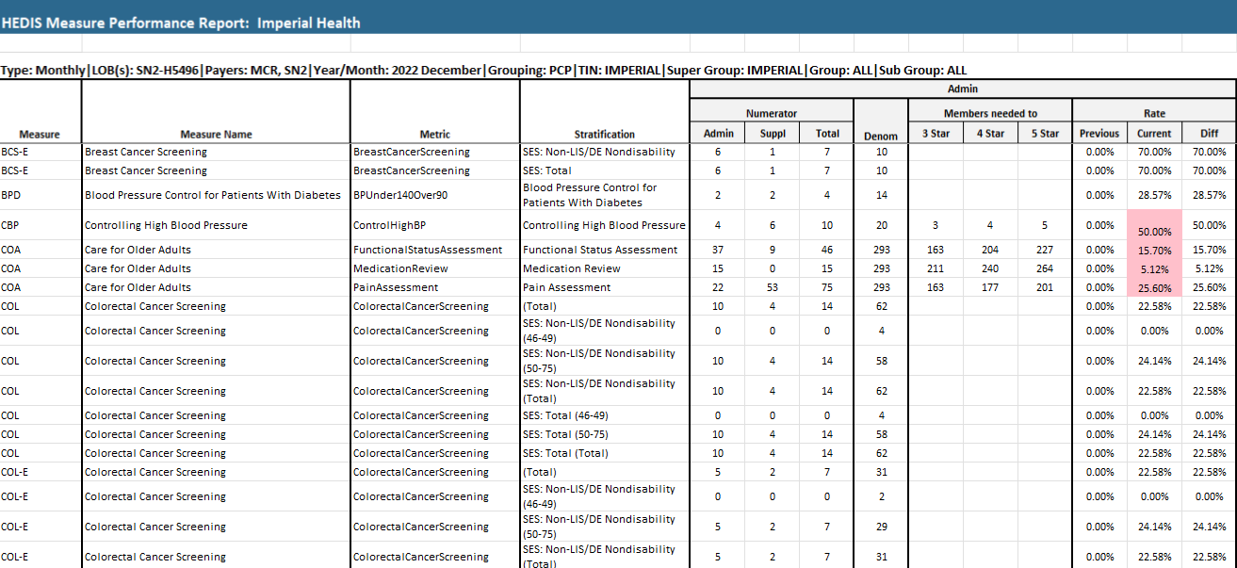
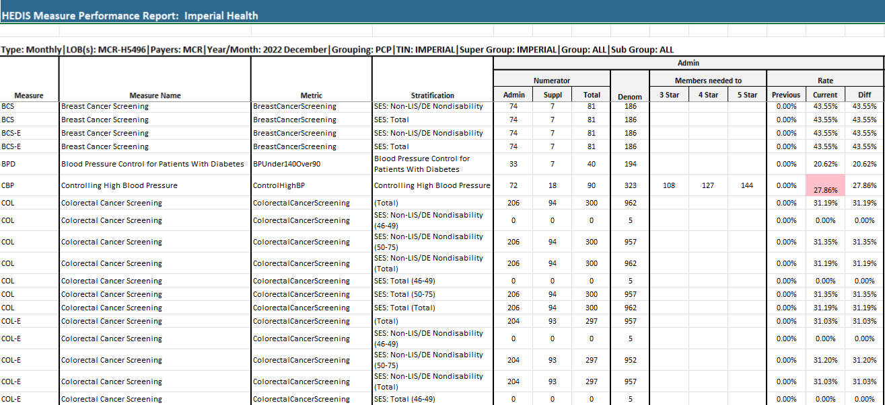

When the benchmarks and internally determined goals are not met, these are used as a rationale for root cause analysis, quality improvement projects, PDSA and opportunity to re-determine priorities and strategies.

4B Factor 2: Identify specific beneficiary health outcomes measures used to measure overall SNP population health outcomes.
Utilizing measurable metrics as identified below, Imperial focuses on measurable goals, benchmarks, and the frequency of each goal. Additional clinical outcomes measures are also described below.

Please see example table 2 below, detailing old and new target goals plus the intervention plan:
Metric | Old Target Goal | Goals Met | Intervention if Goals Not Met | New Target Goal | Goal Source | Data Source | Measurement Frequency
Improving Access to essential services such as medical, mental health and social services
Provider Network Access and Availability | Access to Providers:  90% | Yes  No  Yes  No  No | - Continuous Provider education regarding appointment access so physicians can provide coverage for urgent and emergent appointments.  - Increase the scope/size of the assessment.  - Prioritize the providers with the highest number of member interactions | Access to Providers:  85% | Internal | Internal Survey  External Surveys | Annually  Continuous
Provider Network Access and Availability | After Hours: 95% | Yes  No  Yes  No  No |  | After Hours: 90% | Internal | Internal Survey  External Surveys | Annually  Continuous
Provider Network Access and Availability | Urgent Care within 24 hours: 95% | Yes  No  Yes  No  No |  | Urgent Care within 24 hours: 90% | Internal | Internal Survey  External Surveys | Annually  Continuous
Provider Network Access and Availability | Non-Urgent Care within 48 hours: 95% | Yes  No  Yes  No  No |  | Non-Urgent Care within 48 Hours: 90% | Internal | Internal Survey  External Surveys | Annually  Continuous
Provider Network Access and Availability | Routine Primary Care within 10 days: 95% | Yes  No  Yes  No  No |  | Routine Primary Care within 10 days: 90% | Internal | Internal Survey  External Surveys | Annually  Continuous
Provider Network Adequacy | Time and Distance Requirements | No | - Continue recruiting Primary Care Physicians, Specialists, Hospitals, Ancillary Providers into network either through direct contracts with Providers or through PPG/IPAs. The recruitment will also consist of high Impact and High-volume providers. | Time and Distance Requirements: | CMS | Quest Analytics Report | Annually
Provider Network Adequacy | Micro: 90% | No |  | Micro: 80% | CMS | Quest Analytics Report | Annually
Provider Network Adequacy | Metro: 90% | No |  | Metro: 80% | CMS | Quest Analytics Report | Annually
Provider Network Adequacy | Large: 90% | No |  | Large: 80% | CMS | Quest Analytics Report | Annually
Provider Network Adequacy | Rural: 90% | No |  | Rural: 80% | CMS | Quest Analytics Report | Annually
Member Complaints about Network Access | <4 complaints/1000 | Yes5.83 |  | <4 complaints/1000 | N/A | Report | Semi-Annually
Generic Drug Dispensing Rate | 80% | Yes/81.1% |  | 80% | Internal | Pharmacy Data | Quarterly
Metric | Old Target Goal | Goals Met | Intervention if Goals Not Met | New Target Goal | Goal Source | Data Source | Measurement Frequency
Improving Access to Affordable Care
Member Service Appeals | Appeals/1000 | Yes/0.83 |  | Member Service Appeals/1000 | Internal | Member Service Appeals Log | Quarterly
Out-of-Network Utilization | 30% | Yes/ 6.15% |  | 30% | Internal | Utilization Reports | Quarterly
Improving Health Outcomes
Health Risk Assessments | 100% | No/ 95% | We are working with two vendors, to assist in member outreach. They contact members three times. Additionally, surveys are mailed out. | Members Complete HRA: 100% | Internal | Utilization Reports | Quarterly
Individualized Care Plans | 100% | No/95% | We will continue having daily IDT meetings to ensure every enrollee has an ICP and IDT. We will provide continuous training regarding the ICP and IDT Process. | Members with ICP: 100% | Internal | Utilization Reports | Quarterly
Individualized Care Team | 100% | No/93% | We will continue having daily IDT meetings to ensure every enrollee has an ICP and IDT. We will provide continuous training regarding the ICP and IDT Process. | Members with ICT: 100% | Internal | Utilization Reports | Quarterly

As the table above demonstrates, outcomes measures related to access and affordability, continuity of care, and care transitions are being measured and evaluated quarterly to annually. Examples of clinical measures are detailed below.
Increase the medication adherence by members who fail to fill their medications regularly because of cost. Even with low-income subsidies, many of our members go without needed medications because of the high-cost sharing. Many of these members have many drugs prescribed each month. The combined cost sharing adds up quickly when a member takes over 10 medications. Here is an opportunity to consolidate medication therapy and educate members about plan benefits that help with costs. In addition, Imperial has an opportunity to work with providers to reduce waste, improve adherence and educate on cost options. Imperial’s Director of Pharmacy collaborates with the Member Services department and the PBM to ensure calls are made to patients to remind them to renew and pick up their prescriptions. When feasible, conversion to 90-day supply is supported. Goal: Achieve >85% adherence to Statins, antihypertensive, and lipid lowering agents.
Improvements made in the coordination of care and appropriate delivery of services through direct alignment of the HRAT, ICP and ICT. The IDT meets daily to review high risk patients. The inter-disciplinary meetings review utilization, clinical metrics, adherence, outreach, admissions, readmissions, care transitions needs and community support for members. The goal is to maintain readmissions less than 7.5%. A quarterly UM committee meeting also reviews metrics related to utilization to ensure that high quality, cost effective care is being delivered. These improvements reduce the number of emergency room visits by the imminently terminal patients (disease prognosis is under six months). For example, a goal for reduction in ER visits is to reduce such visits by 10% over the course of the year. This goal is to be achieved by careful outpatient care planning, member outreach, facilitating appointments with providers, care planning and medication adherence. Data sources for measurement of these metrics is from medical claims data, hospital reports, prescription drug events (PDE), medication therapeutic management (MTM) reviews, Comprehensive Medication Reviews. The time frame for these measurements is monthly as reports are received through the CMS TPA and HPMS reports along with internal tracking. If goals are not met, the QI team confers with the clinical teams to perform a root cause analysis (RCA) to identify the barriers or reasons that we did not meet this goal for members and practitioners. Resolution of the issue may involve working with primary care providers and patients to address the barriers. The IDT and QI teams develop a plan of action and implement changes to meet the goal.
Expected Health Outcome:
Remain independent at home and symptoms well controlled.
An important target for the CSNP population is the management of chronic conditions. To manage such beneficiaries, the following steps are taken:
- All heart failure patients have a comprehensive assessment every 12 months
- Those who are determined to be high risk are contacted weekly for approximately six months
- Those developing symptoms of a heart failure exacerbation are referred to their primary providers
During member touchpoints, case managers provide self-management support, educate individuals and caregivers about the disease process, promote medication adherence and help identify early signs of a heart failure exacerbation. The clinical team, in collaboration with the data management team tracks metrics as below to identify high risk patients who are then closely followed over the year by care transitions nurses.
The following are examples of outcome measures:

  - Hospitalization Rate
  - Readmission Rate
  - Emergency Department Utilization Rate
  - Blood pressure control

4B Factor 3: Describe how the SNP establishes methods to assess and track the MOC's impact on SNP beneficiaries' health outcomes.

Goals are set based on Imperial’s MOC and conditions targeted. Quality Dept Staff uses tools such as internal reports and/or our population health platform, Cozeva® to assess whether goals are met. Barrier analysis and PDSA is conducted on metrics falling below established goals/thresholds and/or remain on the next year’s Work plan until it meets specified goal.
Both Cozeva® and our internal reports are designed to measure our CSNP program. All reported measures are stratified to reflect only C-SNP membership. This ensures we address the unique needs of the C-SNP population and tailor interventions accordingly. Goals are also set based on the needs of the membership and the health outcomes believed to merit high priority. Goal setting also addresses the plan’s ability to impact an outcome. The QI committee reviews these goals and makes recommendations. (the figure below shows an example of Cozeva® for CSNP-only members)
Measures related to readmissions and utilization are measured continuously. These health outcomes are monitored using reports which provide member specific compliance data. Case management uses these data to identify members who may need intervention. By comparing the current data to the previous year, Imperial can determine improvements between measurement periods. As referenced in Factor 1, When the benchmarks and internally determined goals are not met, previous interventions analyzed and modified using continuous quality improvement models.

Example of Cozeva® tracking CSNP HEDIS® rates for MY2024
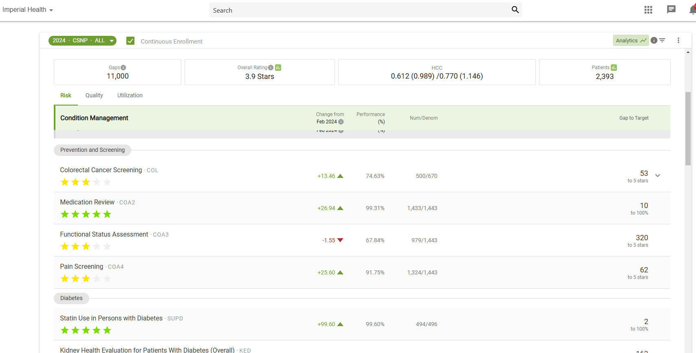

4.B. Factor 4: Describe the processes and procedures the SNP will use to determine if health outcome goals are met.

Performance indicator results are reviewed process owners, quality department staff, and/or key leadership. This leadership may include but are not limited to: Managers/Directors of case management, quality improvement, VP Member Experience, Clinical Services Director, and the Chief Medical Officer. These MOC Annual Summary results are then reported to the Quality Management Committee. Results are measured against established goals.
Quantitative and qualitative analysis is performed to assess current performance against prior performance and against the plan goal and/or benchmark for the measure. Process data and population characteristics specific to the SNP membership may be used to provide context and insight into the results.
Available benchmark data may be obtained from the following sources:
- Medicare Health Outcomes Survey (HOS)
- Chronic Care Improvement Program Reports
- HEDIS® Effectiveness of Care Measures
- Consumer Assessment of Healthcare Providers and System (CAHPS)

4B Factor 5: Describe the steps the SNP will take if goals are not met in the expected time frame.

As mentioned in Factor 1, when the benchmarks and internally determined goals are not met, staff uses quality methodology such as root cause analysis, quality improvement projects, and/or PDSA studies to analyze the results and effectiveness of previous interventions. Identified remediation activities and interventions are often multifaceted and may include members, providers, other external stakeholders and/or systems of care.
When goals are not met, the results are then shared with all stakeholders. Stakeholders are notified about the results. If necessary, senior leadership is involved as well. Performance improvement plans may be implemented and monitored until the under-performance is resolved.
Other actions taken when goals are not realized may include:
- Quality Improvement investigates and follows-through with report and recommended actions.
- Internal and/or external stakeholders are notified about the deficiency, and a corrective action plan is established.
- Internal and/or external stakeholders are placed on a performance improvement plan for the identified deficiency.
- Members are notified about new quality initiatives and performance improvement projects through mailings, newsletters, websites and/or text campaigns.

  - Measuring Patient Experience of Care (SNP Member Satisfaction)
4C Factor 1: Describing the specific SNP survey used.
Imperial Health Plan recognizes the importance of member experience and satisfaction. A good experience can lead to better member engagement and a willingness to participate in a provider’s care instructions. These two points alone can lead to improved patient outcomes. Imperial uses patient experience surveys to identify barriers and carry out improvement activities to improve patient satisfaction.
Member experience surveys are the key mechanism for this feedback. The plan leverages the CAHPS surveys for comprehensive feedback which are done annually. This survey was selected since it is externally validated, valid, and reliable. The instrument is standardized and captures issues related to quality of care. The survey reaches beneficiaries enrolled for 6 months or more, who receive a survey through the mail. They receive a letter, booklet, and business reply envelope. A random sample of the population is drawn and deduplicated.
Imperial may measure member satisfaction in the following ways:

- Grievance Process- Clinical grievances can be reported by members and their authorized representatives telephonically, in person, or in writing. This provides a means to report and seek resolution of concerns regarding any practitioner’s ability to provide appropriate health care services, access to care, cultural and linguistic issues, or quality of care/service issues. Issues that become apparent through resolving the grievance process allow Imperial to identify and mitigate patient dissatisfiers. Feedback from patients during disenrollment, when available, is an opportunity for improvement. Complaints available from the CTM module on HPMS is very helpful to track and trend issues.
- CAHPS: Findings from the Consumer Assessment of Healthcare Providers and Systems® survey as relevant to Imperial are leveraged along with the Health Outcomes Survey (HOS) are used to identify issues affecting care for beneficiaries.
- Member Satisfaction Surveys are conducted to monitor members’ satisfaction with health care services, accessibility to care, continuity of care, quality of care and service, cultural and linguistic issues, and to identify and pursue opportunity to improve member satisfaction and the processes which impact satisfaction. Survey is conducted annually.
- Disenrollment Reasons Survey- The reason for leaving a SNP plan is reviewed in a survey administered by CMS via both mail and phone follow up. Imperial reviews these results to identify areas for improvement and develop and improvement plan to address identified issues.
It consists of six questions:
- How would you rate the overall service you receive from the special needs program?
- Is the written information you receive from Imperial clear and understandable?
- Is the information you receive from Imperial helpful in managing your condition?
- How would you rate the knowledge and helpfulness of Imperial staff?
- How would you rate the friendliness and courtesy of Imperial staff?
- How would you rate the SNP treatment plan for managing your condition?

Survey results are compiled and reviewed for trends below established benchmarks for the SNP MOC. Results are reported to QI for recommendations and interventions. QI reviews and determines the status of proposed changes and interventions.
In addition to the annual CAHPS, we conduct a mid-year targeted survey for high-risk C-SNP members (e.g., those with frequent hospitalizations). Results are analyzed by chronic condition category to identify trends and address issues promptly. We share these findings with the QIC and incorporate changes into the annual MOC evaluation.

4C. Factor 2: Explain the rationale for the selection of the specific tool.
The topics in the survey are derived from the CMS findings from the CAHPS survey. These are important determinants of the healthcare experience. They have been validated through focus groups and studies. Interviews with patients identified these issues to be the types that are important to them. It affects their perception of quality and experience. Imperial’s satisfaction survey also addresses the unique needs of our SNP membership. Surveys that assess a member’s experience with programs, such as the case management satisfaction tool evaluate the primary functions and services performed. The survey focuses on the quality of member interactions and member’s perception of the case manager’s assistance in improving his or her health status. Survey results are evaluated annually to determine opportunities for improvement.

4C Factor 3: Describing how results of patient experience surveys are integrated into the overall MOC performance improvement plan.

The SNP integrates the results of experience surveys into the overall MOC performance improvement work plan. Findings from member satisfaction surveys are reported at QI Committee and shared with relevant shared services departments as well as marketing staff. Survey results are evaluated against internal plan processes, operations, and observations to determine opportunities for improvement. In addition to the QIC, staff evaluates member satisfaction survey results and make recommendations based upon completion of the qualitative and quantitative analyses. This allows Imperial to identify opportunities for improvement and needed interventions, based upon remeasurement. The annual satisfaction surveys are documented on thework plan. This annual performance is included in the MOC work plan reviewed by the QI Committee.

4C Factor 4: Describing steps taken by the SNP to address issues identified in survey responses.
Survey results are shared with clinical staff, administrative staff, member services and the marketing team. Educational points from these results can then be discussed and incorporated into operations so that dissatisfaction factors are mitigated to improve the patient experience. Internal processes are reviewed for opportunities for improvement which are then implemented. Changes are tracked and measured and effectiveness analyzed. Staff monitors these results and works with stakeholders to help achieve better results.
The QI department analyzes the results and works with stakeholders to determine when and what intervention is needed. The results are measured on a regular cadence and effect of interventions analyzed. Status updates are provided. These processes for patient satisfaction are like Imperial’s other performance improvement initiatives. The results of the survey are shared organization wide for discussion and opportunities for improvement discussed, when applicable. Positive results are also evaluated to ensure that the processes are hardwired and replicable. Low score areas are processed through the CQI process. The results are then used to change processes which are monitored as described in MOC4. The changes are reassessed with the next cycle of measurements and surveys.

  - Ongoing Performance Improvement Evaluation of the MOC
4D Factor 1: How the organization uses the results of the quality performance indicators and measures to support ongoing improvement of the MOC.

Imperial uses performance indicators and measure results to monitor and make supported changes to the MOC. The data is collected and analyzed to track issues that are relevant to the specific SNP populations. When possible, measures are compared to National benchmarks. Measures that do not achieve benchmark goals are targeted for improvement. Interdisciplinary teams collaborate to identify root causes for the outcome and determine ways to improve the outcome. Using the Plan-Do-Study-Act or PDSA methodology, Imperial teams plan on an intervention by launching a pilot, study the results, and if successful, act on the approach more globally.

Annually, Imperial has identified reports which analyze emergency department visits, inpatient admissions, readmissions, and transitions which have occurred, to identify areas for improvements by minimizing transitions and maintaining members in the least restrictive setting. These reports are reviewed by management and provided to QM to identify changes to the current process.

Evaluation of the MOC is recorded on the workplan and measured against goals/benchmarks. These elements are part of the organization wide Key Performance Indicators which are discussed monthly organization wide and are also linked to leaderships metrics for evaluation. Such an approach has allowed the organization to remain focused on enhancing quality and value for patients. The evaluation process involves the following steps:
- Measure selection
- Identification of specific MOC goals
- Identification of measurement periods
- Reporting frequency (monthly, quarterly, and annually)

- Categories measured:
  - Structure and Process measures,
  - HEDIS® measurement and outcomes,
  - HOS measures and outcomes,
  - Health & Lifestyle Assessment analysis

- Examples of tools used for measurement:
  - Member surveys,
  - Provider office evaluations,
  - Internal reports,
  - Population health software
  - Provider use of appropriate clinical practice guidelines,
  - Provider interaction with the Model of Care
  - Staff consistency and accuracy of decision making measured by KPI
  - Analysis of staff effectiveness in participation in the Model of Care per KPI

- Interventions: Measures specific to Imperial’s SNP population are reported out as well and monitored.
  - Data are analyzed considering variations in contributing factors.
  - Results of clinical and satisfaction studies allow an opportunity to understand and address the health status of the members.
Findings and recommendations are presented to the QI committee for feedback.

4D Factor 2: How the organization will use the results of the quality performance indicators and measures to continually assess and evaluate quality.

Imperial’s performance and activity reports build towards measurement of the efficacy of Imperial’s health management programs. The results of quality performance indicators are used to support ongoing improvement of the Model of Care and continually assess and evaluate quality. The Chief Medical Officer, the Quality/Risk/Data Analytics Director, and the Senior Manager of Quality Programs (QI) have oversight responsibility for monitoring and evaluating the effectiveness of the MOC. The QI committee. is chaired by the Chief Medical Officer and meets on at least a quarterly basis. The Chief Medical Officer and the Senior Manager of QI present and review performance data and analyses at the meetings of the MOC committee. At these meetings, participants discuss and plan for opportunities to improve the MOC. Discussions also include identifying priorities for the allocation of resources to improve the MOC, and setting any revised goals for quality, availability, and continuity of care for members. The Chief Medical Officer and the quality staff are responsible for follow-up actions, implementation plans and/or additional analyses that are called for by the MOC committee. Key leadership and other internal staff throughout the health plan also support efforts to improve the MOC.

Performance data are analyzed considering variations in many factors including key demographic indicators, the reasons for grievances and appeals, and the overall effectiveness of the program. All those components help identify opportunities for improvement of our MOC. Care managers and the ICT are provided with reports and/or tools that assist them to understand and address the health status of the members. Additional measures are collected through encounter data to determine access/availability of care and appropriate use of services. HEDIS® results are used to report and measure progress and opportunities for improvement. Findings and recommendations are presented to the QI committee. Feedback is incorporated into the workplan.
4D Factor 3: The organization's ability for timely improvement of mechanisms for interpreting and responding to lessons learned through the MOC performance evaluation.
Imperial’s committee structure, open communication culture in the organization and channels of contact with providers and beneficiaries is an important component of its ability to timely improve mechanisms for interpreting and responding to the results of MOC evaluations. Data collection, analysis and remediation is done on a continual basis. Imperial’s reporting system is user-friendly, allowing for analysis by all stakeholders. This helps facilitate analysis by all stakeholders.
Cozeva, Imperial’s population health/HEDIS® software updates measure results weekly and is available to internal staff, providers, and contracted IPAs. Additionally, the health plan may also use internal reports to track measures that are calculated outside of Cozeva. The tools and reports show results at the member, provider, practice, medical group and aggregate/health plan level. This frequent measurement and data availability helps track the effectiveness of interventions and ensure that quality care is being delivered, and care gaps are being closed. This approach has allowed Imperial to address patient care comprehensively, proactively, and better engage patients and providers.
Calculating the measures more frequently allows Imperial to systematically assess effectiveness of the improvement activities for the various components and overall effectiveness of the CSNP MOC.

4.D. Factor 4 How the performance improvement evaluation of the MOC will be documented and shared with key stakeholders.

The Quality Department maintains the annual program evaluation including the measurable goals, performance through a qualitative and quantitative annual evaluation. In addition, the MOC performance metrics, goals, and interventions are documented in the annual Work Plan. Any MOC performance metric not meeting goal is added to next year’s Work Plan with re revised goal. The quality improvement program includes specific MOC reporting activities, programs, and studies that support the quality plan, organizational goals, and objectives. The quality improvement program includes the measurable improvement goals identified in the MOC. Ongoing MOC reporting of activities is carried over year-toyear. This is also the case with regulatory measurements and reporting requirements. The MOC program, activities, results and evaluation is documented in a variety of ways;
- Committee and workgroup minutes
- Activity worksheets/tracking documents
- Work plan
- QI Program Description
- Annual Program Evaluation

Imperial completes a formal, written annual MOC evaluation as part of the QI Program. The final MOC evaluation is reviewed and approved by the QIC and the Board. Feedback is solicited from front-line case managers, providers, and members via a short survey or focus group, and results are incorporated into next year’s MOC Work Plan. Results of the MOC improvements and initiatives are communicated at least annually to key stakeholders, providers, and members. The communication may be shared via conference calls, mailings, webinars, town halls, website distribution, and newsletters. This communication may also includes the performance improvement evaluation and any lessons that were learned during the evaluation period. Such communication helps underscore the dynamic nature of the evaluation process and strengthens a culture of continual improvement.

4E. Dissemination of SNP Quality Performance related to the MOC
4E Factor 1: Describe how performance results and other pertinent information are shared with multiple stakeholders.

The stakeholders with whom Imperial shares the performance results on a regular basis are diverse and broad. They include but are not limited to:
- SNP leadership
- SNP management groups
- SNP boards of directors
- SNP personnel & staff
- SNP provider networks
- SNP beneficiaries and caregivers
- The public
- Regulatory agencies

There are many ways Imperial communicates with stakeholders. Effective and timely communication among all parties participating in the MOC is important to ensure positive health outcomes and improved health status for the member as well as ensuring the engagement of the whole organization.

Providers and community partners receive information on the current goals and objectives, performance results, improvements, updates, and ad hoc alerts on the MOC. Notifications involve quarterly newsletters, monthly to annual joint operating meetings with the provider network staff, meetings with quality staff, website postings that are monthly to quarterly, and email/fax notifications that are as needed.

Members receive information on changes, performance results, improvements, updates, and ad hoc alerts on the MOC in the following formats and schedules during ICT meetings (as needed) and Written notification (as needed). Furthermore, patients, caregivers, and the public can access the SNP’s public website for communications. They may also access the quality performance information on Medicare’s website when the annual Star Ratings are reported.

Key quality improvement activities are presented and reviewed by the Quality Improvement Committee.
Regulatory agency such as CMS, State agencies and public health departments also receive Imperial’s performance data through contractually and statutorily mandated reports. Some examples of such QI reports may include: Star Rating; CAHPS survey results; HOS survey results; HEDIS® performance measures; Chronic Care Improvement Plan updates.

4E Factor 2: Scheduled frequency of communications with stakeholders

Communication schedule shall be as follows

Stakeholder | Report | Frequency
Plan leadership | Committee reports | Quarterly
 | Board Reports | Annual (QIPE, minutes)
 | SNP MOC Training | Annually
Beneficiaries & Caregivers | Member newsletter | Annually
Regulatory Agencies | SNP applications/MOC | Annual or every 3 years
 | Quality submissions | Per agency
Provider Networks | QI projects | Annually
 | Provider newsletter | Quarterly
 | Delegated JOC | Quarterly

4E Factor 3: Describe the methods for ad hoc communication with stakeholders.
Ad hoc communications to stakeholders may be made through email, weekly reports, telephone, committee meetings, in-person meetings, website, email, staff meetings, townhalls, in person meetings, workgroups, US mail, interactive voice response calls, Medicare Health Plan Management system, fax blasts, provider portal, patient profile reports. Ad hoc communications are those that are undertaken outside of regularly scheduled communication cycles due to a clinical or operational need. These may be sent out as a blast fax to providers, a text through the text platform by the quality department, a mail outreach to share a quality initiative by the clinical team. Other scenarios are also possible.

4E Factor 4: Identify the individuals responsible for communicating performance updates in a timely manner

The results of the annual MOC performance evaluation are shared internally at all the committee meetings as well as manager meeting and at the staff meetings. The Managers of the Case Management, Utilization Management, Population Health, and Quality Improvement departments are responsible for sharing and discussing these results with their teams. These internal stakeholders also review and provide input to the annual MOC executive summary before it is shared publicly. The MOC Executive Summary is then reviewed and approved by the Chief Medical Officer. The CMO will share the MOC Executive Report with medical directors and the Director of Provider Relations to disseminate the findings in the provider newsletter. The Senior QI Manager is responsible for communicating the performance updates in a timely manner.

The Senior QI Manager and Quality Manager draft the contents for the MOC Executive Summary for Members and Providers and coordinate the dissemination plan. For the Provider dissemination, the Senior QI Manager and Quality Manager will coordinate with Sr. Provider Relations Manager. A quarterly newsletter to the provider network disseminates performance updates as well.
The MOC Executive summary may be shared, but is not limited to the following: employee and provider trainings, provider newsletters, member newsletters and the Imperial website. RePerformance updates are also provided to CMS monthly through the regularly scheduled meetings that Imperial and its CMS Account Officer conduct monthly. The CEO and Compliance Officer from Imperial attend this meeting when CMS is updated about progress, successes, and opportunities for improvement.

APPENDICES

Appendix A: Organizational Chart

Appendix B: Health Risk Assessment Survey

Appendix C: Medical Services Committee Contact Sheet

Appendix D: MOC Training Slides and Attestation Form

APPENDIX A - ORGANIZATIONAL CHART

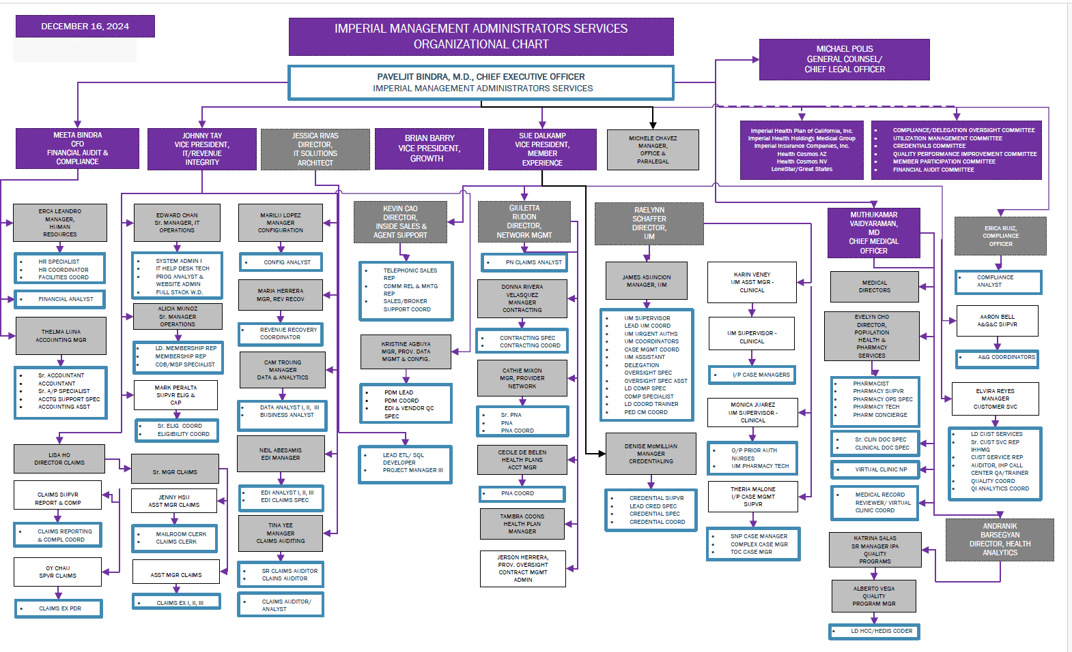

Appendix B – Health Risk Assessment

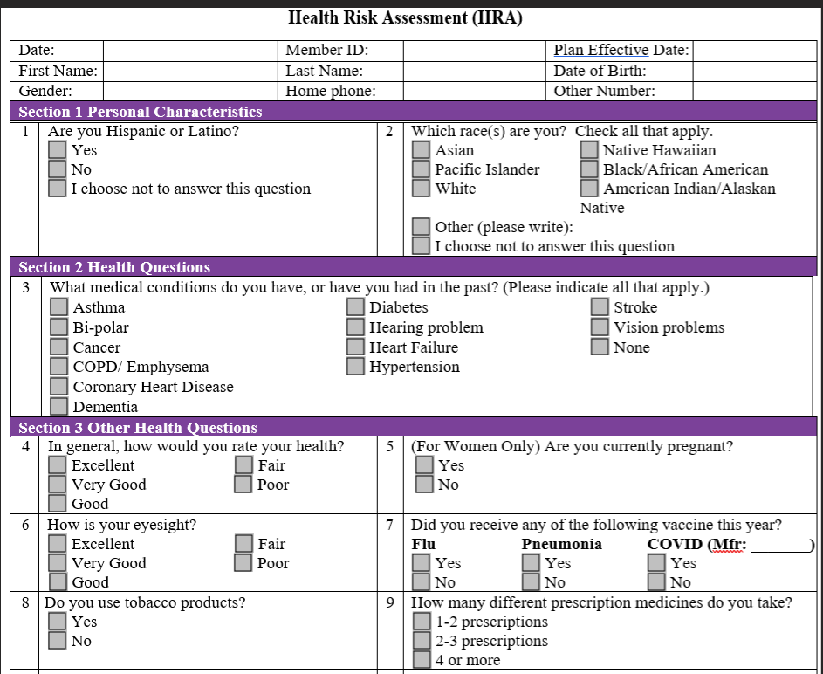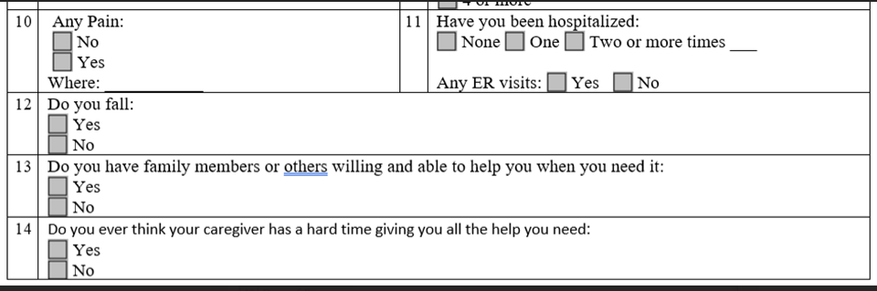
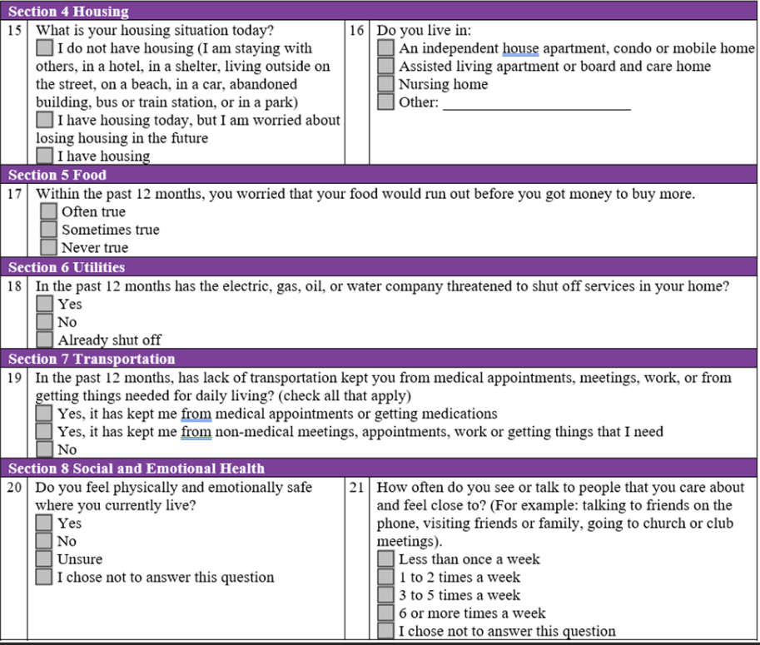
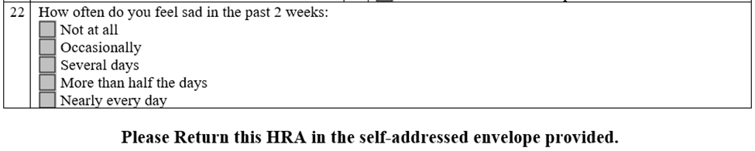

Appendix C ( 3A Factor 2): Evidence of Specialized Providers for ICT

Printed Name | Specialty/  Title
Paveljit Bindra, MD | CEO, Cardiology/electrophysiology
Muthukumar Vaidyaraman, MD | Chief Medical Officer/  QMC/ UMC Chair, Anesthesiology/Pain Medicine
Laja Ibraheem, MD | Behavioral Health Director, Psychiatry
Iselda Gentry, NP | General Practice, Primary Care
Aldijana Hodzic, NP | General Practice, Primary care
Eldo Frezza, MD | General Surgery
Evelyn Cho, Pharm D. | Clinical Pharmacist
Kenny Mo, Pharm D. | Clinical Pharmacist
Theria Malone RN | UM Supervisor, Clinical
Katherine Rivas, NP | General Practice, Primary care

Appendix D: MOC Training Attestation and Slides

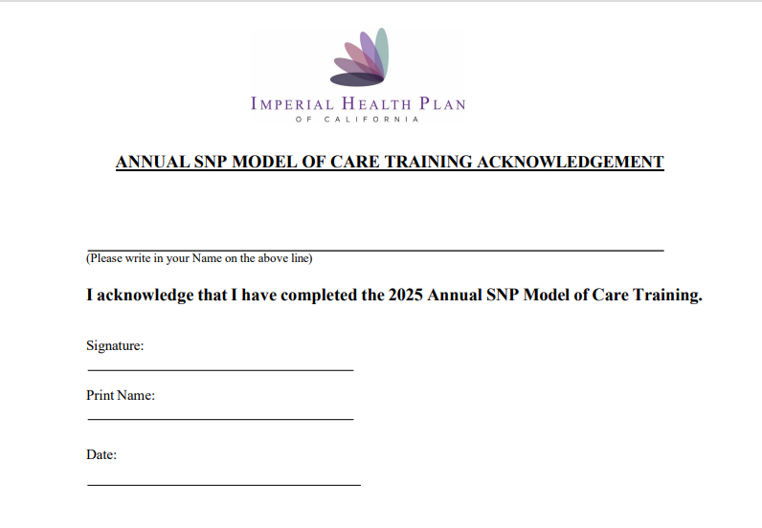

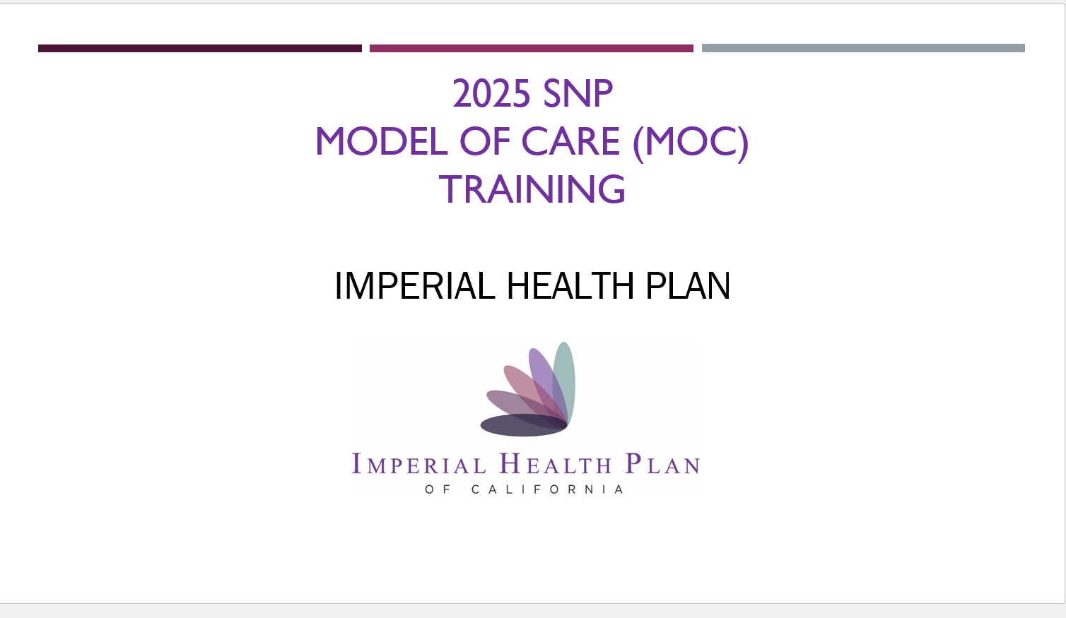
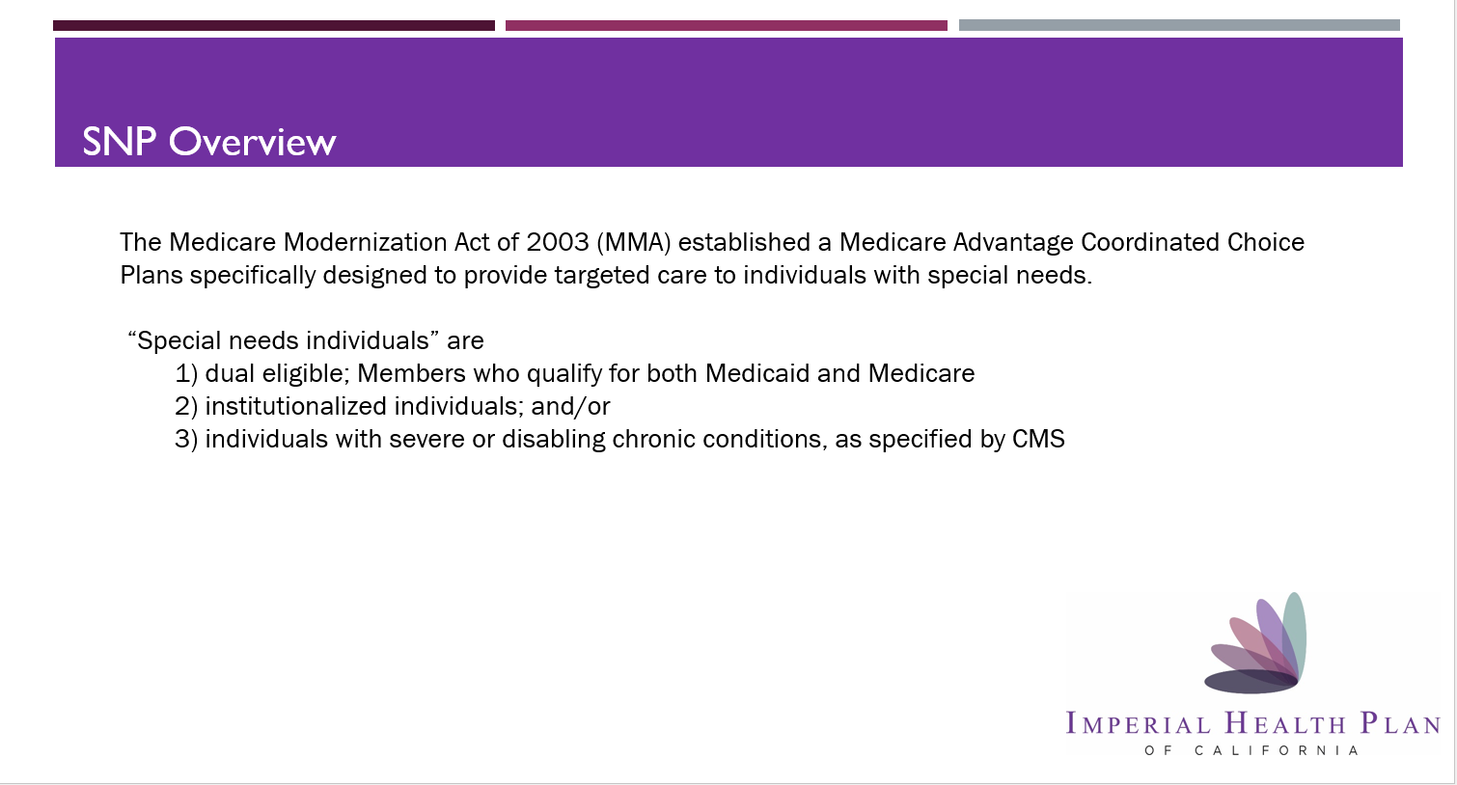
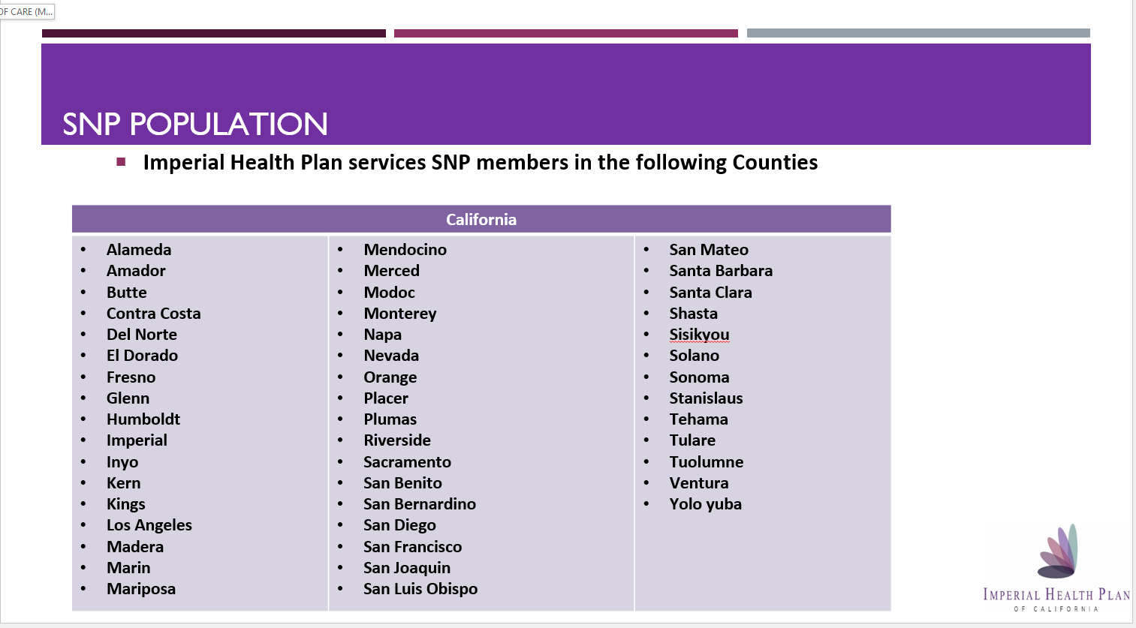
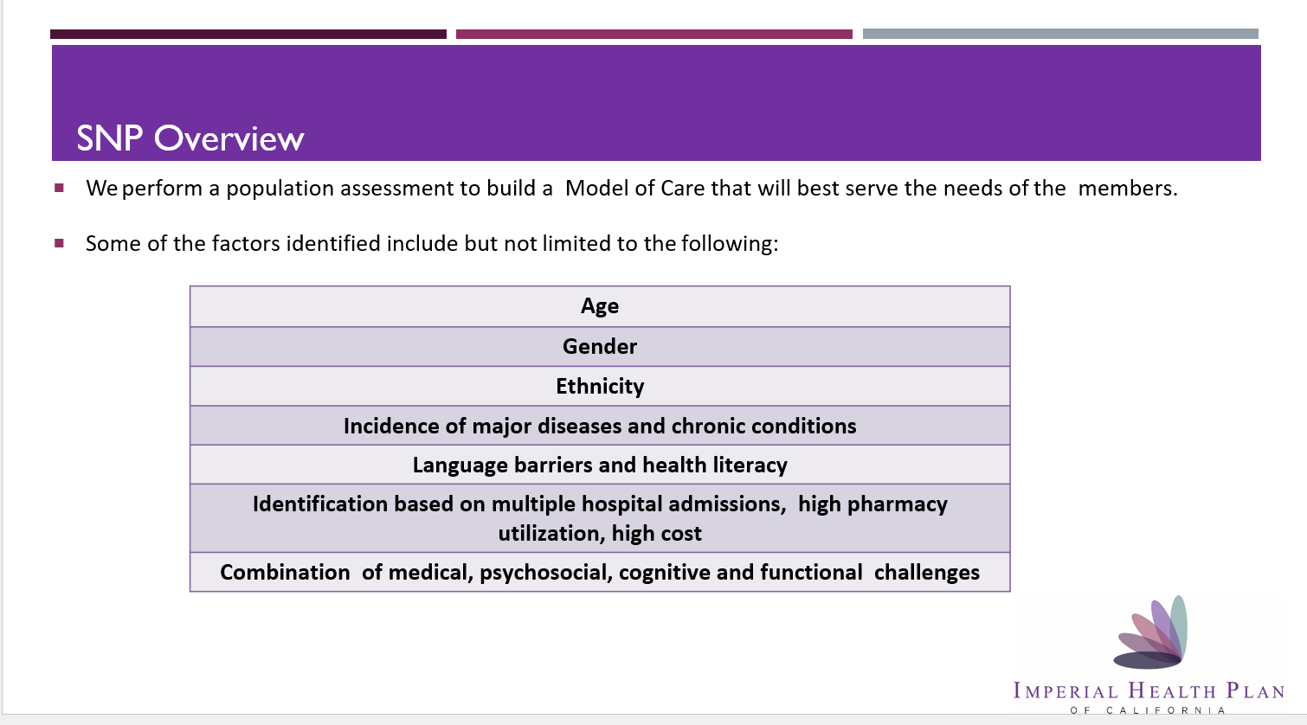
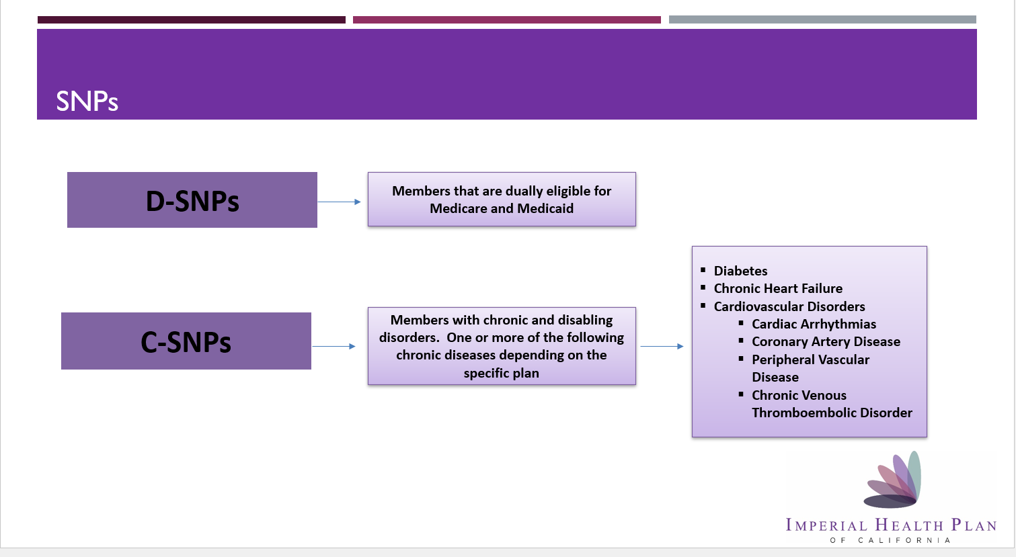
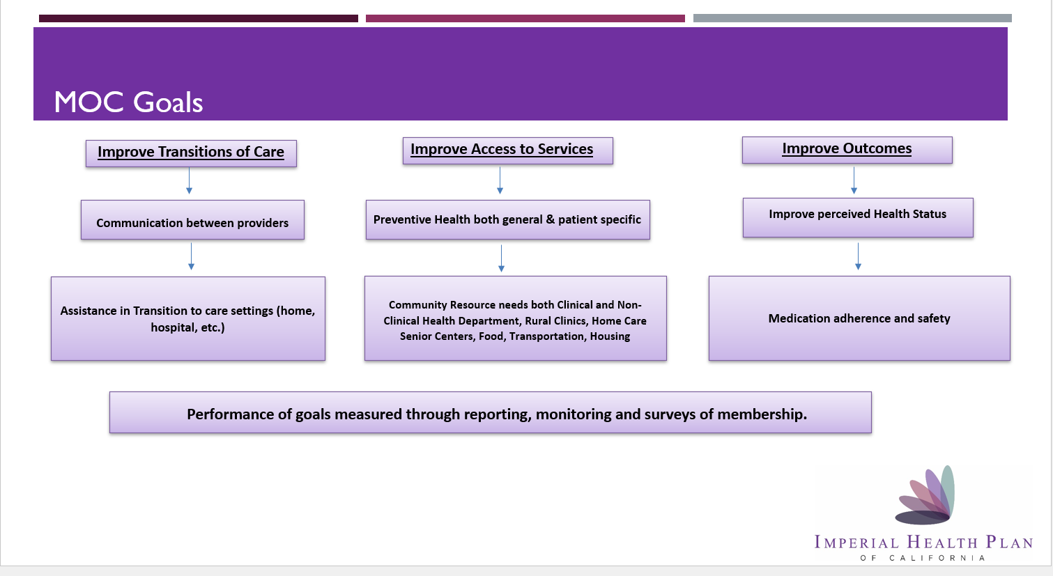
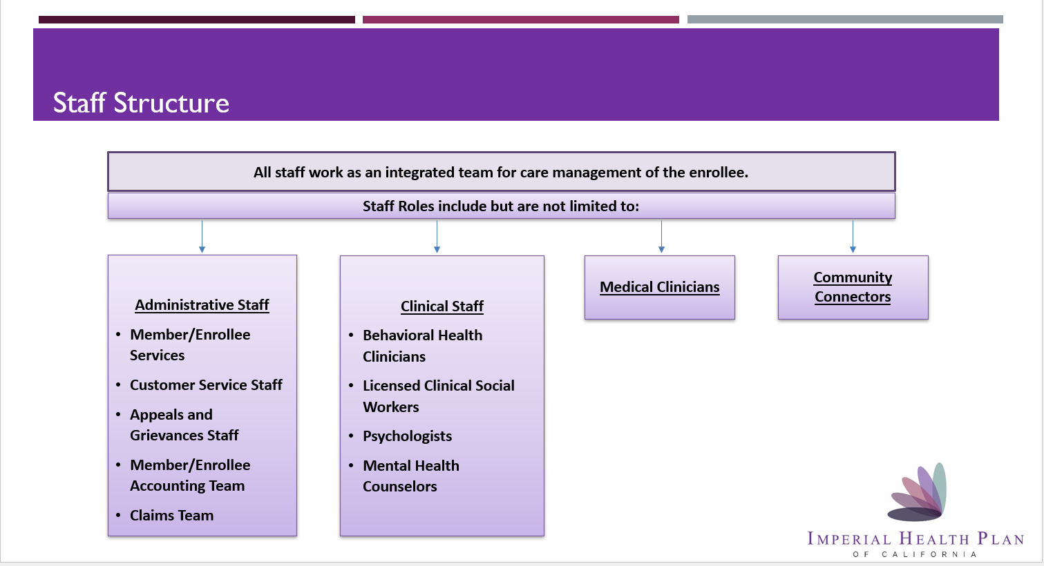
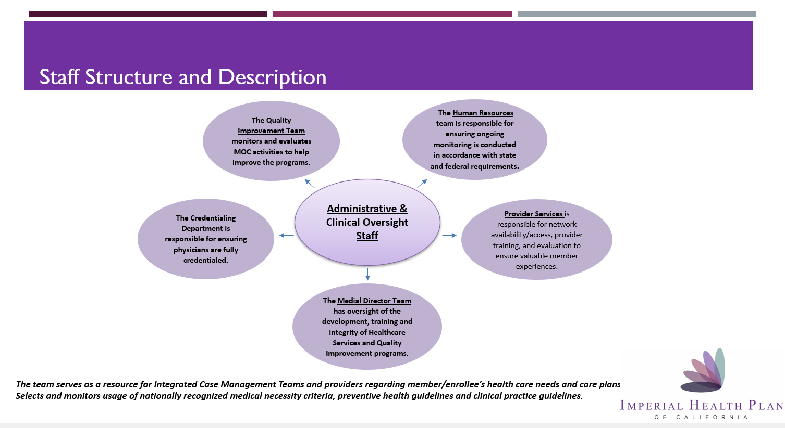
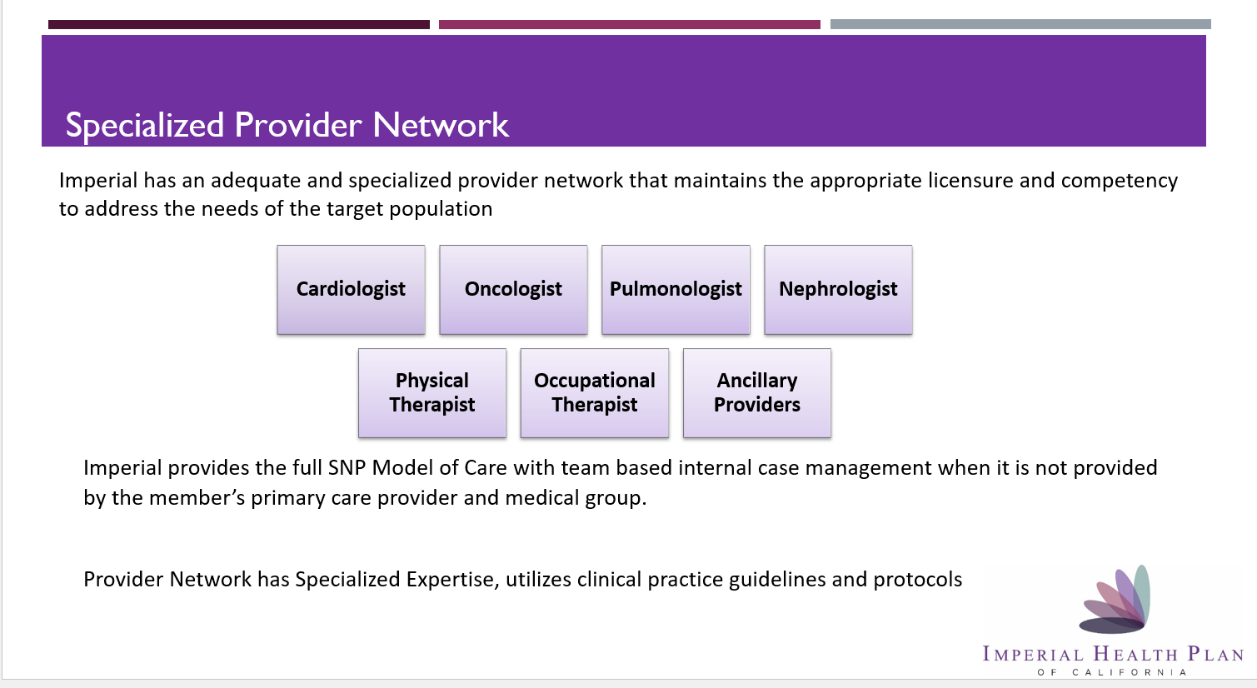
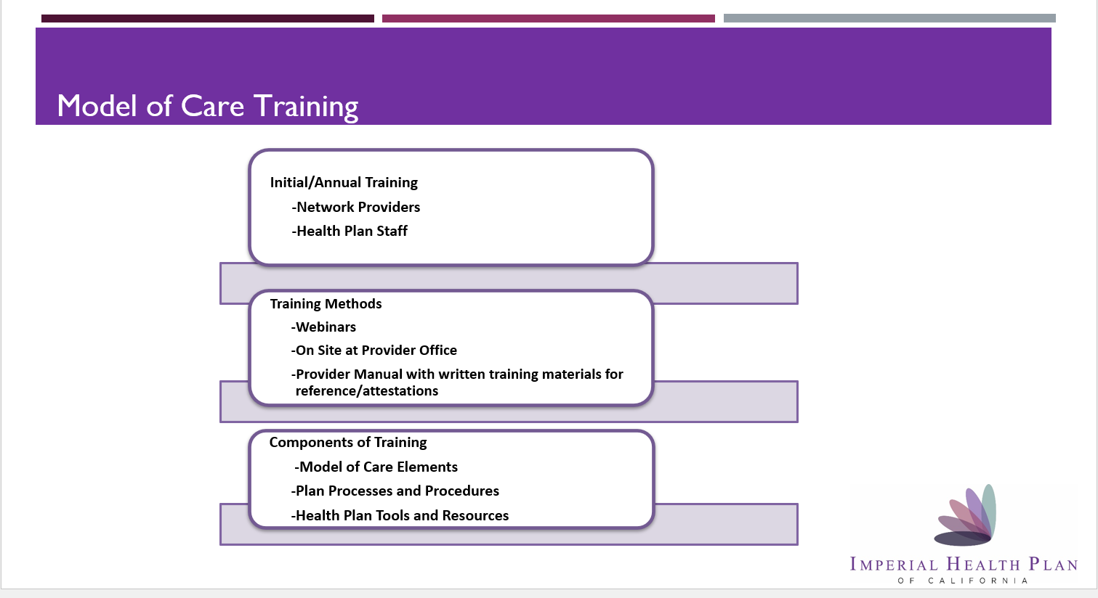
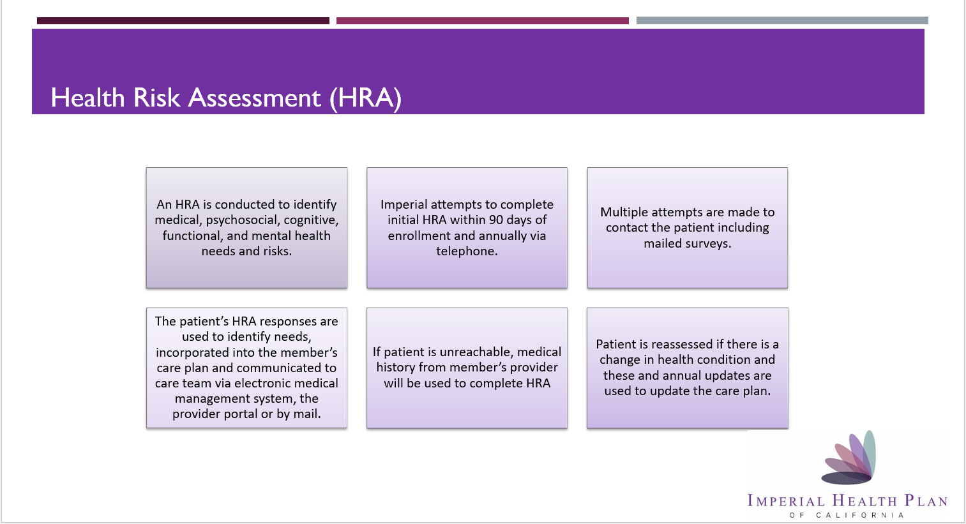
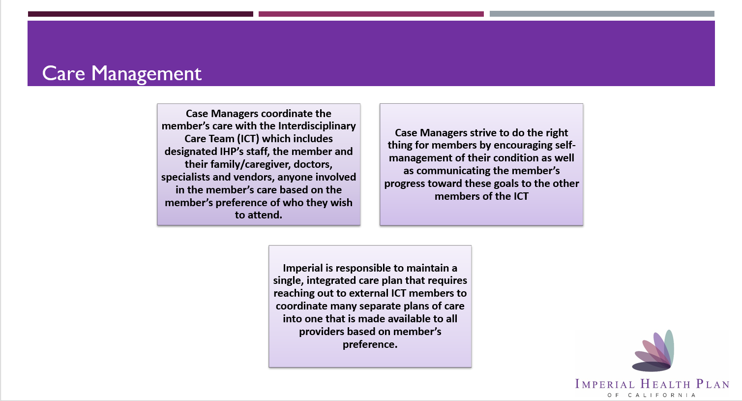
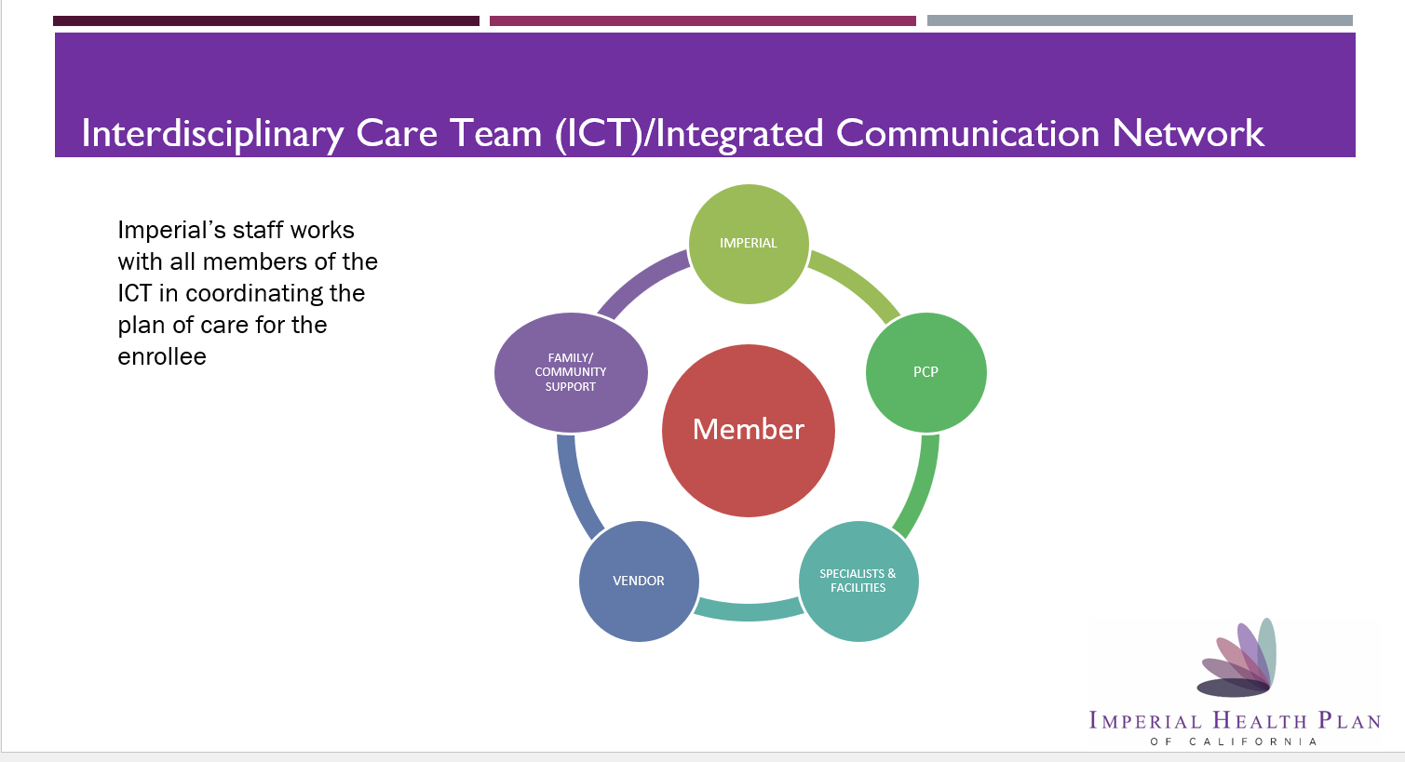
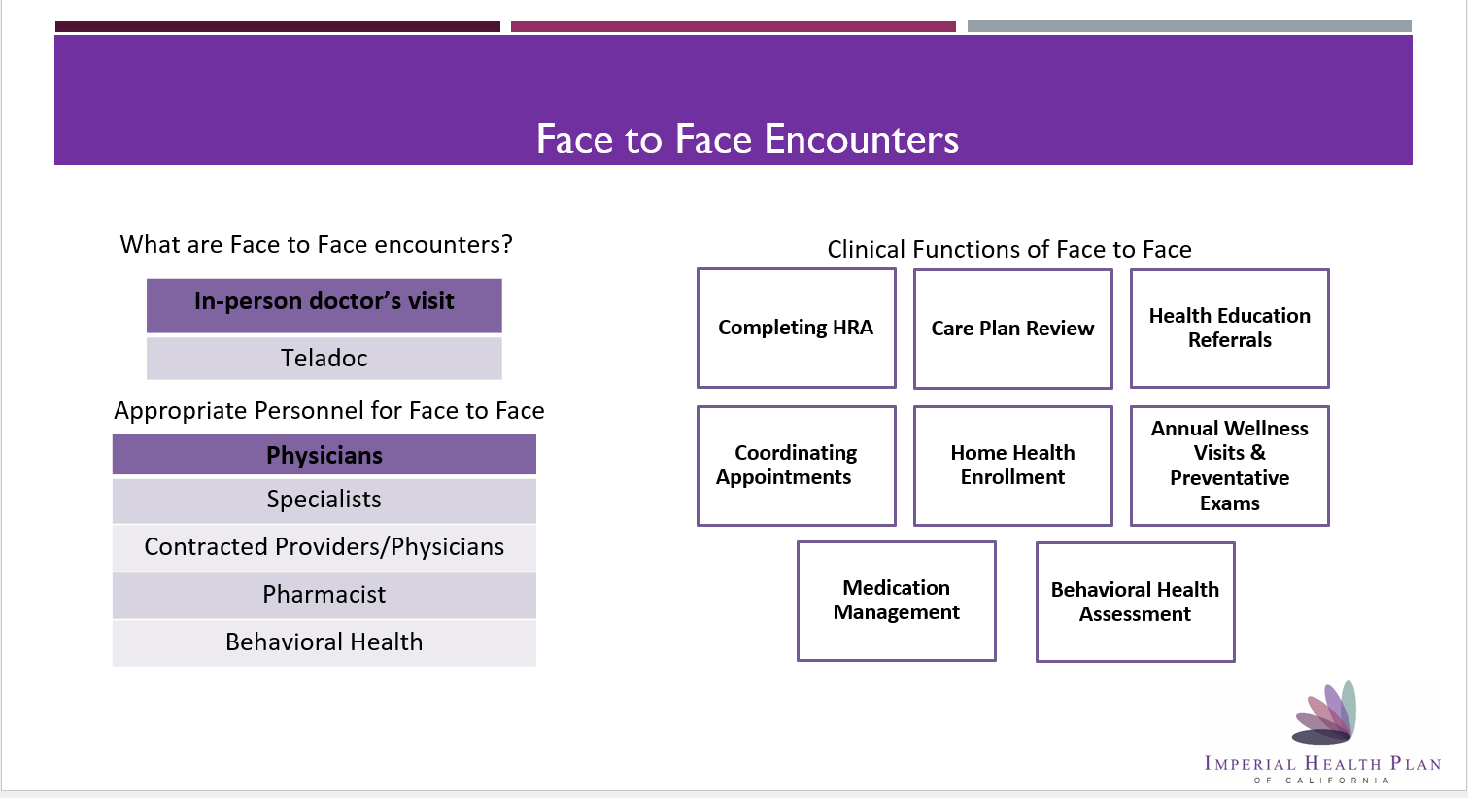
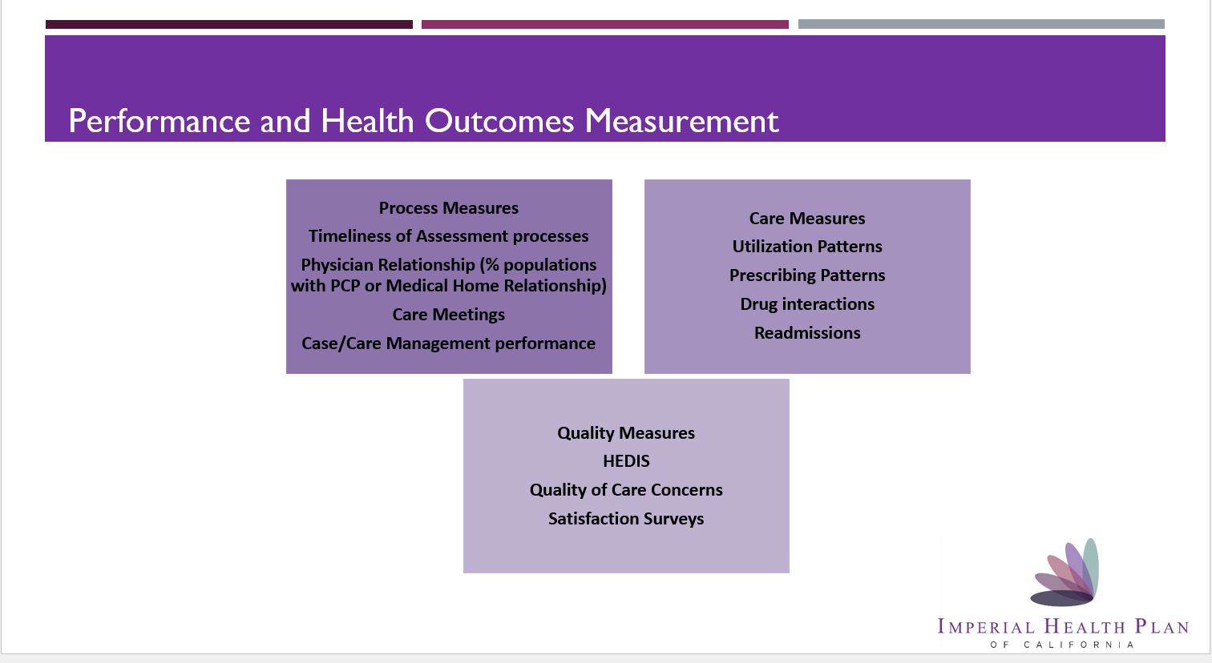
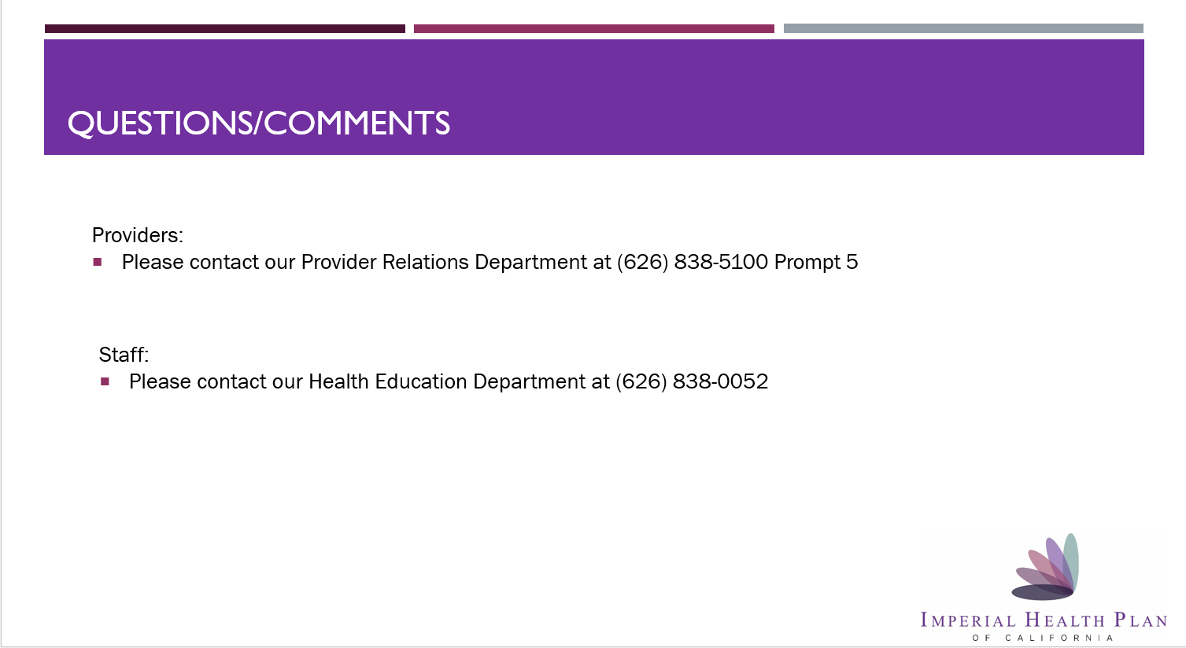

https://nccd.cdc.gov/weat/#/analysis
https://cms-oeda.maps.arcgis.com/apps/MapSeries/index.html?appid=062934f815eb412182b3d324054ea6f0
https://data.census.gov/cedsci/table?t=Poverty&g=0400000US04,06,12,13,26,31,32,35,37,39
https://data.census.gov/table?t=Poverty&g=0400000US04,06,12,13,26,31,32,35,37,39&tid=ACSST1Y2021.S1701
https: https://www.cms.gov/Research-Statistics-Data-and-Systems/Statistics-Trends-and-Reports/Medicare-Geographic-Variation/GV_PUF
Evans TS, Berkman N, Brown C, et al. Disparities Within Serious Mental Illness [Internet]. Rockville (MD): Agency for Healthcare Research and Quality (US); 2016 May. (Technical Briefs, No. 25.) Background. Available from: https://www.ncbi.nlm.nih.gov/books/NBK368430/
http://assets.americashealthrankings.org/app/uploads/2022_senior_report_action_toolkit_executive_brief.pdf
Evans et al 2016.
Evans et al 2016.
https://www.mhanational.org/issues/state-mental-health-america
https://www.mhanational.org/issues/state-mental-health-america
https://www.kff.org/medicare/issue-brief/medicare-advantage-in-2023-enrollment-update-and-key-trends/
https://www.kff.org/medicare/issue-brief/medicare-advantage-in-2023-enrollment-update-and-key-trends/
Physical and Mental Health Condition Prevalence and Comorbidity among Fee-for-Service Medicare-Medicaid Enrollees. Centers for Medicare & Medicaid Services, September 2014.
CCEHI, 2017
CCEHI, 2017
https://www.americashealthrankings.org/explore/annual/measure/severe_housing_problems
https://memory.ucsf.edu/symptoms/healthy-aging
https://ldi.upenn.edu/our-work/research-updates/social-isolation-and-anxiety-in-older-adults-with-cognitive-impairment/
https://www.ncbi.nlm.nih.gov/pmc/articles/PMC4809245/
Center for Consumer Engagement in health innovation, SNP Alliance. Special Needs Plans: Focusing on Social Determinants of Health among Duals. Washington, DC 2017.
Swihart DL, Yarrarapu SNS, Martin RL. Cultural Religious Competence In Clinical Practice. 2021 Nov 17. In: StatPearls [Internet]. Treasure Island (FL): StatPearls Publishing; 2022 Jan–. PMID: 29630268.
Chronic Condition Special Needs Plans (C-SNPs). (2021, December 12). Retrieved February 10, 2022, from https://www.cms.gov/Medicare/Health-Plans/SpecialNeedsPlans/C-SNPs
https://www.chcf.org/wp-content/uploads/2021/10/DisparitiesAlmanacRaceEthnicity2021.pdf
https://www.journals.uchicago.edu/doi/full/10.1086/708616
https://www.cdc.gov/oralhealth/oral_health_disparities/index.htm
https://www.cdc.gov/oralhealth/oral_health_disparities/index.htm
https://www.cdc.gov/oralhealth/oral_health_disparities/index.htm
Anthem Health Plans. H2593 Texas/Arizona. 2020 C-SNP MOC Cardiovascular. Available at: 2020 C-SNP MOC (vanlangipa.com). Accessed February 7, 2022.
NCQA. 2023 CY2023 NSP Model of Care Training FAQs. January 26, 2022. Available at: CY2023 SNP Model of Care Training FAQs (ncqa.org). Accessed February 7, 2022.
Philip AM, Saper MH. Interdisciplinary Care Teams for Me3dicare-Medicaid Enrollees: Considerations for States. Center for Health Care Strategies, 2016. Available at: https://www.chcs.org/media/INSIDE_ICTs_for_Medicare-Medicaid_Enrollees-012216.pdf. Accessed April 30, 2021.
Office of the National Coordinator for Health Information Technology. PCP referral to a specialist. Available at: https://www.healthit.gov/public-course/interoperability-transitions-of-care/HITRC_lsn1080/010301----.htm#. Accessed February 14, 2022.

